Stalin on Class Analysis of the Crisis of Power
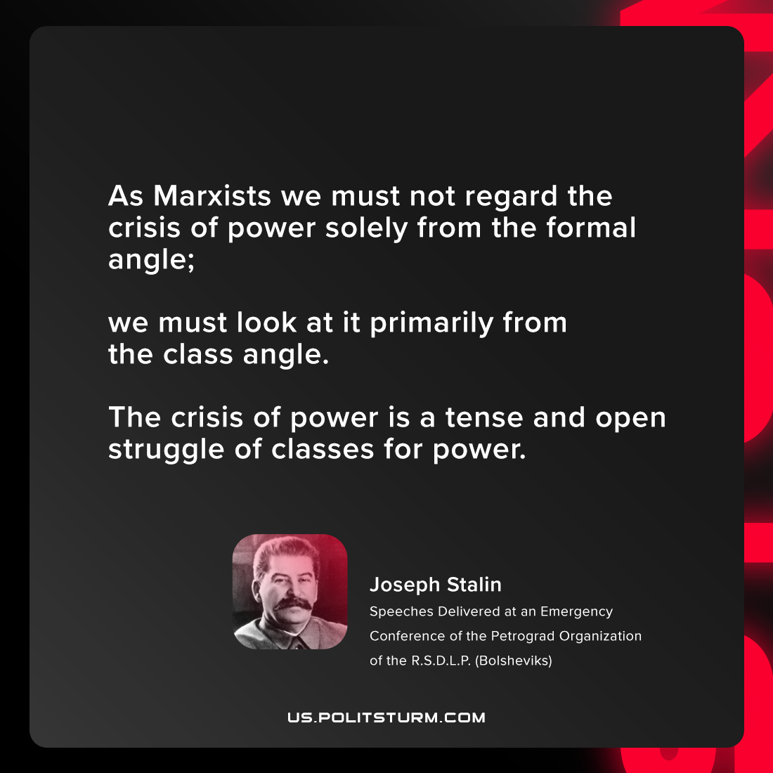

Original article
2021-07-22

As Marxists we must not regard the crisis of power solely from the formal angle; we must look at it primarily from the class angle. The crisis of power is a tense and open struggle of classes for power.

Joseph Stalin, “Speeches Delivered at an Emergency Conference of the Petrograd Organization of the R.S.D.L.P. (Bolsheviks)”

Original article

