Stalin on Character of the October Revolution
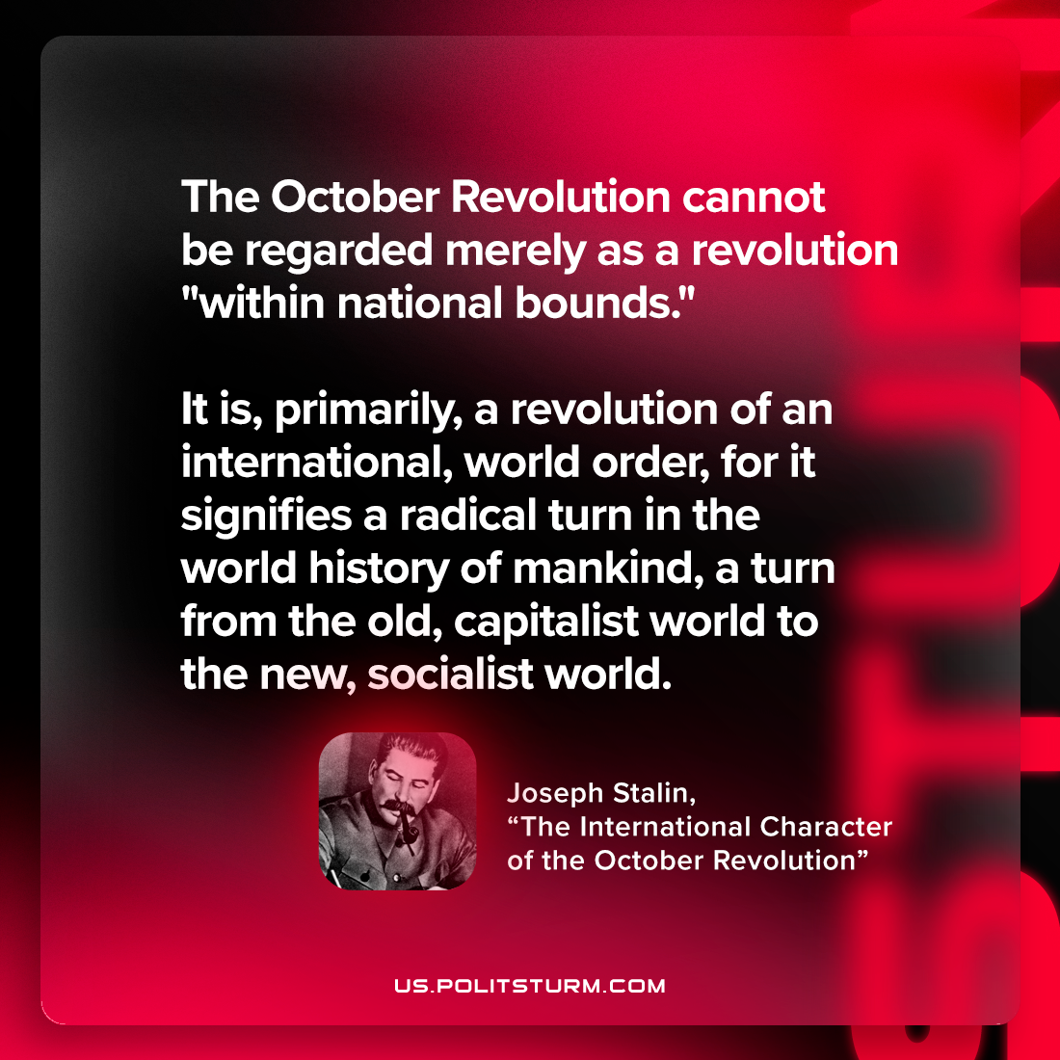

Original article
2022-12-24

"The October Revolution cannot be regarded merely as a revolution "within national bounds." It is, primarily, a revolution of an international, world order, for it signifies a radical turn in the world history of mankind, a turn from the old, capitalist world to the new, socialist world."
Joseph Stalin, "The International Character of the October Revolution"

Original article

