Stalin on Censorship
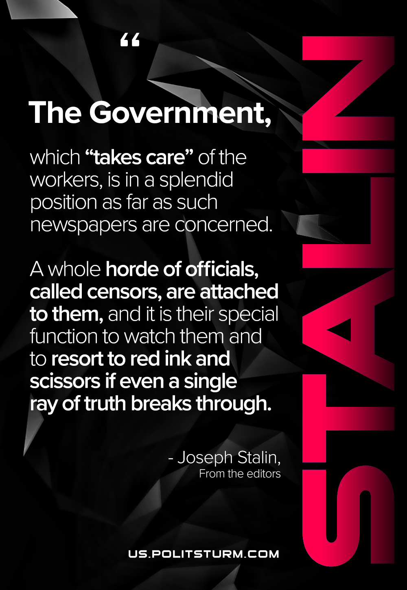

Original article
2021-02-26

The government, which “takes care” of the workers, is in a splendid position as far as such newspapers are concerned. A whole horde of officials, called censors, are attached to them, and it is their special function to watch them and to resort to red ink and scissors if even a single ray of truth breaks through.
Stalin, Collected Works Volume 1, From the editors

Original article

