Stalin on Capitalists Aggravating Crisis
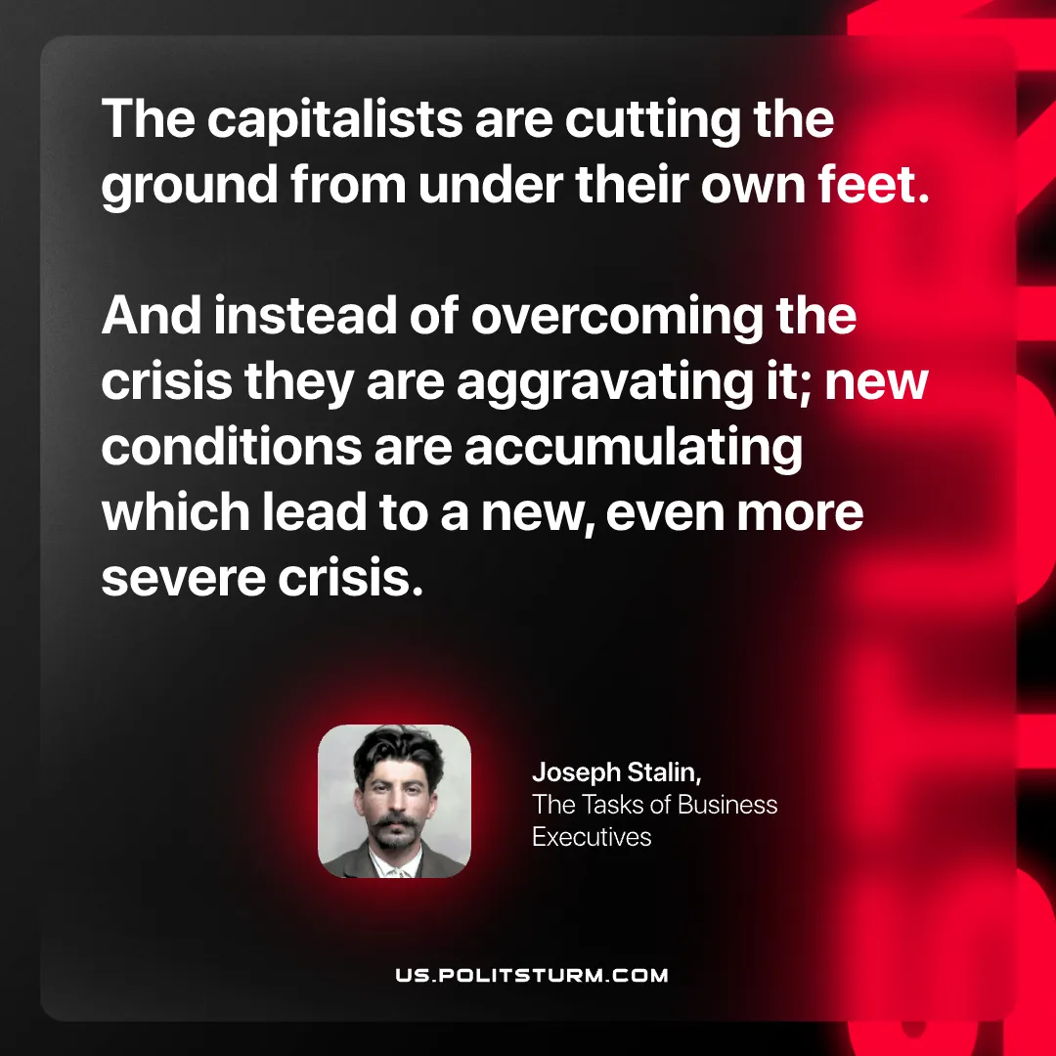

Original article
2026-09-17

The capitalists are cutting the ground from under their own feet. And instead of overcoming the crisis they are aggravating it; new conditions are accumulating which lead to a new, even more severe crisis.
Joseph Stalin, The Tasks of Business Executives

Original article

