Stalin on Capitalist Overproduction
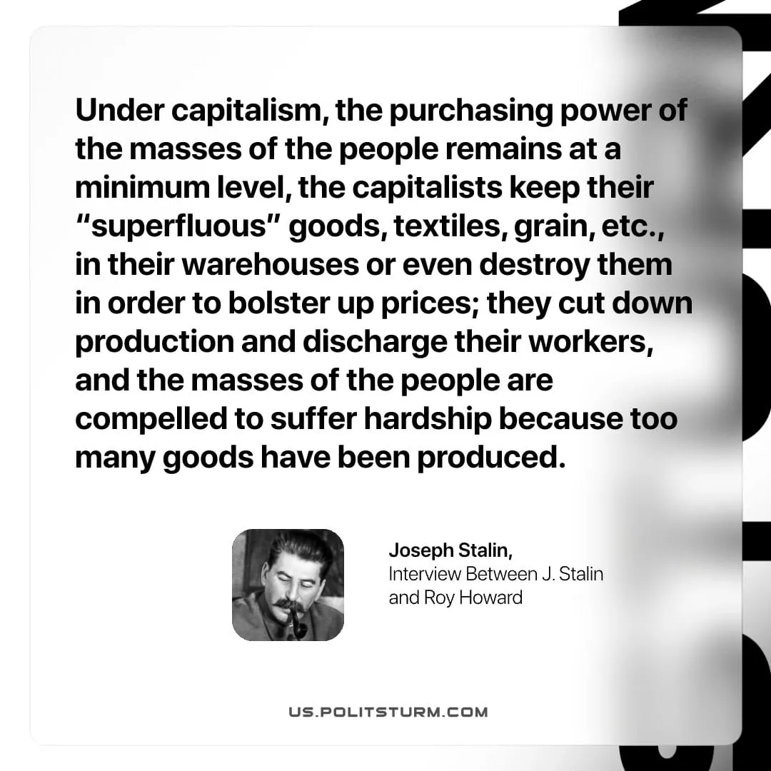

Original article
2026-05-03

Under capitalism, the purchasing power of the masses of the people remains at a minimum level, the capitalists keep their "superfluous" goods, textiles, grain, etc., in their warehouses or even destroy them in order to bolster up prices; they cut down production and discharge their workers, and the masses of the people are compelled to suffer hardship because too many goods have been produced.
Joseph Stalin, Interview Between J. Stalin and Roy Howard

Original article

