Stalin on Capitalism’s Market Crisis
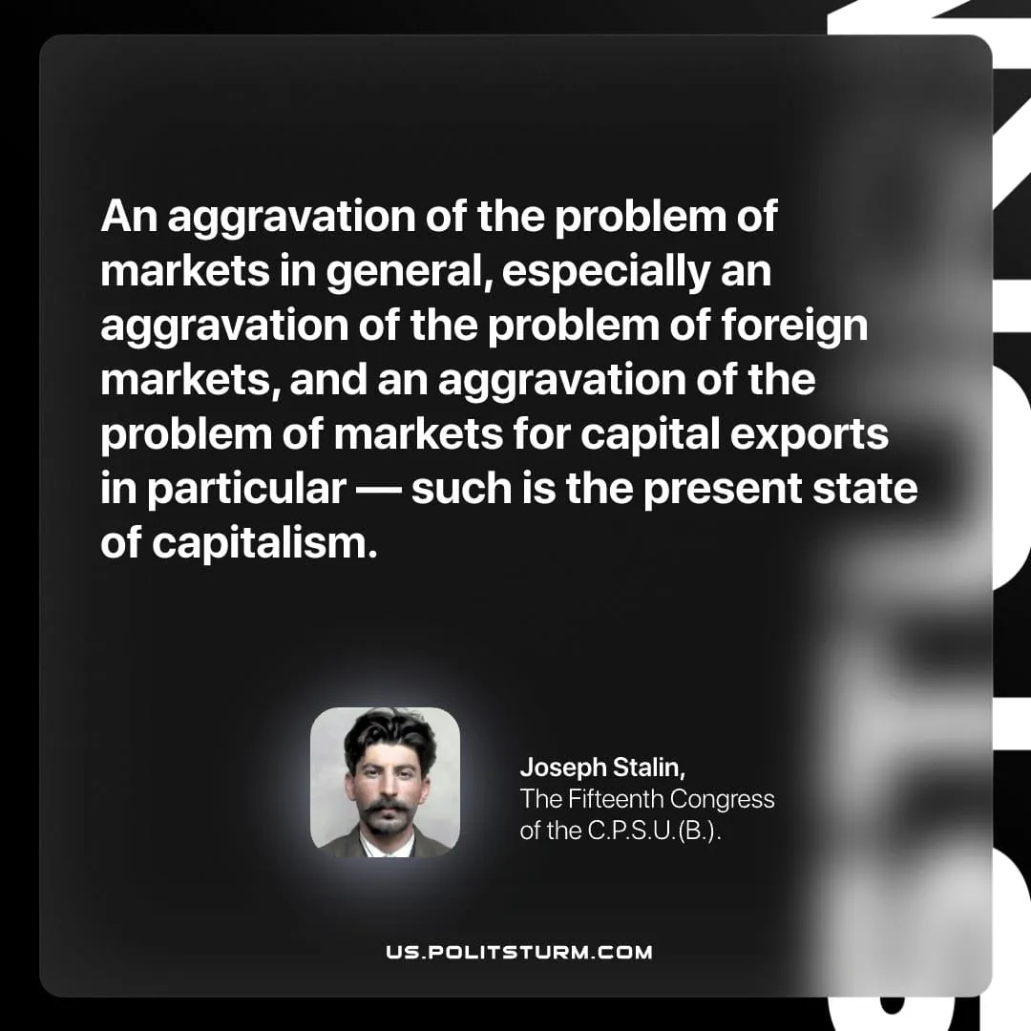

Original article
2026-05-21

An aggravation of the problem of markets in general, especially an aggravation of the problem of foreign markets, and an aggravation of the problem of markets for capital exports in particular — such is the present state of capitalism.
Joseph Stalin, The Fifteenth Congress of the C.P.S.U.(B.)

Original article

