Stalin on Capitalism’s Inevitable Wars
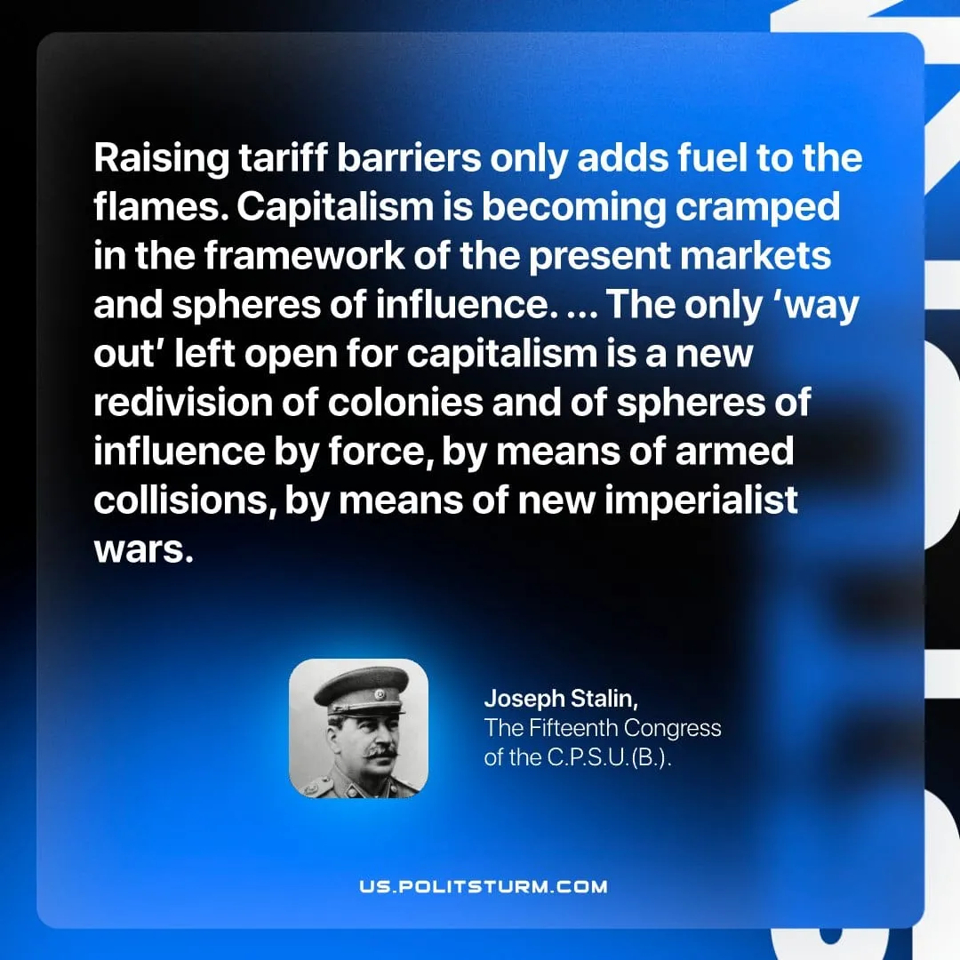

Original article
2026-05-10

Raising tariff barriers only adds fuel to the flames. Capitalism is becoming cramped in the framework of the present markets and spheres of influence. ... The only ‘way out’ left open for capitalism is a new redivision of colonies and of spheres of influence by force, by means of armed collisions, by means of new imperialist wars.
Joseph Stalin, The Fifteenth Congress of the C.P.S.U.(B.)

Original article

