Stalin on Bourgeoisie and Competition
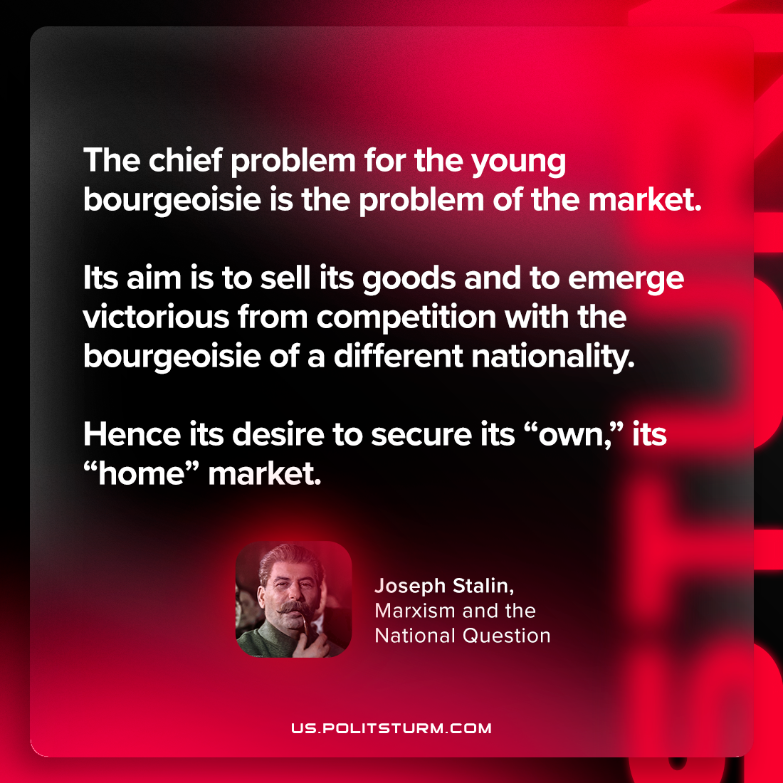

Original article
2023-08-12

"The chief problem for the young bourgeoisie is the problem of the market. Its aim is to sell its goods and to emerge victorious from competition with the bourgeoisie of a different nationality. Hence its desire to secure its “own,” its “home” market. "
Joseph Stalin, Marxism and the National Question

Original article

