Stalin on Bourgeois Constitutions
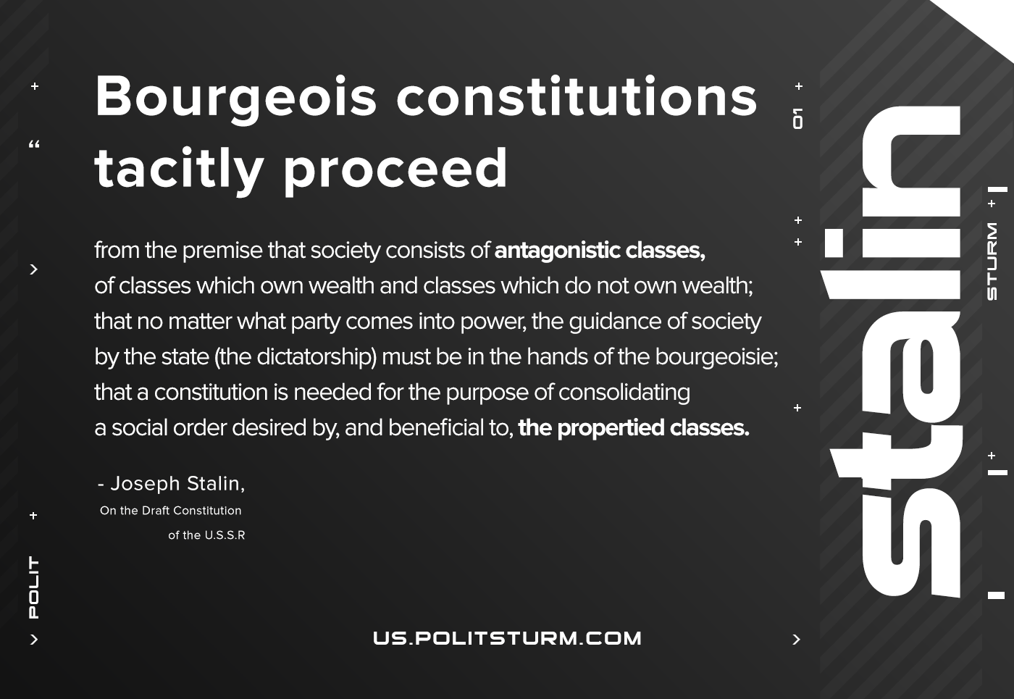

Original article
2021-01-27

Bourgeois constitutions tacitly proceed from the premise that society consists of antagonistic classes, of classes which own wealth and classes which do not own wealth; that no matter what party comes into power, the guidance of society by the state (the dictatorship) must be in the hands of the bourgeoisie; that a constitution is needed for the purpose of consolidating a social order desired by, and beneficial to, the propertied classes.
Joseph Stalin,
On the Draft Constitution of the U.S.S.R

Original article

