Stalin on Artificial Scarcity
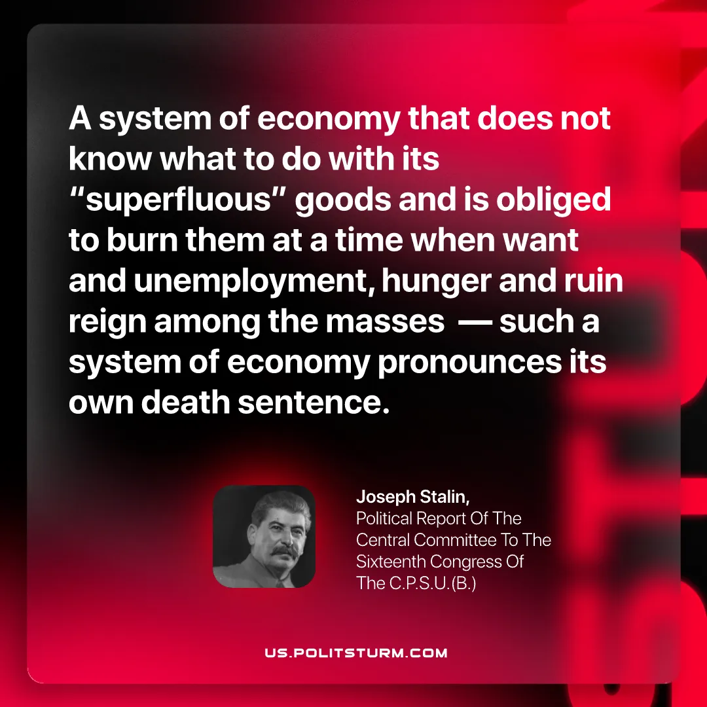

Original article
2026-05-23

A system of economy that does not know what to do with its "superfluous" goods and is obliged to burn them at a time when want and unemployment, hunger and ruin reign among the masses — such a system of economy pronounces its own death sentence.
Joseph Stalin, Political Report Of The Central Committee To The Sixteenth Congress Of The C.P.S.U.(B.)

Original article

