Stalin on Anarchy in Production Under Capitalism
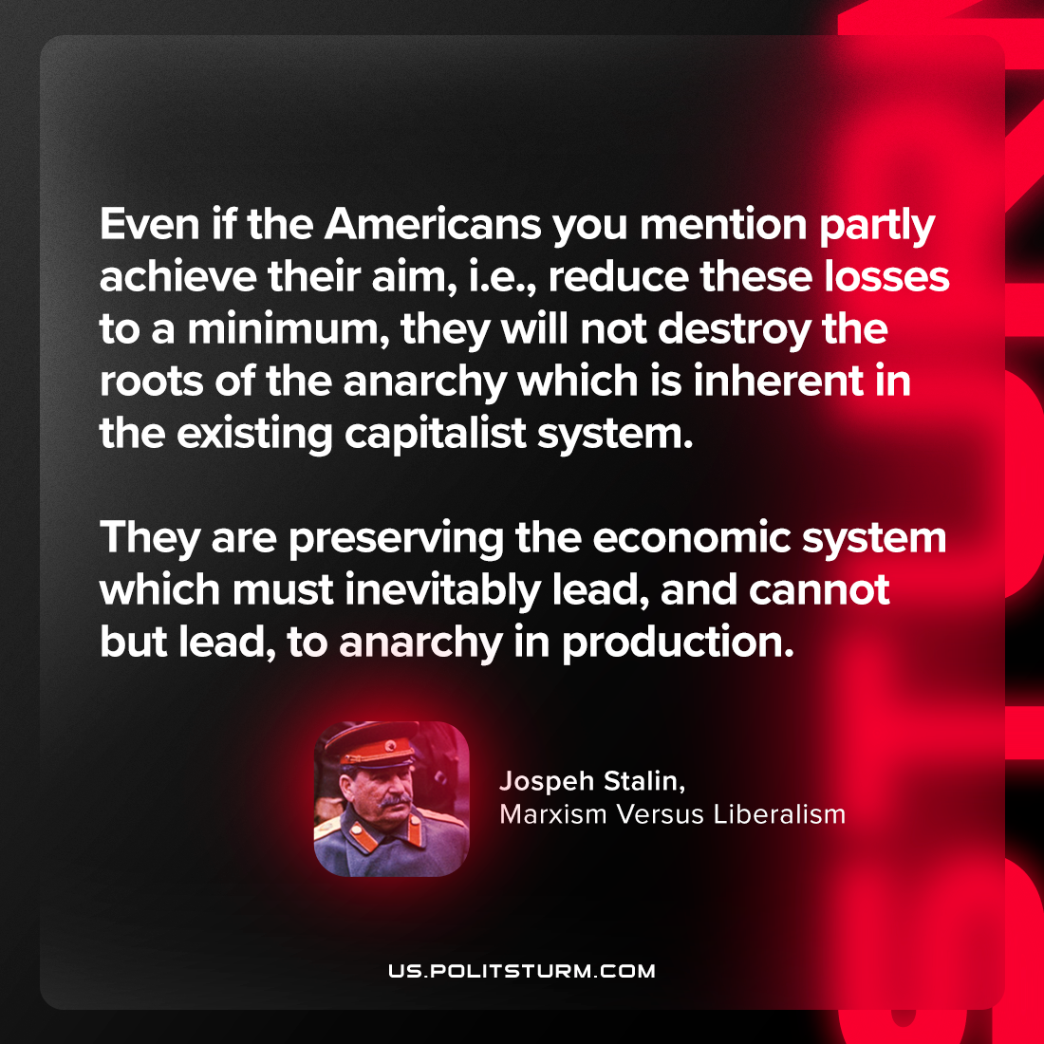

Original article
2023-08-13

"Even if the Americans you mention partly achieve their aim, i.e., reduce these losses to a minimum, they will not destroy the roots of the anarchy which is inherent in the existing capitalist system. They are preserving the economic system which must inevitably lead, and cannot but lead, to anarchy in production."
Joseph Stalin, Marxism Versus Liberalism

Original article

