Stalin on Agriculture and Co-operatives
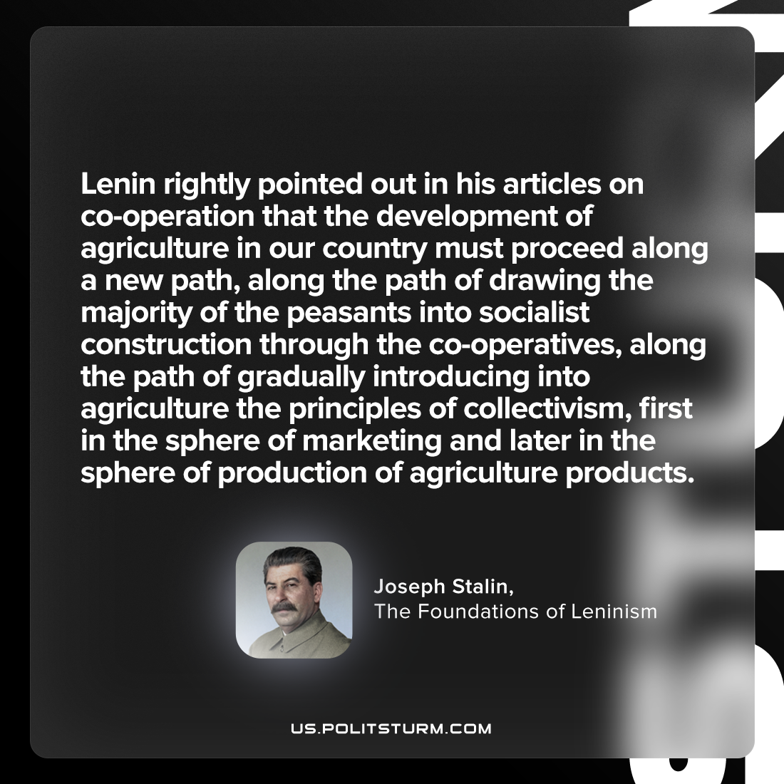

Original article
2023-06-22

"Lenin rightly pointed out in his articles on co-operation that the development of agriculture in our country must proceed along a new path, along the path of drawing the majority of the peasants into socialist construction through the co-operatives, along the path of gradually introducing into agriculture the principles of collectivism, first in the sphere of marketing and later in the sphere of production of agriculture products."
Joseph Stalin, The Foundations of Leninism

Original article

