Stalin on Abolition of National Enmity
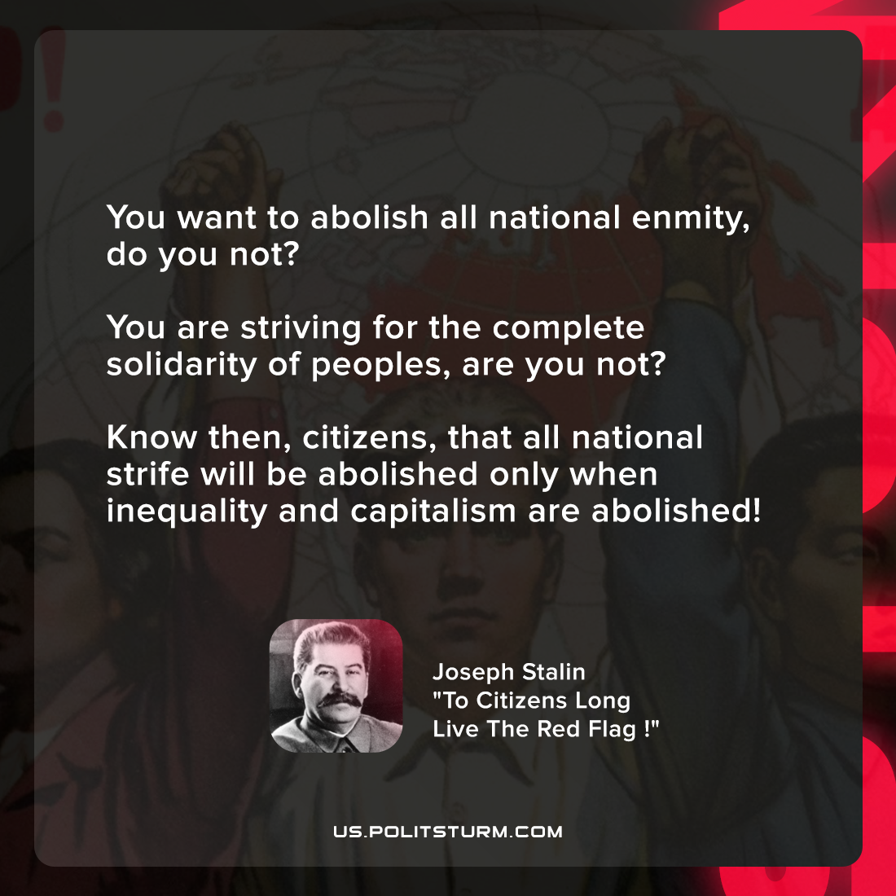

Original article
2022-04-16

You want to abolish all national enmity, do you not? You are striving for the complete solidarity of peoples, are you not? Know then, citizens, that all national strife will be abolished only when inequality and capitalism are abolished!

Joseph Stalin, “To Citizens Long Live The Red Flag !”

Original article

