Stalin on being a Communist
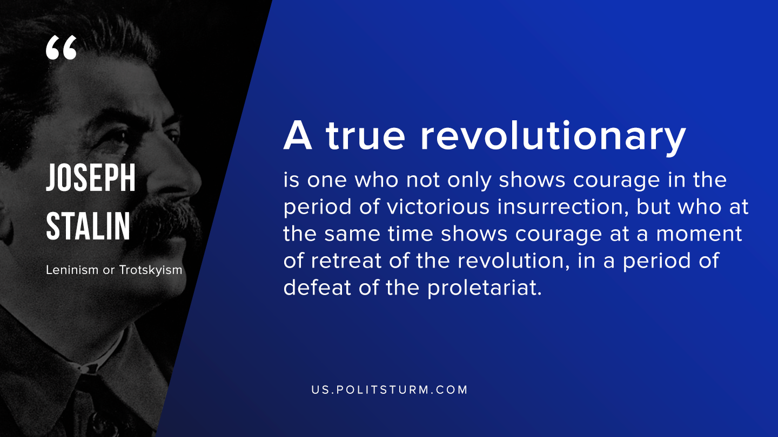

Original article
2019-11-15

A true revolutionary is one who not only shows courage in the period of victorious insurrection, but who at the same time shows courage at a moment of retreat of the revolution, in a period of defeat of the proletariat.
J.V. Stalin, “Leninism or Trotskyism”

Original article

