Pentagon Speech Unveils the Priorities of American Imperialism
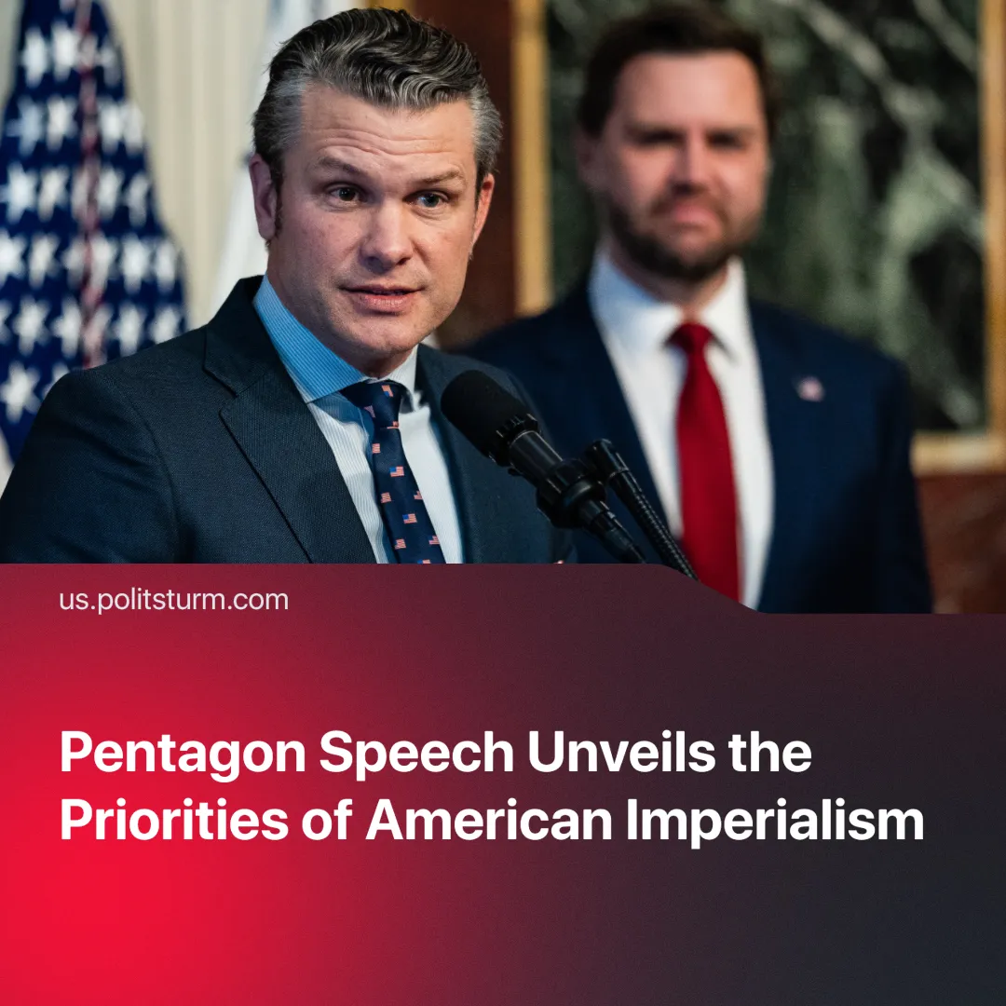

Original article
2025-03-05
2 min read

U.S. Defense Secretary Pete Hegseth gave his speech on the Department of Defense at the Pentagon Town Hall revealing the priorities of American imperialism.
Details. On February 7, 2025, Pete Hegseth delivered a speech at the Pentagon Town Hall about significant policy changes, his vision and priorities for the Department of Defense. He outlined three main priorities for the American military.
► First, he emphasized restoring the “warrior ethos” of the U.S. military, rejecting the phrase “Our Diversity is Our Strength” as “the dumbest military phrase in military history.” Instead, he called for unity as the military’s primary strength, aiming to deter military conflicts and if necessary, decisively defeat enemies.
► Second, he aims to expand and modernize the U.S. military by accelerating the adoption of new technologies.
► Lastly, he stressed the need to reinforce deterrence in global conflicts, citing events in Afghanistan, the Gaza conflict, and Russia's operation in Ukraine—all of which he blamed for creating a “perception of American weakness”—and he emphasized securing the homeland's southern borders as a key priority.
Context. Hegseth also outlined additional priorities in his speech, including countering China as a primary competitor, securing global resources, expanding militarization, addressing perceived threats at the southern border and “empowering” allies.
► The U.S. prioritizes addressing “bigger threats” at certain times, currently framing border security as its most pressing national security concern. It has proposed a “peace” deal for the Ukraine conflict and is closely monitoring the rise of “Communist” China.
► The U.S. is interested in controlling territories in countries like Ukraine, proposing its mineral deal, and acquiring Greenland for its vast mineral resources.
► The U.S. demands its allies increase their military spending and has threatened the EU with tariffs. He stressed that the U.S. “will no longer accept partnerships with unequal burden,” as “America has many assets, but they are not unlimited, and can’t be guarantor security for everything forever.”
Important to Know. These policies are designed to boost profits for U.S. capitalists by offloading costs while preparing the U.S. military for more potential direct conflict. Through jingoistic policies and rhetoric, the new U.S. administration aims to restore American hegemony and maintain its global dominance. However, this is not a departure from the previous administration, which pursued the same objective—it is simply a more overt and aggressive “hawkish” approach.
► U.S. imperialism will intensify military conflicts in the most strategically and economically valuable regions, directly contradicting Trump’s frequent claims of advocating for “world peace” and opposing war.
► The administration's military doctrine emphasizes readiness and lethality, using national security as a pretext for its expansionist strategies. At the same time, it seeks to obscure class contradictions and divide the working class by promoting chauvinism.
► As of 2025, the U.S. military budget has risen to $850 billion, up from $842 billion the previous year under the Biden administration, which has consistently expanded military spending. With over 900 bases spanning at least 96 countries, the U.S. maintains the world's largest and most costly military, securing extensive territorial and strategic dominance.
Conclusion. Hegseth’s speech exposes the core aim of U.S. imperial policy—to secure and expand the profit margins of American capitalists at the expense of the global working class. By reviving a reactionary “warrior ethos,” accelerating the militarization of state power, and fortifying national borders, the U.S. is funnelling resources into an overtly hawkish foreign policy. This clear message reveals that global imperialist rivalries are intensifying, pushing most of the globe ever closer to conflict.

Original article

