Spanish Bank Workers Demand Wage Increase
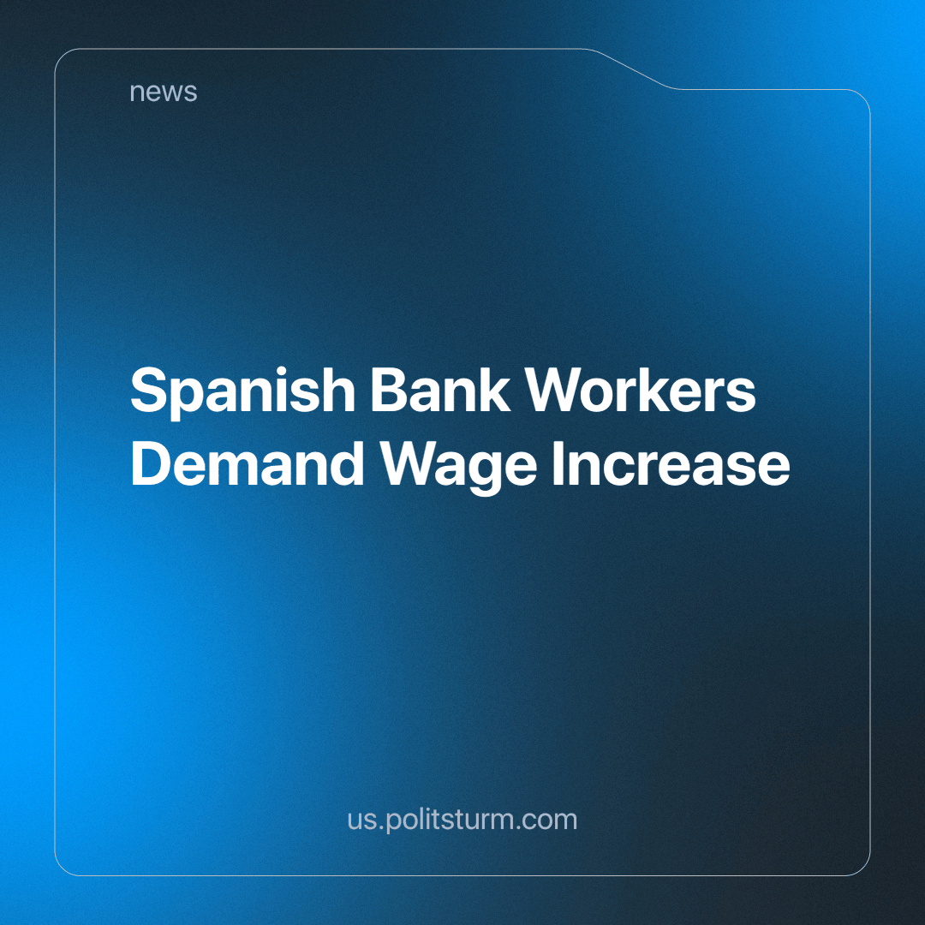

Original article
2024-05-02
1 min read

According to Reuters, bank workers in Spain took part in a strike on 22 March, demanding higher wages against a backdrop of record bank profits.
The CCOO union said the strike affected 75% of the approximately 80,000 bank employees, although the Spanish Banking Association said only a quarter of workers took part.
The main demand of the leading unions is an increase in the minimum wage. Currently, the workers are demanding a 13% increase over three years starting in 2024, although previously the range was 17-23%. The banking association, however, is only willing to agree to 8.25%. In 2023, salaries were already increased by 4.5%, but in the face of high inflation, people's purchasing power was only partially compensated.
"We express our willingness to find the necessary points of convergence that will allow us to reach an agreement in the upcoming meetings (with the unions)," the association said.
At the same time, the banks are expressing their regret at what has happened and the negative consequences it may have.
In 2024, Spanish bank workers protested alongside their Portuguese counterparts, whose banks also posted record profits. While bank employees were previously recognised as the "fundamental support" of the financial sector, trade unions now report that bank employees are being treated "like slaves". By cutting jobs, bankers are forcing the remaining workers to work overtime, which is not always paid.
"While employees face unstable working conditions, super profits flow into the hands of shareholders, many of whom are foreigners," the unions also note.
As long as capitalism, which is based on the private appropriation of the results of socialised labour, exists, the employers will continue to squeeze every last drop out of the workers who generate unimaginable profits for the owners of the means of production. Only by uniting to defend their rights, through trade union activity and the fight for socialism, can all workers significantly improve their situation.
Source: Central trade union newspaper "Solidarity" - "Spanish bank employees demand wage increases against the backdrop of bank super profits" dated March 27, 2024.

Original article

