Southwest Warns Almost 7,000 Workers of Furloughs
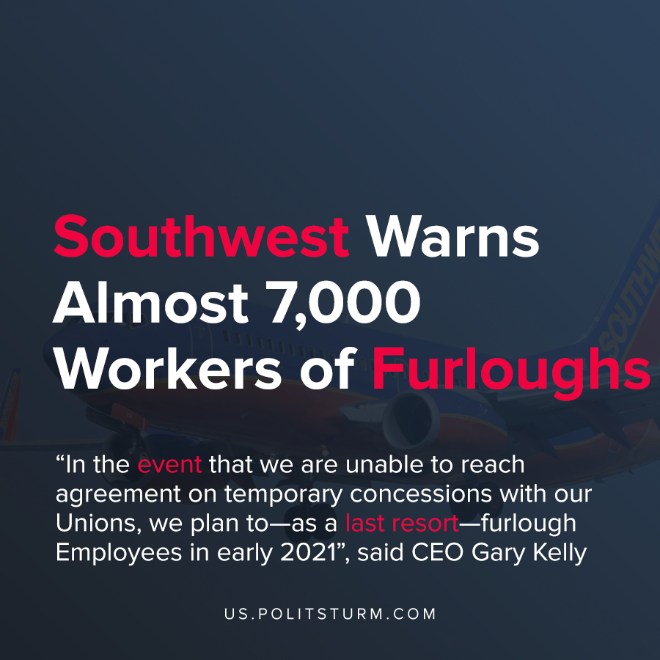

Original article
2020-12-05
1 min read

Southwest Airlines issued notice to almost 7,000 employees that they will potentially be furloughed. The company has struggled with declining revenue due to the impact of the coronavirus pandemic on the travel industry.
The company is flush with cash with nearly $15 billion in cash and short term investments on hand, but it suffered a $1.2 billion loss in Q3 2020.
In order to protect the interests of the shareholders, the company is reducing labor costs as a short-term strategy to maximize profitability.
The company has engaged in various methods of “cost savings” to reduce labor costs including voluntary buyouts and voluntary “emergency time off” programs. The company expects to reduce cash expenditures through various labor reduction programs in the amount of $2 billion through 2025, according to the Q3 2020 report.
“In the event that we are unable to reach agreement on temporary concessions with our Unions, we plan to—as a last resort—furlough Employees in early 2021”, said CEO Gary Kelly in the prior shareholder report. We are now seeing the threat of layoffs and furloughs come to pass.
The capitalist economic system is predicated on the private appropriation of profits at the expense of the working class. In order to protect the profits for the oligarchs and major shareholders, the workers suffer from unemployment and all its negative consequences.
Sources: 1 , 2 , 3

Original article

