Southwest Airlines CEO Says Employees Should “Sacrifice More”
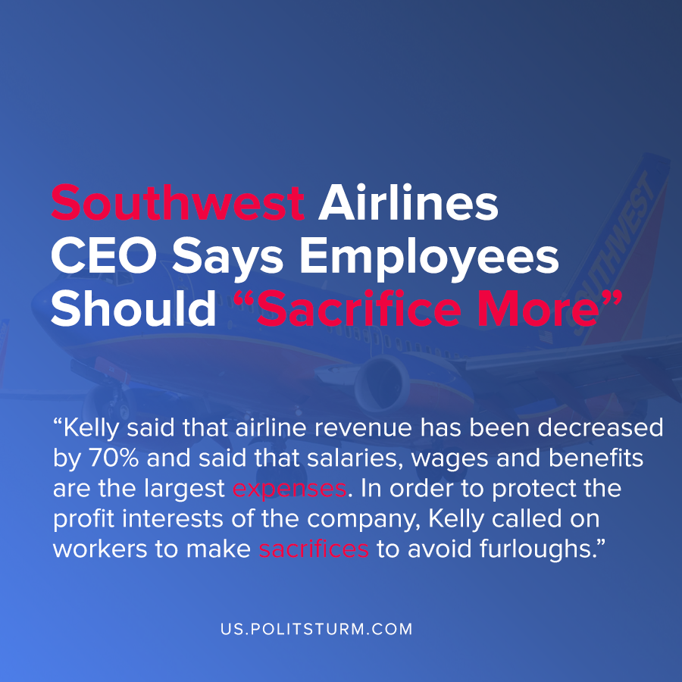

Original article
2020-10-07
1 min read

In a video message to employees, Southwest Airlines CEO Gary Kelly called on employees to “sacrifice more” and for union members to provide concessions. The CARES Act allowed the Payroll Support Program (PSP) which allowed for 6 months of economic support.
Kelly said that the company is “burning cash every day” and that the company cannot “afford to continue with the conditions required to maintain full pay and employment”. He went on to refer to the employees of the company as “Southwest Warriors”.
Kelly said that airline revenue has been decreased by 70% and said that salaries, wages and benefits are the largest expenses. In order to protect the profit interests of the company, Kelly called on workers to make sacrifices to avoid furloughs.
Through the end of 2021, non-contract employees will face a 10% salary reduction. For union employees, Kelly said that if “reasonable concessions” are not made, then furloughs will be the last resort.
As demonstrated by the actions of the chief executive, the capitalist class will push the negative impacts of a crisis onto the working class. While the capitalist class preaches class harmony and a common effort to overcome crisis, they target the salary and benefits of the working class. Under capitalism, the capitalist class will always put the maximum profit over the interests of the working class.
Source: 1

Original article

