Southern California Garment Workers Paid As Little as $1.58 Per Hour
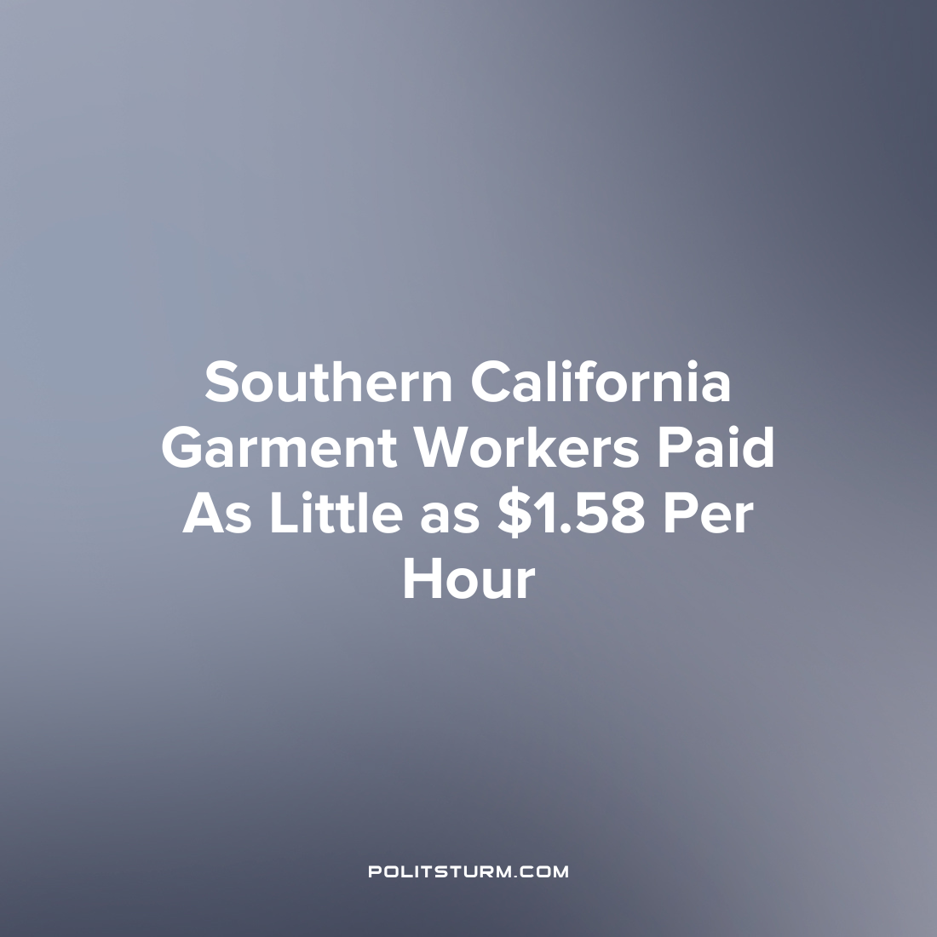

Original article
2023-04-10
1 min read

According to an investigation conducted by the Wage and Hour Division of the Department of Labor (DOL), 80% of sewing garment contractors in Southern California had violations of the Fair Labor Standards Act. These contractors supplied garments to large retailers including Nordstrom, Dillard’s, and Neiman Marcus. Contractors were found to have paid garment workers as little as $1.58 per hour, 22% of the federal minimum wage. 64% of the contractors did not keep accurate time and pay records and 36% were found to have falsified such records. In addition, 32% of the contractors surveyed paid their workers in piece rates which is prohibited by California law.
“Despite our efforts to hold Southern California’s garment industry employers accountable, we continue to see people who make clothes sold by some of the nation’s leading retailers working in sweatshops”, said Wage and Hour Regional Administrator Ruben Rosalez.
The majority of the contractors surveyed were found to be violating federal labor law and exploiting workers beyond the extent permissible by law. Under capitalism, the maximization of profit drives capitalists to increase the exploitation of labor which increases the ratio of unpaid to paid labor hours. The most vulnerable workers are the most exploited in capitalist society, while the capitalists increase their profits at the expense of the workers.
Sources: 1 2

Original article

