South Carolina Burger King Franchisee Assessed Child Labor Violations
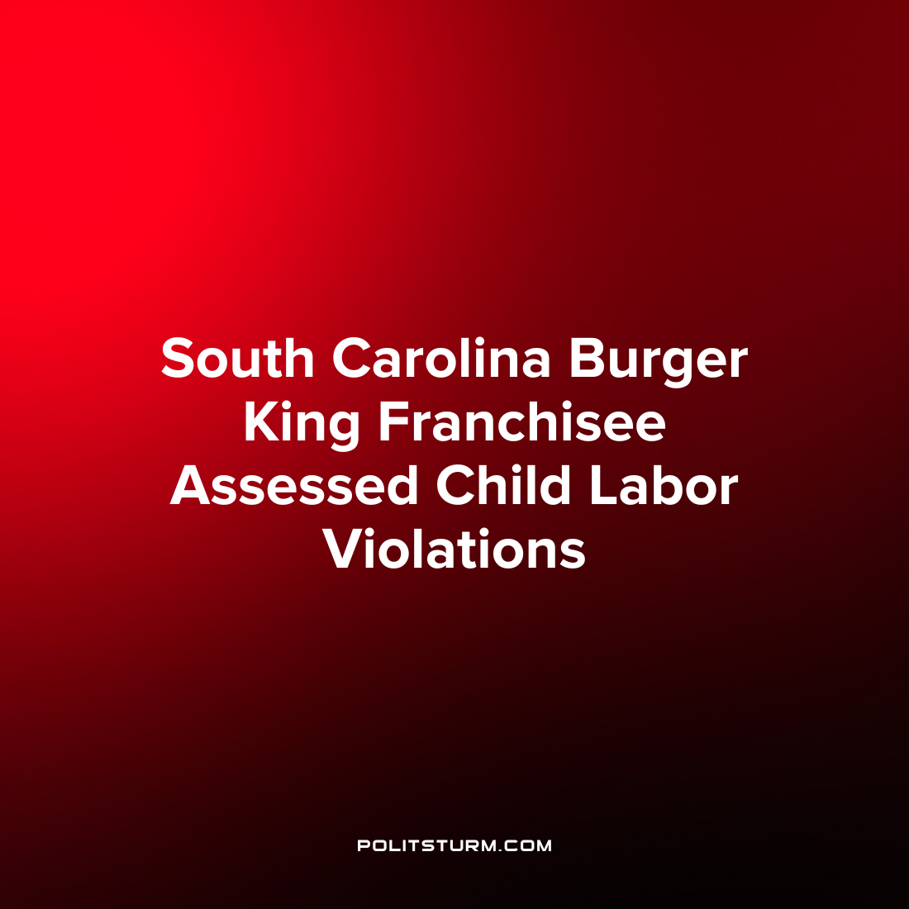

Original article
2022-09-07
1 min read

A Columbia, South Carolina Burger King franchisee called Applegreen USA Central Services LLC was found to have child labor violations at 9 locations. The Department of Labor Wage and Hour division reviewed the time sheets of the company and found that the employer allowed twenty-six 14 and 15 year old minors to work more than 3 hours on a school day and past 7 p.m. while school was in session.
As a result, the company was found to be in violation of the Fair Labor Standards Act and was fined $17,966.
“With schools back in session, employers must make sure each member of their management team is familiar with and implements child labor rules concerning hours and permitted occupations. By entering into an enhanced compliance agreement with the Wage and Hour Division, Applegreen USA Central Services has shown they’re committed to protecting the safety and well-being of young workers”, said Wage and Hour Division District Director Jamie Benefiel.
As we can see, when a capitalist firms break the law in search of higher profits the fines assessed are meager and are hardly a deterrent to breaking child labor laws. Capitalists are always willing and able to exploit workers, even children, if it means increasing their profits by any margin. Capitalism has a history of exploiting the youth in production and despite the laws which have been passed over time this exploitation continues to the present day.
Source: 1

Original article

