Solidnet's Key Party Held Cuba Solidarity Events as Capitalism Was Legalised
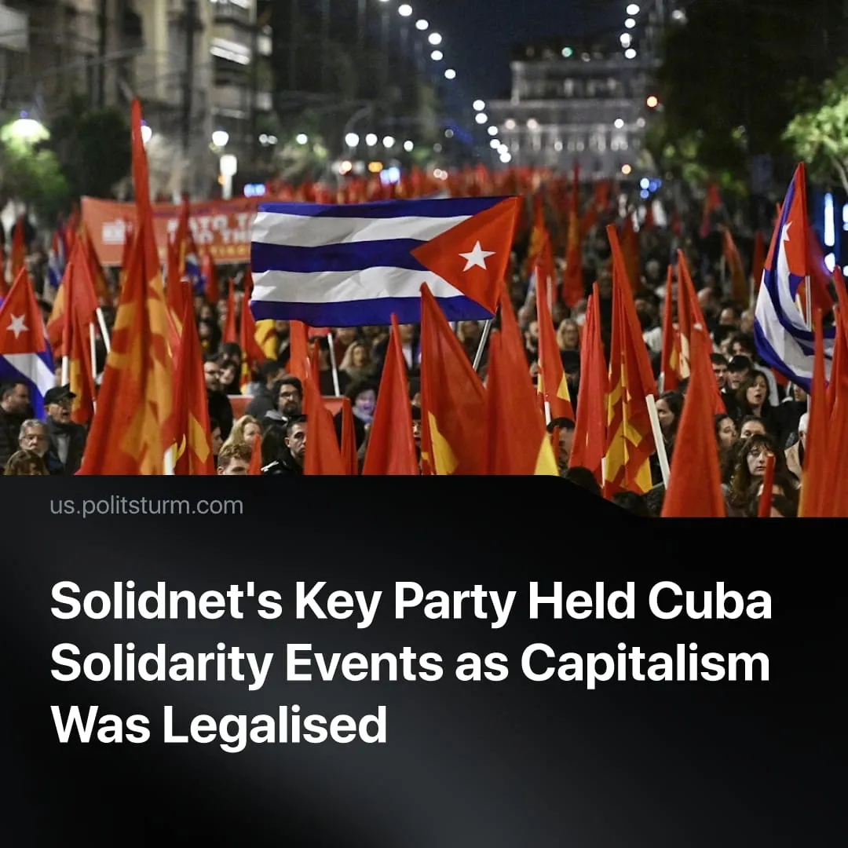

Original article
2026-06-28
3 min read

The restoration of capitalism in Cuba was ignored for almost a week by Solidnet's key party. During this period, it continued to organize "solidarity events". One of its leaders placed Cuba alongside Iran and declared the Iranian regime's "victory" over American imperialism.
Details. The Cuban parliament passed a sweeping package of laws that completed the transition of the Cuban economy to a capitalist model on June 18. The day before, the Communist Party of Greece – the key party of the Solidnet and European Communist Action – held a rally to commemorate the 100th anniversary of Fidel Castro's birth.
► The KKE and its allies regularly speak out in support of the Cuban government. KKE delegations have repeatedly visited Cuba and met with senior leaders. The signing of a declaration of solidarity with Cuba is one of the usual rituals of the annual "International Meetings of Communist and Workers' Parties". The next "Meeting" remains scheduled for August 2026 in Havana, Cuba. The 2022 meeting was previously held there.
► Since the adoption of the laws, the KKE has held several events dedicated to Cuba, but the reports of these events do not contain any specific statements on this topic. The member of the Central Committee G. Marinos limited himself to general words when speaking at a youth festival on June 21. In the context of his speech, he compared Cuba to the Ayatollah regime in Iran, which he implied by the words “Iranian people”. This rhetoric is consistent with the positions of the social-chauvinist "World Anti-Imperialist Platform", which the KKE criticizes.
Quote: "We support Cuba and its people in the difficult times it is going through. We defend the Cuban Revolution and fight to end the criminal blockade of American imperialism. We roar 'hands off Cuba.' ... In the Middle East, in the Persian Gulf, a major realignment of forces is being attempted. Americans and Israel seek to control the region rich in raw materials, to shape the so-called new Middle East and to cross the Indian trade route to Europe, in competition with the new Chinese Silk Road. The people of Iran resisted and proved once again that imperialism is not omnipotent!"
► The KKE responded to the legalization of capitalism only on June 25 with a publication in the party newspaper "Rizospastis." It presents a summary of the reforms, composed in the same vague style as the original list. The position itself boils down to a general statement of the "serious dangers" of "the further strengthening of commodity relations and market mechanisms." The paragraph after it effectively undercuts this assertion, calling on communists to continue supporting "the Cuban people," without mentioning the government's role in the restoration of capitalism or what the communist position toward the ruling "Communist Party of Cuba" should be.
Context. The adoption of a package of economic laws effectively transitioning the economy to a market system was preceded by many years of development and strengthening of capitalist elements in Cuba. This process occurred with the approval and direct support of the Cuban government and the “Communist Party of Cuba”. The immediate pretext were the US-Cuban secret negotiations, caused by economic and political pressure from the United States, which intensified with the start of Donald Trump's second presidential term.
► The "International Meeting of Communist and Workers' Parties" is a broad structure, created and functioning with the active participation of the Communist Party of Greece. It unites groups and organizations that formally identify themselves as Marxist-Leninists. Participants range from the KKE itself and aligned organizations to non-existent, opportunist, or openly imperialist structures, including the "Communist Party of the Russian Federation", the "Communist Party of the United States of America", and the " Communist Party of China". The "IMCWP" is supplemented by "Solidnet", a media platform created during the first "Meetings" with the goal of exchanging information.
Important to Know. Despite regular statements of support for Cuba for decades, the KKE didn’t produce theoretical materials that contain an objective analysis of the Cuban Revolution, the state of the Cuban economy, or provide a substantiated communist position on it. Among the KKE's allies, one could see rare occasional news materials pointing to the growth of capitalism in Cuba, but they did not contain a direct characterization or assessment of the Cuban regime today.
► The events unfolding in Cuba have effectively called into question the pro-Cuba statements of the IMCWP/Solidnet parties. The Cuban government, with which they had called for solidarity, capitulated to the United States, thereby exposing itself as a defender of the interests of Cuban capital, represented by the state corporation GAESA and private enterprises. It betrayed both Cuban workers and the foreign communists who sincerely supported Cuba's struggle.
► These events demonstrate the importance of a direct, objective analysis of every issue important to modern communists. Only such an analysis can form the basis for any further action, especially in the matter of communist solidarity with one political force or another.

Original article

