Solidnet Convenes in Havana After Its Organizer Begins to Admit Its Failures
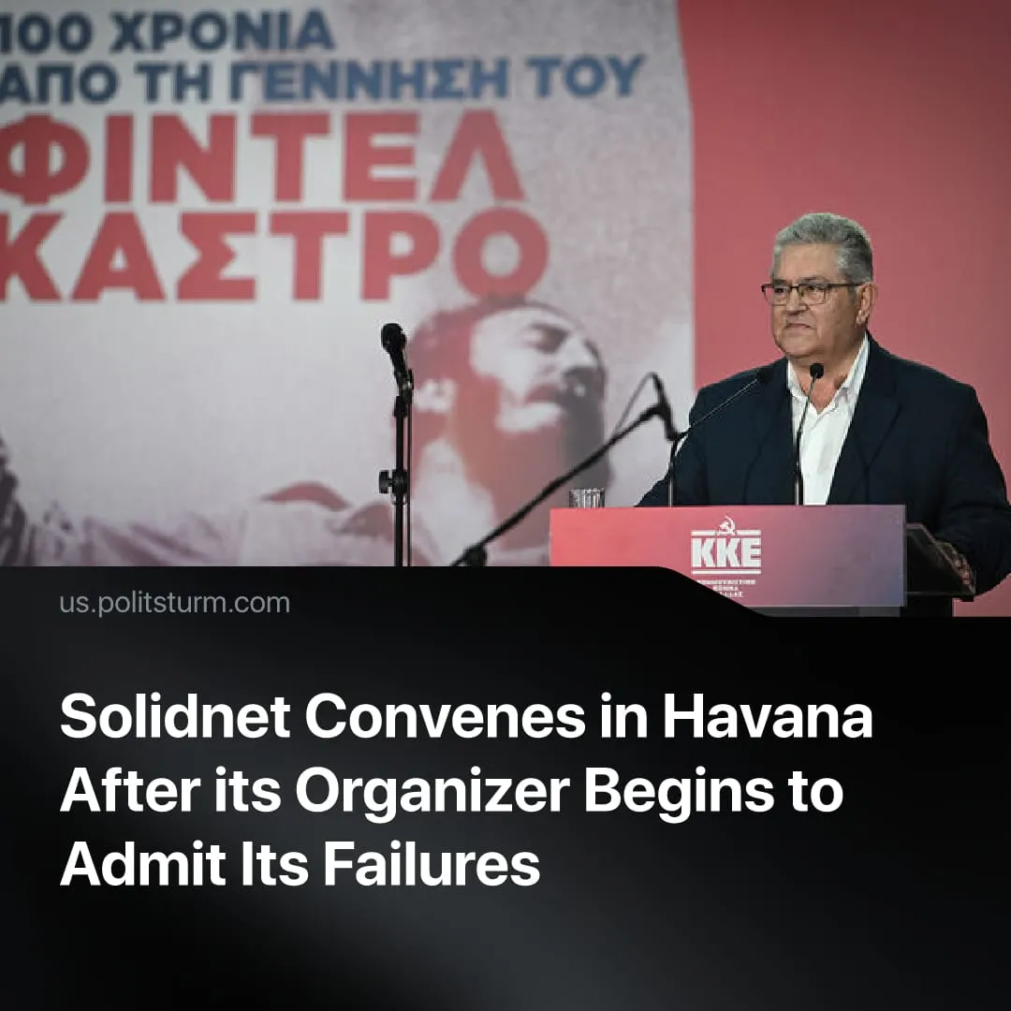

Original article
2026-08-07
3 min read

The annual Solidnet meeting is taking place in Havana on Friday. Its organizer has recently begun to cautiously acknowledge its problems. Politsturm has been writing about these problems for many years.
Details. On August 7, the 24th "International Meeting of Communist and Workers' Parties" takes place in Havana. This will be the first meeting in three years, following the 23rd "International Meeting of Communist & Workers' Parties" in Izmir, Turkey, in 2023. This marks the first time in Solidnet's history that its conferences have not been organized for more than two years.
► The Communist Party of Greece remains the initiator and main organizer of the IMCWP and Solidnet. In its materials, the party has repeatedly praised its work within the IMCWP as an important part of the struggle to revive the international communist movement.
► However, in early 2026, before the 22nd party congress, the KKE started to cautiously acknowledge the problems of Solidnet. The report of the Central Committee pointed to the loss of "momentum", "reasons" and "initial significance" of this structure. In essence, the party leadership was demonstrating the falsity of its own previous statements about the party's "successful work" within the IMCWP.
Quote: "…the International Meetings of Communist and Workers’ Parties (IMCWP), which were initiated by the KKE but have gradually lost momentum, along with the original reasons for their creation and their initial significance. They have increasingly become a space of intense, fruitless confrontations, recycling the crisis of the communist movement. At the same time, serious and unresolved operational problems remain, mainly of an ideological and political nature…".
► However, Solidnet's problems were evident much earlier. In its materials and speeches over the past four years, Politsturm has repeatedly pointed out the critical problems of the IMCWP and Solidnet. PS criticized the looseness of this structure, its support of opportunists and social chauvinists, their presence within Solidnet's ranks, as well as the errors of Solidnet organizations in assessing a number of contemporary events, including the Ukrainian crisis, the Palestinian question, the war in the Middle East and its consequences, and the restoration of capitalism in Cuba.
► The problems of Solidnet and the KKE as its organizer are also actively exploited by social chauvinists. During the polemics of recent years, a number of organizations, including the "RCWP", the "CPGB(M-L)", the "ACP" and others have regularly cited them in their materials against the KKE. PS published materials exposing the positions of social chauvinists, including refuting their accusations against the KKE.
► During the discussion, the social-chauvinists formed their own international structure called the "World Anti-Imperialist Platform". Essentially, it is a social-chauvinist analogue of Solidnet with a number of improvements. Unlike the IMCWP, the WAP has a regular theoretical organ, a comprehensive information system, a unified program, and membership criteria.
► The beginning of the KKE's recognition of its mistakes proves the validity of Politsturm's criticism of the IMCWP and Solidnet. They have made no serious contribution to resolving the communist movement's pressing problems and have failed to unite Marxist-Leninists. On the contrary, the social chauvinists have consolidated themselves and are appropriating the title of communists, while the "M-L pole" of the KKE has been deprived of the will to address pressing issues head-on and resolve them.
Context. The "International Meeting of Communist and Workers' Parties" and its associated website, "Solidnet", were founded in the late 1990s with the active participation of the Communist Party of Greece to exchange information and address pressing issues of communist theory and practice. Over time, this structure’s activities morphed into repetitive conferences, during which high-profile but insignificant resolutions and action plans were adopted. Since its inception, the IMCWP has included opportunist and revisionist organizations, as well as now-defunct organizations. After 2022, Solidnet split over its stance on the Ukrainian crisis. However, the KKE, as the organizer of Solidnet, failed to seize this momentum to decisively disassociate itself from the social-chauvinists and pursue a course of isolating the anti-Marxist elements in the IMCWP. The social-chauvinists, in turn, used this opportunity to provide a theoretical defense of their views and created their own international organization.
► Cuba previously hosted the IMCWP in 2022. In 2026, the conference will take place against the backdrop of the final restoration of capitalism in Cuba. Social-chauvinists responded generally positively to the adopted “reforms”. The KKE’s "Marxist-Leninist pole" refused to consider the essence of the Cuban regime and its anti-people actions and continued to hold "solidarity events" with the Cuban government, which is conducting behind-the-scenes negotiations with the United States through a wealthy member of the Castro family.
Politsturm regularly publishes Marxist-Leninist analysis on the state of the communist movement. Follow us on Telegram, YouTube, Discord, and X. Join us to support our work.

Original article

