"Solidarity with the Cuban People" Slogan Opportunistically Used
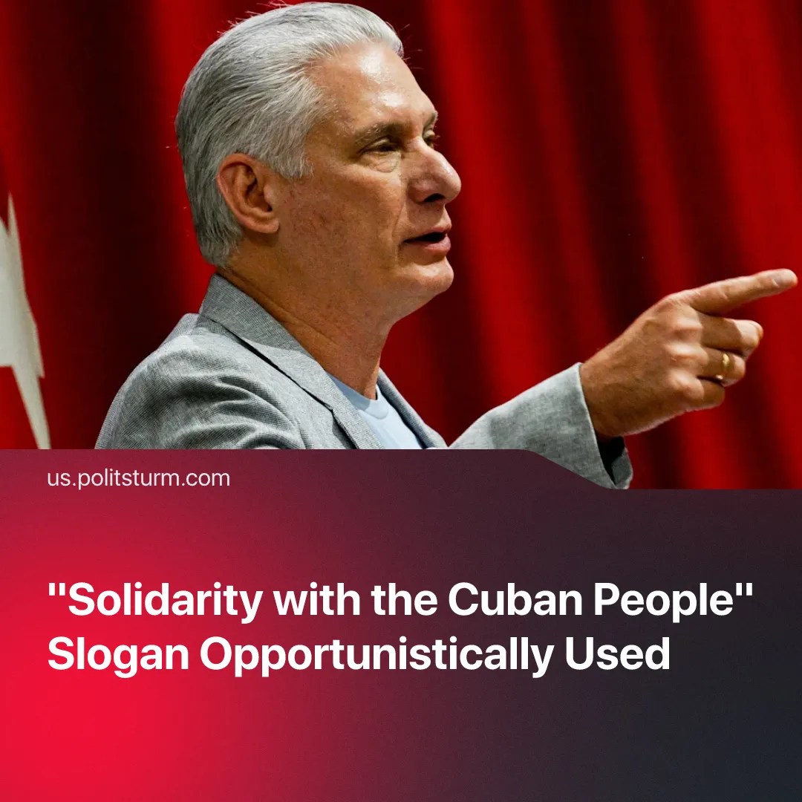

Original article
2026-10-08
3 min read

The slogan of “solidarity with the Cuban people” and “defence of the revolution” is opportunistically used by Centrists, social-chauvinists, Trotskyists, broad left activists, and even American Imperialists.
Details. After the US intensified its embargo and sanctions on Cuba, followed by a 176 reforms package which officialised the restoration of capitalism on the island. Numerous “left-wing” organisations were quick to come out and declare their solidarity with the Cuban people.
► Cuba’s President justified the reforms around the vague concept of “defence of the revolution and its gains”. Meanwhile, Castro’s grandson, whilst claiming he would never sacrifice the principles of the revolution, began negotiating with the US and framing this as his “revolutionary duty”. He has continued to meet up with US executives to explore setting up real estate transfer opportunities. The deputy foreign minister said the reforms are “for the Cuban people, to improve Cuba”.
► Solidnet affiliated parties, such as the Communist Party of Greece (KKE), responded to the legalisation of capitalism warning vaguely of "serious dangers", before calling on communists to support "the Cuban people", with no mention of the government's role in the restoration. Solidnet held its 24th International Meeting in Havana between August 7-9. One of the latest examples of this is the Communist Party of the USA which declared defending Cuba "a core party priority".
► Social-chauvinists celebrated the capitalist reforms as a strategic socialist adaptation in the interests of the Cuban people, a “defence of socialism under siege”, making no mention of GAESA, the military-bourgeois elite, or the class character of the regime overseeing them. Prominent member of the social-chauvinist American Communist Party Haz Al-Din said this “would be great for Cuba… If [they] do this the right way”.
► The slogan of solidarity is also adopted by Trotskyists, with the International Marxist Tendency calling for the defence of “the Cuban Revolution with all our might”, whilst the Socialist Worker offers solidarity with the “class struggle against the state capitalist bureaucracy” but then effectively opposes domestic protests, because “if the Cuban regime implodes…there would be nothing progressive about its fall”. Both parties use this as an opportunity to attack the USSR, its achievements and the concept of socialism in one country.
► Even the US government and businesses use this slogan. In late July, the US State Department announced a humanitarian flight to Cuba, $100 million in food and hygiene kits for up to 700 families, vaguely framed as aid for "the people, not the Cuban government”, with Rubio saying he envisions “a brighter future for Cuba and its people”. By using the loophole “Support for the Cuban People”, private companies are bypassing the embargo and increasing exports to Cuba, with the State Department claiming the US is a top exporter of food and humanitarian aid to meet the “basic needs” of the people.
Context. Trump intensified his pressure over Cuba in January by blocking Venezuelan oil shipments and issuing an executive order authorizing tariffs on any country supplying oil to the island. The blockade and embargo are responsible for exacerbating Cuba's medical supply shortages, falling nutrition and blackouts across the island.
► The Cuban reforms that followed are a continuation of a decades-long process of capitalist restoration. Today Cuba is a bourgeois dictatorship flying a socialist flag, as Díaz-Canel himself confirmed by pointing to China and Vietnam as a model.
Important to Know. The slogan of “solidarity with the Cuban people” is empty phrase-mongering. The slogan fails to specify which Cuban people it is referring to, fails to distinguish the different classes and does not clarify whether it supports the Cuban state or not. The vagueness of the slogan means it can be used by various left and right deviations, by the Cuban state itself, and even by US imperialists.
►By adopting this slogan, the various “communist” organisations end up supporting the actions of the bourgeois Cuban government, by calling on workers and activists to lend their support to capitalist restoration under the guise of “protecting the revolution”. It portrays communists as incapable of distinguishing between a workers' state and a capitalist one.
► Communists must turn this vague slogan into something more concrete, that offers an independent working-class position and exposes the capitalist nature of the Cuban economy, its leadership, and the reforms. A more suitable slogan for us would be "solidarity with Cuban workers in their fight against American imperialism and new Cuban capitalists".
Politsturm regularly agitates along Marxist-Leninist lines and provides communist analyses of the key political and economic issues. Follow us on Telegram, YouTube, Discord and X. Join us to help us in our work.

Original article

