Socialism In the USSR
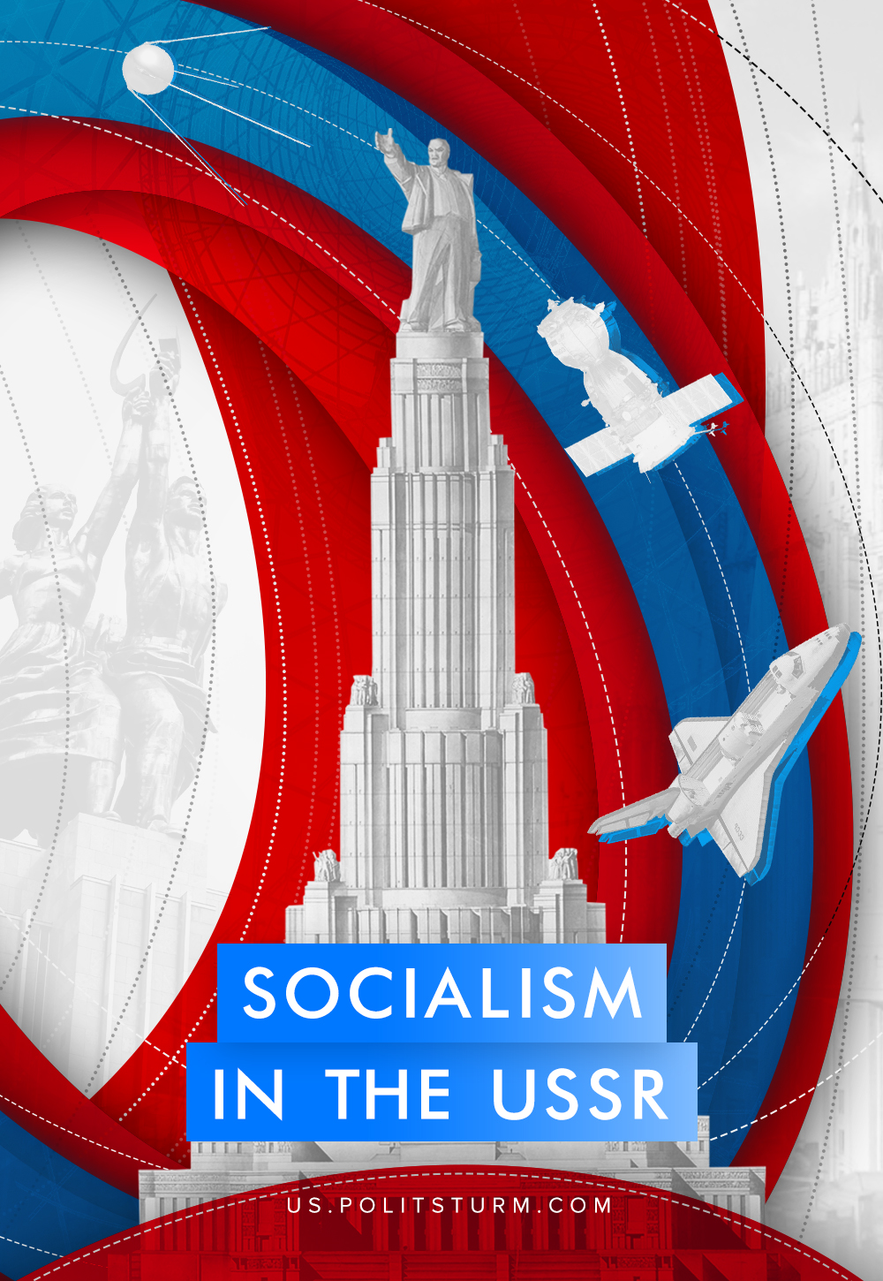

Original article
2019-02-08
40 min read

Today’s communists are facing several important issues that define their tactics and strategy, describe their cumulative experience and allow them to understand the direction of social development.
One of these burning issues is the social system of the USSR. What was the Soviet Union? Was it socialism, a transitional period or something else? The socialist movement has interpretations regarding the nature of the USSR. Let’s try to find out which theory of the USSR social system is correct.

SOCIALISM
Despite the fact that Marx spent most of his time exploring the current social formation, he did not fail to describe a communist society as well. In the Critique of the Gotha Program he wrote:
What we have to deal with here is a communist society, not as it has developed on its own foundations, but, on the contrary, just as it emerges from capitalist society; which is thus in every respect, economically, morally, and intellectually, still stamped with the birthmarks of the old society from whose womb it emerges…
In a higher phase of communist society, after the enslaving subordination of the individual to the division of labor, and therewith also the antithesis between mental and physical labor, has vanished; after labor has become not only a means of life but life’s prime want… only then can the narrow horizon of bourgeois right be crossed in its entirety and society inscribe on its banners: From each according to his ability, to each according to his needs! [1]
In this work, Marx not only described the attributes of communism, but also outlined the development of this system. It presupposes two phases or two levels of development: a lower phase and a higher phase, or incomplete communism and complete communism.
Error loading image
Under incomplete communism, tangible and intangible values are distributed according to the amount of labour performed. Marx also assumed that there must be some deductions for reserve, accumulation and consumption funds:
Only by suppressing the capitalist form of production could the length of the working-day be reduced to the necessary labour time. But, even in that case, the latter would extend its limits… because the notion of “means of subsistence” would considerably expand, and the labourer would lay claim to an altogether different standard of life…. a part of what is now surplus-labour, would then count as necessary labour; I mean the labour of forming a fund for reserve and accumulation… [2]
The worker receives one part of the values directly. He works for some time, gets a claim check and receives certain values according to this check: food, household items, etc. Another part of the produced values is received indirectly as an undivided value: housing, education, health care, development of science and technology, expansion of production, pensions, allowances, etc. It is expected that such integral benefits are to be distributed mainly according to one’s needs.
Thus, incomplete communism still has but overcomes the division of labor, the difference between cities and villages, the lack of products for abundance and universal equality, imbalance in production, social and cultural differences, etc.
But it is already communism, where “the means of production belong to the whole of society… the exploitation of man by man will have become impossible…” [3]. Here the workers administer the economy themselves, the means of production belong to the whole society, the productive forces are centralized and operated according to a unified plan, and values are distributed agreeably to labour inputs. This incomplete, quite undeveloped communism with the remnants of the past formations we call socialism.
Consequently, the vast majority of communists believe that there was socialism or incomplete communism in the USSR. Strange as it may seem, this theory is not the figment of someone’s imagination or the result of personal sentiments. On the whole, it conforms to the facts and the reality quite well.
For example, in the Soviet Union, the direct and indirect regulation of the economy was conducted by the working people. [4] Thus, for the first six months of 1926-1927, the workers offered 11,868 suggestions, 75% of which were accepted by the administration and 7 thousand were implemented during that period. [5] Since that time, the workers’ involvement in the production management grew enormously. By 1963, over 30 million workers, engineers, technicians and clerks had attended production meetings.
The meetings adopted and implemented annually more than 2 million proposals for the improvement of production organization and labour conditions, the introduction of the best workers and innovators’ experience, cultural and everyday issues, etc. [6]
By 1935, the proletarian state had directly and indirectly concentrated all the productive forces in its hands. The land, mineral resources, plants, tractor depots, collective farms, facilities and so on – all these constituted “state” or public ownership. [7]
Though a part of the work equipment was isolated within cooperatives and collective farms, it was still possessed by the socialist state, i.e. the whole society. The proprietary interests of such enterprises were significantly limited and their activities were woven into the system of Gosplan (the State Planning Committee).[8]
In other words, by 1935, all the productive forces had been centralized throughout the country and had formed a unified complex. The economic life of the country had been conducted according to a uniform plan and controlled by the same bodies.
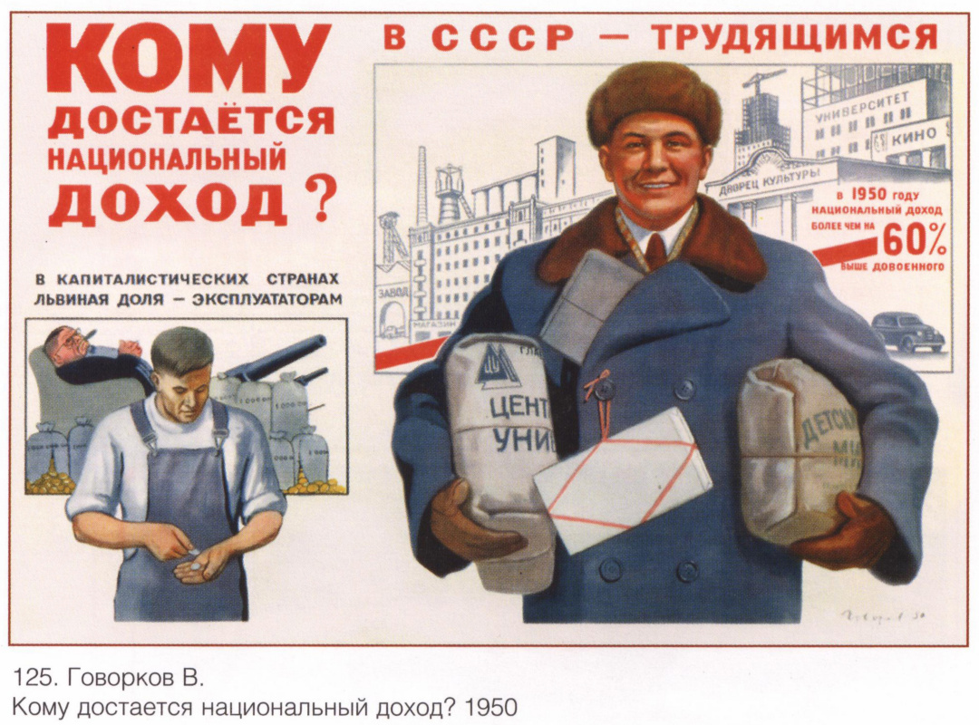
State property, since it was public, was aimed to meet the people’s needs. Thus, “state” ( or public) incomes immediately provided workers with free and high-quality housing, health care and medicine, maintenance of a public order, leisure and recreation activities and so on. We may say without any doubts that Soviet citizens worked for the good of the whole community.
The structure of the Soviet society was as follows. There were two social classes in the USSR: the working class, the collective farm peasantry, and a layer of working intellectuals [9]. A separate layer could be distinguished for the state and major party officials.
As it had been before, the state and party officials were paid salaries and premiums for their everyday service. They exchanged their labour for public income. The income of this group of persons was directly related to their employment and depended on it. They were engaged in the socially necessary administrative work, which demanded certain activities from them. It did not require the consumption of others’ labour power, which was simply impossible.
The working intellectuals (scientists, technicians, professors, creators) received their share of common wealth for their labour, their activities, their contribution to the public welfare.
Collective farms had a cooperative-like structure. Every kolkhoznik was a co-owner (or a shareholder) of the kolkhoz and got his share from the cooperative in accordance with the labour performed. Kolkhoz peasantry as a class neither provided anybody with their labour power to use nor sold it to anyone.
Collective farms sold one part of the food products to the state at set prices (it was an even exchange), the second part was sold to the kolkhoz households or to other farms, and the third part was left as a share or a stock for the future.
The Soviet working class was no longer an exploited and oppressed class.
Due to the eradication of private property:
– labour power could be sold to no one, as there was no class of capitalists;
– people did not need to sell their labour power, as there was no alienation of the means of production;
– there was no one to sell it, as there was no class of proletarians;
– it was impossible to sell someone’s labour power, because it ceased to be alienated, ceased to be a commodity.
The workers received their income for their work in accordance with their labour input.
By 1935 and right down to 1985, Soviet society had been devoid of private property and exploitation, wage labour and capital, market elements and the anarchy of production. Collective ownership, scientific planning and the distribution of values according to the labour input had dominated throughout Soviet society. Stalin called this type of society socialism, which was supported by many communists.
Error loading image
The theory of socialism in the USSR obviously coincides with a reliable description of reality. It does not invent anything and appeal to the metaphysical “it must be so…”. It is based on facts, can be proved by a body of evidence and corresponds with reality.
However, the theory has a number of problems. For example, it contradicts some statements of the classics. They believed that incomplete communism, or socialism, would have been already devoid of all classes, commodity production and statehood:
Future society will be socialist society. This means also that, with the abolition of exploitation commodity production and buying and selling will also be abolished… in socialist society there will be no need for the existence of political power… [10]
Socialism, as we know, means the abolition of commodity economy… So long as exchange remains, it is ridiculous to talk of socialism…[11]
…the class distinction between workers and peasants should be abolished. That is exactly our object. A society in which the class distinction between workers and peasants still exists is neither a communist society nor a socialist society… [12]
The Soviet Union was known for well-developed statehood and bureaucracy, regular army and militia, classes and commodity production. And the supporters of socialism in the USSR admit that all these phenomena may exist under socialism. Besides, the Soviet economy operated such old categories as “profit”,” wages”, “profitability”, “surplus labour”, “surplus product”, etc.
These two circumstances raise doubts among a great number of theorists about the correctness of the theory and allow them to say it openly that there was no socialism. Suppose these circumstances are sufficient for such a conclusion. The question arises: if there was no socialism, what was the Soviet regime? Which of the existing theories corresponds best with the facts and the theses of Marxism?

DEGENERATED WORKERS’ STATE
One of the first theories that opposed the Soviet Union was worked out by Leon Trotsky. He believed, “the Soviet Union is a contradictory society halfway between capitalism and socialism…” [13]. Furthermore, due to some circumstances, the bureaucracy managed to seize the reins of power and establish a Bonapartist regime.
As a rule, Bonapartism develops as a military and police despotism flirting with democratic elements. However, the essence of the regime is “… the maneuvring of state power, which leans on the military clique (on the worst elements of the army) for support, between two hostile classes and forces which more or less balance each other out…” [14]. Bonapartism comes into being in particular periods of social life. These are the periods of the balance between the classes, when one class can not rule any longer and another can not take power yet; when one class is still not able to dispose of the revolution at once and another is not able to seize power any more.
And that’s where the problem arises. A number of basic and key issues are so far (!) wrapped in mystery. All the theorists of Trotskyism, including Trotsky himself, have avoided any explanations and clarifications like the plague. It is still a question when, between which classes and in what exactly there was a balance in Soviet Russia or the Soviet Union; it is unknown how exactly the transition to Bonapartism occurred; it is unclear what exactly the maneuvering was expressed by and between whom it was carried out.
It is notable that Trotsky acknowledged that the antagonistic classes had been eliminated in Soviet society after the NEP (New Economic Policy). In this case it is not quite clear about what kind of maneuvering between the struggling classes he might talk about, if there had been no such classes anymore.
Error loading image
In addition, the socio-economic characteristic of the USSR as a “transitional society” is equally problematic. This type of a society corresponds to the period of social revolution [15]. Here wage labour and capital coexist with collective ownership and distribution according to labor input, the market is combined with embryos of state-planned economy. At the same time, socialization of the means of production and the building of socialism are in full play. In other words, the transitional society includes the periods of military communism, the NEP and perestroika when socialism was collapsing and capitalism was regenerating itself.
We already know that by 1934, all the means of production had been somehow centralized in the hands of the state. Even Trotsky admitted the fact that only few nonessential features of capitalism still remained: the division of labour, bourgeois patterns of distribution, imbalance in industries, low labour productivity and so on. Ted Grant, one of the major theorists of Trotskyism, added that in the USSR the elements of capitalism were also such things as “… wage labour, commodity production, that the bureaucracy consumes an enormous part of the surplus value…” [16]
Meanwhile Grant acknowledged the absence of private ownership, i.e. wage labour and capital. It means that in the USSR there was neither salary as an objective phenomenon nor surplus value.
In other words, Trotsky’s theory can hardly lay a claim to a reliable description of reality. It is not consistent with facts and logic, it has a lot of indeterminable blank spots as well as gems and sheer follies. The USSR was definitely not a transitional society, and the Soviet state was not a Bonapartist one.

STATE CAPITALISM
Many researchers and prominent figures of the communist movement reject both Trotsky’s theory of degenerated workers’ state and the transitional period in the USSR at all. They believe that there was state capitalism in the USSR. [17]
Capital had reached the highest degree of concentration in the hands of one owner, and the bourgeoisie became monolithic as the class of bureaucracy. State capitalism is essentially imperialism, which makes the USSR an imperialist power.
Adherents of this theory, as a rule, are divided into two categories. Some of them believe that state capitalism originated in 20-30s due to “Stalin’s bureaucracy”. Others suppose that the regime appeared during the leadership of Khrushchev, but there had been socialism before it. The foremost representative of the first line is the former supporter of Trotsky, Tony Cliff. The most important exponents of the other line are the German Maoist Willi Dickhut and the leader of the socialist Albania Enver Hoxha.
It is interesting that there is only one distinctive feature between these political figures that is the time frame. As for the rest, the Trotskyist, the Maoist and the Orthodox Marxist speak almost identically and suffer from the same symptoms.
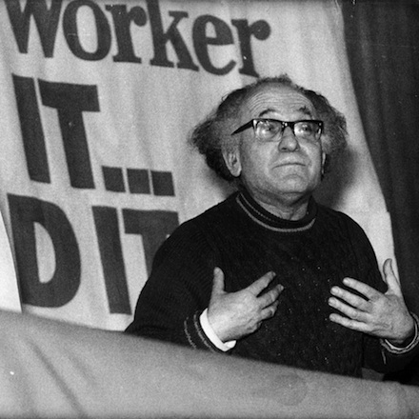
Tony Cliff
For instance, it is positively not clear what monolithic bourgeoisie is. The theorists of state capitalism prefer to duck the issue. Meanwhile, it is quite a unique phenomenon. The very notion of “class” implies the existence of individuals united by some objective characteristics. Besides, there are actually no indivisible things in our world. All phenomena and processes consist of a certain number of other details, other phenomena and processes. So, how is the “monolithic bourgeoisie” possible?
It is also not clear how and on what basis the profits are distributed within this “monolithic bourgeoisie”. The explanation of this mechanism would allow to understand the degree of correctness of the theory and the way the Soviet society was organized. However, none of the theorists actually did it. Moreover, few people ask such questions, let alone a detailed description of the mechanism itself.
Though much attention is devoted to other issues. For example, the existence of surplus labour and surplus value, wage labour and capital is proved as follows:
Even if he [the specialist] earned six times more than the unskilled worker, while he produced only five times more, there still would not exist a relation of exploitation… But if the specialist earned 100s. or 200s… a large part of his income would necessarily come from the labour of others. [18]
…The size of this income is in itself sufficient to reveal the qualitative difference between the income of the bureaucracy and the wages of the workers… [19]
The bureaucrat earns $100 and the worker $30. How can they deduce from this fact that the worker derives his income from the sale of his labour power and the bureaucrat from owning the means of production and bagging the surplus value? Further clarifications, arguments and evidence based on solid research are necessary in this case. Cliff, Dickhut and others do without it quite well. They need merely a superficial difference to make not simple assumptions but thundering conclusions.
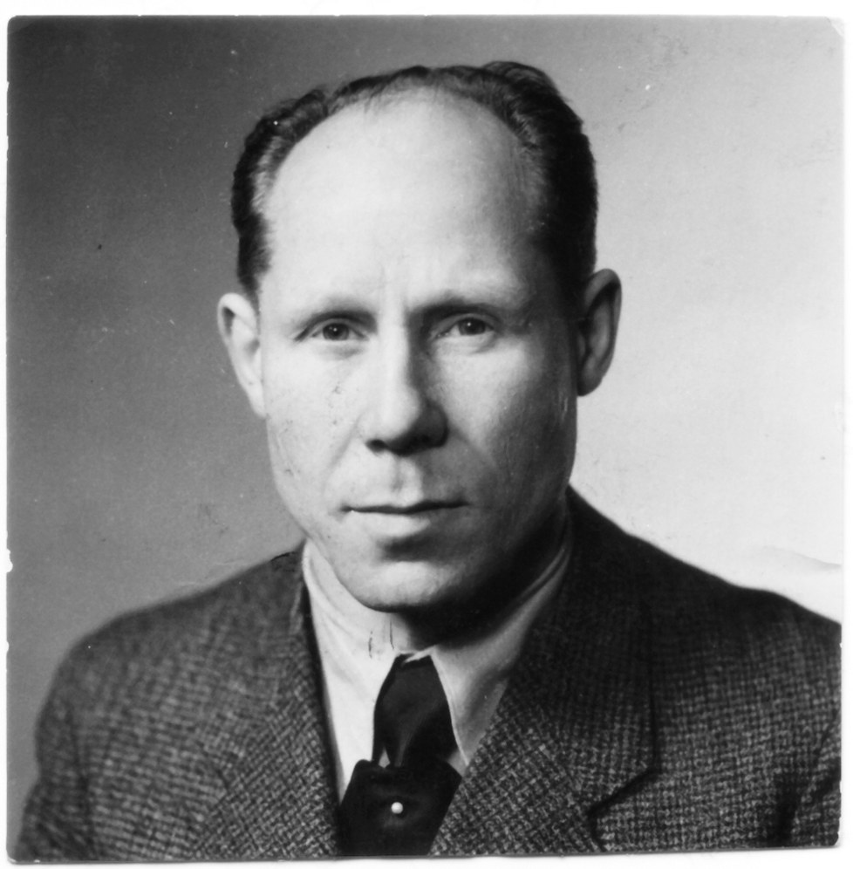
Dickhut
The restoration of capitalism in the USSR is described in the same strange and superficial manner. For instance, Dickhut claimed that Khrushchev had abolished the dictatorship of the proletariat, he said exactly “abolished”, and introduced the political hegemony of the bureaucracy. At the same moment, state-owned property turned from public ownership into private ownership of the bureaucracy, which turned the latter into the “monolithic bourgeoisie”. And finally, capitalism has been restored by the introduction of the term “profit” into the country’s economy as a fundamental and driving category [20].
Of course, the description is supported not by evidence but merely by hollow words. Besides, the description in itself is rather doubtful and strange. For example, the Soviet “profit” was not a transformed form of surplus value. Dickhut knew it perfectly, because he had characterized the peculiar usage of old categories in the new economy. Nevertheless, he refused to understand that “profit” as a leading indicator of the socialist economy was merely a prerequisite to the coming counter-revolution and not the confirmation of an accomplished restoration.
In addition, it is impossible “to abolish” the dictatorship of the proletariat. This is an objective phenomenon. It can be transformed, destroyed, replaced, etc., but not abolished. The author of the theory also gave no explanations concerning what kind of transformation had happened to the USSR superstructure that it had turned into the dictatorship of the bourgeoisie, what the manifestation of this change and of the bourgeois dictatorship had been, what structure the dictatorship had had.
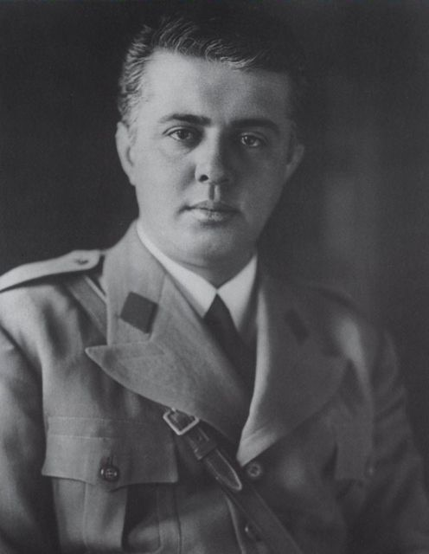
Enver Hoxha
If Cliff and Dickhut tried to simulate at least some evidence (through manipulation and misinterpretation of the facts) and arguments, Enver Hoxha relieved himself of such a burden. The leader of socialist Albania did not provide the slightest argument to support his claims. The scoundrel Khrushchev restored capitalism in its highest phase, the bureaucracy and the party establishment turned into the “monolithic bourgeoisie”, etc. Why Hoxha claimed it, how the restoration occurred, the way state capitalism worked – all is a mystery. We have to believe “the torch of Orthodox Marxism” on his say-so.
Moreover, the USSR turns to be a fascist state that committed fascist aggressions and occupied other countries. Hoxha considered the war in Afghanistan one of the last and greatest fascist aggressions. In his not-really humble opinion, mujahideen were true patriots [21], “… they are displaying exemplary bravery and proving their determination to keep the banner of freedom and national sovereignty flying and to fight to the end to drive out the occupiers” [22] And again, it is not accompanied by a slightest argument.
Another thing is that all mujahideen were Islamists: Hezb-e-Islami (the Islamic Party of Afghanistan), Jamayat-E-Islami (the Islamic Society of Afghanistan), the Egyptian Islamic Jihad, Iranian Hezbollah and so on. All these organizations fought for the Islamic Caliphate in Afghanistan. What is more interesting is the fact that most of mujahideen were the citizens of Pakistan and Palestine, Iraq and Iran, Saudi Arabia, Jordan and Kuwait, Yemen and Turkey, Lebanon, Egypt and other countries.
Blinded by the hatred for the USSR, Hoxha might not even guess that he applauded to downright reactionaries, fascists.
To put it simply, the consistency and correctness of the theory of “state capitalism” falls apart at the seams. It is not only unable to describe Soviet reality, because it does not agree with many facts, and denies awkward ones, but also it can’t clarify its own theses, provide somehow meaningful evidence of its own statements.

CAPITALISM
The Italian “communist” Amadeo Bordiga and his followers also considered the USSR a capitalist country. But these people believed that there had been common capitalism in the USSR. According to the theory, the difference between the USSR and the Russian Federation is not significant: it is merely a one-party system or a multi-party system, the presence or the absence of the iron curtain, etc. As for the rest, the Soviet Union had the same problems as modern Russia: unemployment and homelessness, wage labour and capital, enslaving mortgages, share markets, stock companies, brokers, etc.
The theory is based on rather superficial, amusing and sometimes highlight declarations:
For Marxists, where workers are rewarded in money, it is capitalism [23]
It is the fact that the Russian economy knows all market capitalist categories… Stalin’s counter-revolution has created senseless theory, according to which socialism is compatible with commodity relations and it is characterized by the same categories as capitalism but… filled with another meaning… [24]
A money reward does not mean anything in itself. It is just a dry and isolated fact for a Marxist. In order to deduce something, a Marxist should find out for what the workers get money rewards, what is hidden behind these rewards and where they originate from. Capitalism will be there and then, where and when the workers receive money rewards for selling their labor power, and the reward is essentially a part of variable capital.
Can the Soviet “money reward” be characterized in this way? Bordiga, as well as his main followers from the International Communist Party, avoid any analysis of the issue. They are satisfied with the existence of “money rewards” and the usage of the old terms which have not been studied by them. This is the approach of amateur scholars craving not the truth, but the refutation of socialism in the USSR.
The drawback of the theory is not only the method of cognition but also the complete rejection of reality. Thus, stock exchanges – the financial market – had been closed by 1930, and labour exchanges had been closed by 1934. In the Soviet society, there were no such business entities as PAO (publicly traded shares, similar to a corporation in the US), АО (privately held shares, similar to a closed corporation in the US), OOO (limited liability company). All the facilities couldn’t be bought or sold, rented, given or inherited. In the USSR, nobody made a living from interest on capital, dividend payments on equity and bond issues, rent and interests on copyright.
“State capitalism” having all its drawbacks, mistakes and gems is based on certain facts – state ownership, bureaucratic control and income difference. The theory of common capitalism puts all the facts away and spins stories. The Soviet society was definitely not a capitalist society.

BUREAUCRATIC COLLECTIVISM
Bordigists are the only theorists who reject state ownership in the USSR. All the other theorists, whether they speak about state capitalism, a transition period or something else, acknowledge state ownership and planned economy. The admission of some facts, not all of them, is half the shave. The correct and proper interpretation of these facts is no less important. And here challenges appear.
We have already seen the way Cliff and Dickhut interpret the facts. Some theorists went even further and created incredible theories. For example, Bruno Rizzi, Yvan Craipeau, Max Shachtman considered the USSR a completely new formation that is bureaucratic collectivism [25]. In this formation, the bureaucracy is the ruling exploitative class, it has not turned into the bourgeoisie but has become exploitative bureaucracy as it is. Rizzi wrote:
In Soviet society the exploiters do not appropriate the surplus value directly, as the capitalist does in cashing the dividends of his enterprise, but they do so indirectly, through the State which appropriates the whole national surplus value and then shares it out amongst the officials themselves [26].
And here one can find quite an interesting thing. The point at issue is a new formation, i.e. a new way of production and a new form of exploitation. However, this formation also has large-scale industry and overall commodity production, wage labour and alienation of surplus value. All these are the attributes of capitalist production. Interestingly enough, the authors do not provide any explanations of the facts.
This idea is very similar to ”state capitalism”, with the same problems. For instance, the problem of the monolithic class and the distribution of surplus product within this class is still open. There is a lot of useless reasoning which is not based on any facts or evidence.
Every exploitative mode of production is connected with the existence of paired class: “the slaveholder – the slave”, “the feudal — the peasant”, “the bourgeois — the worker”. Each class is paired with another class. Accordingly, only the bourgeoisie can exploit workers. Moreover, Marx found out and proved that capitalism is the last exploitative formation in the history of mankind, and the pair “the bourgeois – the worker” is the last pair of antagonists in the history.
Everything that ripens inside capitalism, including some features of capitalism itself, conduces to classless society alone.

POLITARISM
“Bureaucratic collectivism” is not the only theory where the USSR built some new formation in which the bureaucracy was the ruling class. The Soviet historian and ethnographer Yuriy Semenov also worked out such a theory and spoke about “politarism”.
According to Semenov, there was industrial politar system in the USSR [27]. Large-scale industry and commodity production formed the basis, but everything belonged to the bureaucracy, the politarist class. This class exploited everybody who was engaged in material production in one way or another: workers, farmers and even labour camp convicts. On the one hand, the bureaucracy bagged surplus value, which gave them a large amount of money, and on the other hand, they obtained direct benefits in the form of privileges, etc.
The reasons for Semenov’s conclusions as well as his studies of the Soviet society, economy and policy are of great interest. It is as follows:
Only when political power actually belongs to the people, state ownership can be a public one… it is generally recognized now that we had neither real nor even formal democracy… Even in the speeches of the CPSU highest leaders… the political regime was characterized as a totalitarian one… The common statement in the latest CPSU documents was that in our country, working people had been alienated from power and property. And this means only one thing: our state ownership was not public and all-people’s one [28].
It is recognized by everyone, but no references and facts are provided; even the highest ranks of the party say something, and they can not make a mistake or lie, therefore in the USSR ownership was definitely not public, it was the possession of the bureaucracy. Such reasoning causes nothing but laughter. But Semenov basing on this empty, speculative reasoning keeps talking froth:
Collective farmers, as it is known, were actually attached to the land, which forced them to work for the state, in fact, for free. They were blatantly exploited <…> The exploitation of a huge army of workers imprisoned in the Gulag barracks during the Stalinist period was rude and explicit… <…> They received their income not as workers but as owners, i.e. they received surplus product… All the members of this group enjoyed what is called privileges. They had access to exclusive distribution centers, exclusive shops, exclusive refreshment bars, exclusive sanatoriums, exclusive hospitals and so on. They were beyond ordinary queues, and often enough, they got the apartments of the highest quality ahead of line [29].
It would be interesting to ask Semenov how exactly people were exploited in the labour camps and also about kolkhoz farmers’ unpaid work, as we know that they sold one part of their product at a set price to the state and etc. Besides, we would like to see certain explanations of how special distribution centers, if they really were, indicate (1) the existence of surplus labour/product and (2)the gratuitous appropriation of the product by the bureaucracy. But Semenov has not provided any arguments or evidence, facts or references and is not going to do it in the future. There are merely empty and bare words proclaimed by another “torch of truth” whom we should take on trust.
In addition, the theory about bureaucrat exploiters has the same trouble as state capitalism, bureaucratic collectivism and other theories about state employee exploiters do. Exploitation is the gratuitous appropriation of vicarious labour. The owner as a class contribute not one jot of its own labour to the immediate creation of a certain product or value. He simply possesses the means of production and allows the workers to use them. When the worker creates some product, the owner takes a part of the product or value away by right of possession.
Semenov, as well as the others, claims that surplus product is divided among the bureaucrats depending on their place in the party hierarchy and position occupied. A person is an exploiter while he is in the public service. To put it simply, a “politarist” earns an income by his work and in exchange for his work. The question arises: where is the exploitation? Then, there is another question. Suppose the bureaucracy abuses its authority and, for example, gets apartments ahead of line, possesses luxurious official cars, country houses, has an access to elite hospitals and sanatoriums, etc. Is it possible to regard it as labour exploitation? Is it correct to consider these privileges something more than simple (though extremely inadmissible and unfair) abuse of authority?
None of the theorists has answered these questions. But it is these questions combined with the absence of any evidence, sophistications and so on that spell the death of the politarist theory.

SUPER-ETATISM
Some theorists were aware that the whole idea of the “monolithic bourgeoisie”, collectivists and politarists was quite precarious. But these authors invented no less pretentious and weird theories instead. One of these theories has been worked out by Alexander Tarasov. The Soviet regime has acquired the formidable name “super-etatism”.
Tarasov also based his theory on state property and large-scale industry in the USSR. But here means of production were not in the hands of individuals or monolithic classes, but in the hands of the state. That’s it: not the bureaucracy but the state itself, as if it were a living substance, owned the means of production. Thereby, under the Soviet “super-etatism”, there was no exploitation of man by man. There was exploitation of man by state. Super-etatism was based on a certain “industrial mode of production”. Such a regime appeared, because “…the features of a new mode of production were not visible, even in the near future, not to mention that this new mode of production had to form its main parts within the framework of the old one… the revolutionary subject was mistakenly defined to be the proletariat.” [30]
Tarasov’s theory is very similar to Bordiga’s one, because they both totally reject the Marxist theory and reality. For example, the Marxist classics repeatedly emphasized the fact that communist way of production should be created from scratch after the power was seized. [31] Only the prerequisites of the new formation can originate in the capitalist womb: associated labour, machinery, high concentration of capital, the liquidation of the whole classes and so on. All the prerequisites that form within the capitalist system (and that existed in the pre-revolutionary Russia) lead only to a classless society.
Come to think of it logically, communism implies collective ownership of the means of production, centralization within the framework of the nation and the absence of exploitation. It is not clear why Tarasov decided that communism might and must emerge from the womb of the old society. It is also not evident on the basis of what prerequisites and from what “super-etatism” has originated.
Moreover, it is not obvious what the phenomenon of “exploitation of man by state” means. Labour exploitation is the relationship between two people (or classes), where one lives at the expense of the other, one alienates the results of the other’s work. Marx and Engels also found out that statehood is merely a tool, a kind of a hammer in the hands of the ruling class. How the hammer itself can exploit people is incomprehensible, because Tarasov has not left any explanations.
Apart from all abovementioned, Tarasov’s “super-etatism” shares the same drawback as “bureaucratic collectivism”: the system is a hodgepodge of other regimes. It is not capitalism and there is no private ownership, but there is exploitation and surplus value. It is not feudalism and there is no private ownership, but the worker is personally dependent on the exploiter.
In other words, Tarasov’s theory is the apotheosis of all the theoretical poverty that has been discussed above. The theory cynically discards facts, reality and Marxism in the hope that this alternative to socialism in the USSR will be accepted. It is evident that such a theory can not claim a reliable description of reality.

CONCLUSION
So, the rejection of socialism in the USSR inevitably results in the denial of facts and reality, logic and common sense, Marxism and a scientific approach in general. The people denying socialism does not thirst for truth and the understanding of the USSR system. They thirst to prove that there was no socialism in the USSR. Everything can be sacrificed for the aim. The defenders of socialism in the USSR do not tell stories and create Frankenstein’s monsters only in order to prove that it was socialism. On the contrary, this theory is based on facts and logic, Marxism and a scientific approach. It has an extensive evidence base and is consistent with logic.
Earlier we have elicited the fact that the theory has a number of drawbacks. In particular, it is the use of old capitalist categories. It is worth mentioning that it is not quite right to talk about the use of the old categories. The thing is that a category is an abstract and subjective expression of an objective phenomenon. The category of “wages” reflects the phenomenon of the price of labour power as a commodity. But in the USSR, the worker received some money reward for his labour. Money reward is only a material representation of quantity and quality of wealth equal to the amount of labour performed by the worker.
Thus, the category used here is completely different, because of the different phenomenon and the different content. The USSR used not the old categories, but merely the old names, i.e. terms. The new phenomenon was still called “wages”, although it had been no longer the same. It is also the case with other names: “profit”, “profitability”, “surplus product”, “surplus time”, etc. All these are names that do not fully correspond to the content and the new categories. Of course, it creates a certain confusion for ordinary people and blind researchers. But there is no problem for socialism itself.
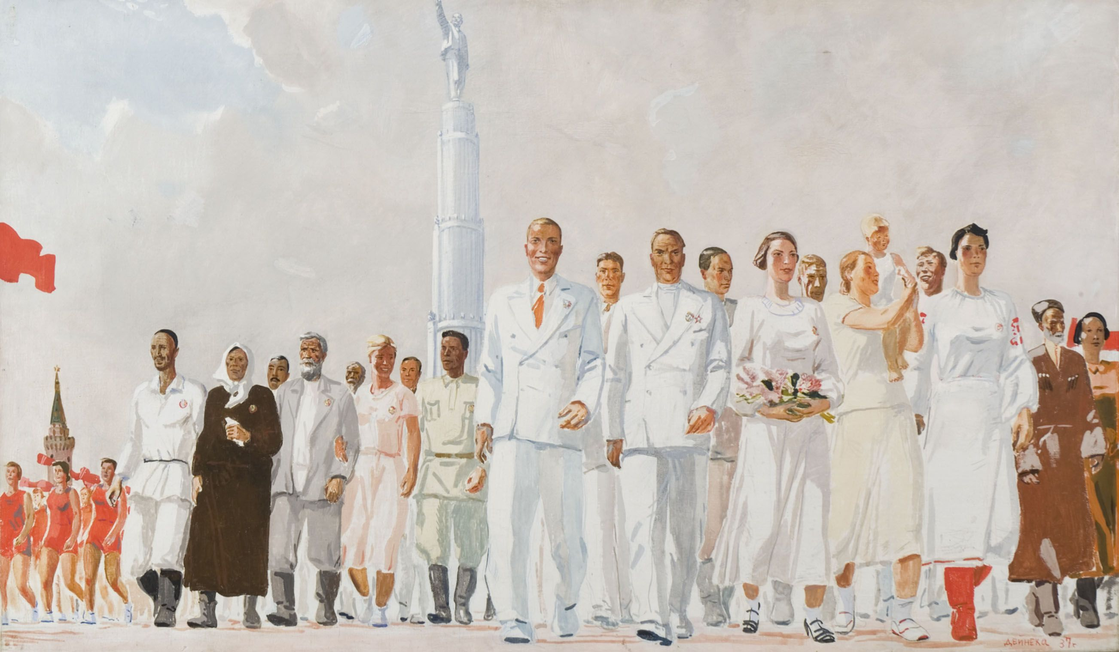
As for conformity with the classics, things are a bit ambiguous. Soviet socialism did not meet only few statements of the classics: the absence of statehood, all classes and commodity production. At the same time, Soviet socialism completely corresponds with their other statements. The USSR had no private ownership and exploitation, but it had collective ownership and economic programming, distribution of wealth according to labour input and etc.
As one can see, the absence of exploitation is the fundamental feature of socialism. Statehood, particular commodity production and solidary classes are secondary features that depend on concrete historical conditions. It means that Marxists shall correct the theory and update our understanding of socialism. This is what Stalin did when he spoke about the necessity of particular commodity production, possible existence of solidary classes at the first stage of communism and the presence of statehood.
Consequently, the theory in question has no more drawbacks. The USSR really had socialism. But there immediately arises another problem which is the collapse of the Union. The counterrevolution misleads many scholars into most increadible conclusions: from the common one “socialism is invalid” to “there was no socialism, because it cannot collapse”. Such conclusions are built on the idea as though the historical development of the USSR was straight-line. There was socialism, then it developed and advanced towards complete communism, and then it collapsed all of a sudden. But it was a little bit different.
Under the leadership of Stalin and the appropriate prerequisites, the Soviet socialism advanced towards complete communism. This process meant the gradual elimination of commodity monetary relations, the transcendence of labor division, the liquidation of the past ideological remnants and etc. In 1952, Stalin noted that commodity production little by little had been turning into an obstacle to social development and it was necessary to adopt the exchange of goods, develop collective farms and cooperatives up to all people’s ownership.
Harsh conditions that required a hell of practical work engendered theoretical negligence among the party members and the leaders of the state. Some other factors also contributed to these circumstances. For instance, during the Second World War, the party and Soviet democracy was minimized and the party assumed the role of the administrative center. The development and mass studies of the theory ceased, and the theoretical level of the masses decreased as well.
Error loading image
These and other circumstances led to the situation when the country was headed by opportunists such as Khrushchev, his supporters and successors. Since that time, the Soviet socialism assumed the opposite direction. Within the Soviet socialism, there were objective and subjective preconditions for the restoration of capitalism. We have already mentioned some of these prerequisites: the introduction of “profit” as a driving economic category, slackening of the proletarian dictatorship, the preservation and expansion of commodity production, increased economic self-sufficiency of the local facilities and etc. Alongside with that, the shadow economy was developing: black-marketeers were gradually undermining the efficiency of the socialist economy.
By 1980-s, the whole complex of such preconditions resulted in the establishment of bourgeois relations. The restoration of capitalism began not without the involvement of the political superstructure. On the one hand, the changes occurred to the superstructure itself: glasnost, the authorization of different factions and parties’ activities, the transformation of the Soviets into parliaments and etc. On the other hand, it was depth conversion of the economy: the emergence of small businesses, the authorization of wage labour, etc.
As it can be seen, the development of Soviet socialism was not straight-lined. At first, the USSR advanced to complete communism, then, it changed the direction to capitalism. Despite the gradual opposite movement, the USSR of 1953 – 1985 was still socialist.
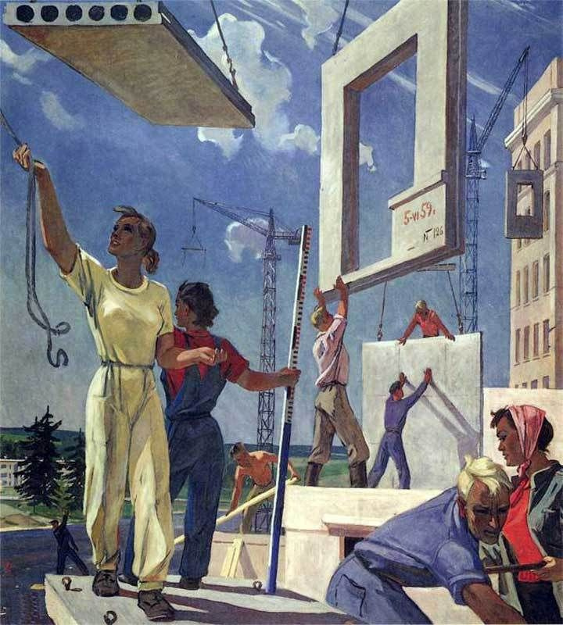
Now we know for sure that there was socialism in the USSR. It was a brief moment, but the working man succeeded in building the lower phase of communism in practice. Of course, the potential of the regime was not realized to the full extent, because the higher phase was not achieved.
But even the lower stage of communism, socialism, assured a high standard of living, carried victories and provided the impetuous development of society. The worker freely straightened his shoulders and was the architect of his own fortunes, and all the people partook in the culture and wealth created by him.
For sure, this article does not close all questions about Soviet socialism. We have discussed just a few aspects of its development, decline and the reasons of restoration, which is not sufficient. In the following articles, we will study in detail the functioning of the Soviet economy and public life, pay more attention to the development of Soviet socialism and explore the causes of the counter-revolution.
Sources:
[1] Marx, Karl. Critique of the Gotha Program // Marx/Engels Selected Works, Volume Three, p. 13-30
[2] Marx, Karl. Capital, Volume I, Chapter Seventeen, Section 4 // First English edition of 1887 (4th German edition changes included as indicated) with some modernization of spelling
[3] Lenin, V. The State and Revolution, Chapter V, The First Phase of Communist Society // Collected Works, Volume 25, p. 381-492
[4] Профсоюзы СССР. Документы и материалы. Т. 2
[5] http://istmat.info/node/23930
[6] Воскресенская M. A., Новоселов Л. И., Производств. совещания — школа управления
[7] См. Экономическая жизнь СССР. Хроника событий и фактов 1917—1959; С.Г. Струмилин. Очерки социалистической экономики СССР; Политическая экономия социализма и др.
[8] https://politsturm.com/stalinskie-arteli/
[9] Краткий политический словарь. М., 1988, с. 411-413
[10] J. V. Stalin. Anarchism Or Socialism? // Works, Vol. 1, November 1901 – April 1907
[11] V. I. Lenin. The Agrarian Question in Russia Towards the Close of the Nineteenth Century. // Lenin Collected Works, Progress Publishers, 1973, Moscow, Volume 15, pages 69-147.
[12] V. I. Lenin. First All-Russia Congress on Adult Education. Deception Of The People With Slogans Of Freedom And Equality. // Lenin’s Collected Works, 4th English Edition, Progress Publishers, Moscow, 1972 Volume 29, pages 333-376
[13] Leon Trotsky. The Revolution Betrayed
[14] V. I. Lenin. The Beginning of Bonapartism // Collected Works, Progress Publishers, 1977, Moscow, Volume 25, pages 223-226
[15] See Lenin’s works of 1918 – 1923; N.I. Bukharin. The Politics and Economics of the Transition Period
[16] Ted Grant. Against the Theory of State Capitalism
[17] See Tony Cliff. State Capitalism in Russia; Willi Dickhut. The restoration of capitalism in the Soviet Union; Enver Hoxha. The Kruschevites; Imperialism and the Revolution.
[18] Tony Cliff. State Capitalism in Russia, Chapter 1: Socio-economic relations in Stalinist Russia (Part 4)
[19] In place cited, Chapter 6: Further consideration of Stalinist society, economics and politics
[20] Willi Dickhut. The restoration of capitalism in the Soviet Union
[21] E. Hoxha. Bravo the Afghan patriots! // E. Hoxha. Reflections on the Middle East. Extracts from the Political Diary 1958-1983, P. 510
[22] E. Hoxha. Aggressors must get out of Afghanistan // E. Hoxha. Selected works. Vol. 5, P. 755 — 757.
[23] Le trotskysme: Critique de la théorie de l’État ouvrier dégénéré // Programme Communiste, n. 57, Octobre-Décembre 1972, p. 50.
[24] En marge du x plan quinquennal: Le mythe de la «planification socialiste» en Russie» // Programme communiste, n. 69-70, mai 1976. p. 85
[25] См. B. Rizzi. La Bureaucrazation du Monde; M. Shachman The Bureaucratic Revolution: The Rise of Stalinist State; T. Cliff. The Theory of Bureaucratic Collectivism: A Critique
[26] B. Rizzi. La Bureaucrazation du Monde, P. 46.
[27] Yu. I. Semenov, The Great October Workers’ and Peasants’ Revolution //The Politarian (“Asian”) Way of Production: Humanity and Russia’s Essence and Place in History: Philosophical and Historical Essays (Volshebnyi Klyuch, Moscow, 2008, p. 149-235) [in Russian]
[28] In place cited;
[29] In place cited;
[30] Tarasov, A. Super-etatism and Socialism: Towards a Statement of the Problem // http://screen.ru/Tarasov/etatism_eng.html
[31] See the Communist Manifesto, Capital. Critique of Political Economy, Critique of the Gotha Program, Anti-Duhring, the State and Revolution, etc.

Original article

