Social Inequality Is Growing In Russia
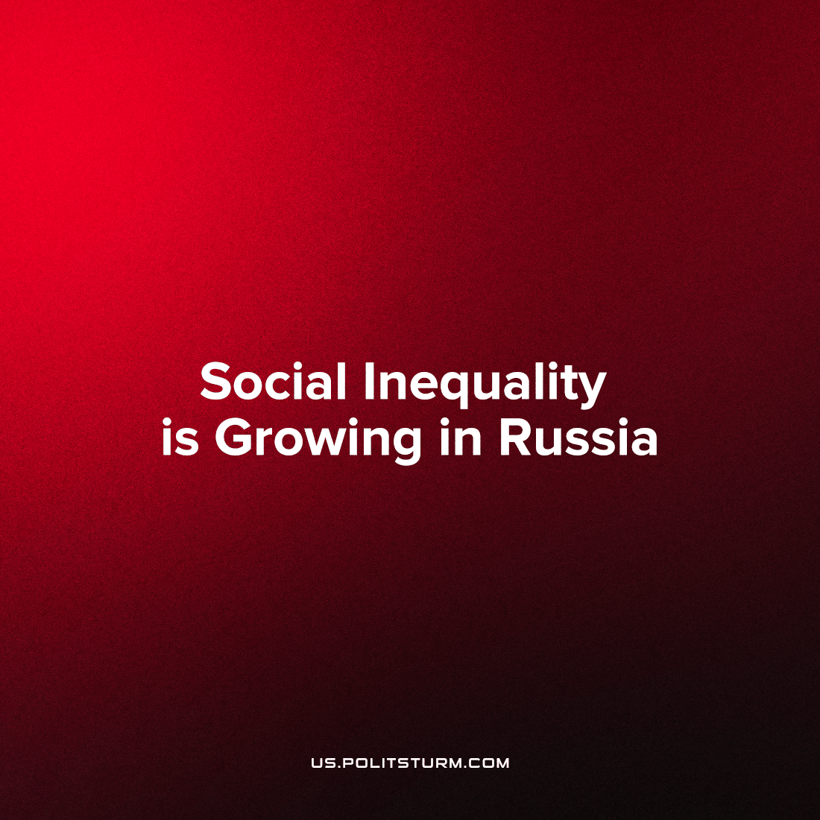

Original article
2023-07-29
1 min read

According to information provided by Rosstat, workers in Russia did not receive 54% of the value they created in 2022, with private business owners pocketing 45%. The share of paid labour fell from 46.4% to 45.6% last year, the lowest since 2000. At the same time, the share of capital reached its highest since 1992 at 46%.
According to the statistics office, in 2022 the total value created by labour amounted to 131 trillion rubles. Of this amount, 60 trillion rubles represents paid labour (wages and social contributions), while the remaining 71 trillion rubles of unpaid labour was distributed as follows: 12.3 trillion rubles for net taxes and 59 trillion rubles for net profits.
According to statistics, in 1990 the labour share was 60% and enterprises were left with 25%. However, since enterprises were state-owned, they were obliged to allocate profits to investment, as well as to housing, canteens, kindergartens, sports and recreation.
Currently, only 15% of shares are owned by the state, and the owners appropriate 45% of the value created by labour. Part of the net profit generated by private capital is invested in social programmes, but this is already dependent on the personal preferences of the owners. In this respect, the years 2021-2022 were the most unfavourable since 2000: 47% of profits were spent on investments (in 2020 the figure was 61%).
The role of the state has also diminished. Whereas in 1990 the state returned more than half of the withdrawn funds to the economy after taxation, now the figure is only a tenth.
As a result, in 1990, the richest 1% of families had 14% of wealth, and now this share is 59%. According to Credit Suisse analysts, in 2016, the Russian Federation was the world "leader" in inequality. The top 1% of people in RF held 74.5% of the wealth in the country.
Russian capitalists are increasingly underpaying workers; under such conditions, reproduction of the working class becomes more difficult. Under the guise of slogans of unity and cohesion, the ruling class is simply robbing ordinary workers more and more.
Sources: 1, 2

Original article

