Small Business – Cure for Poverty? Capitalist Myth Explained
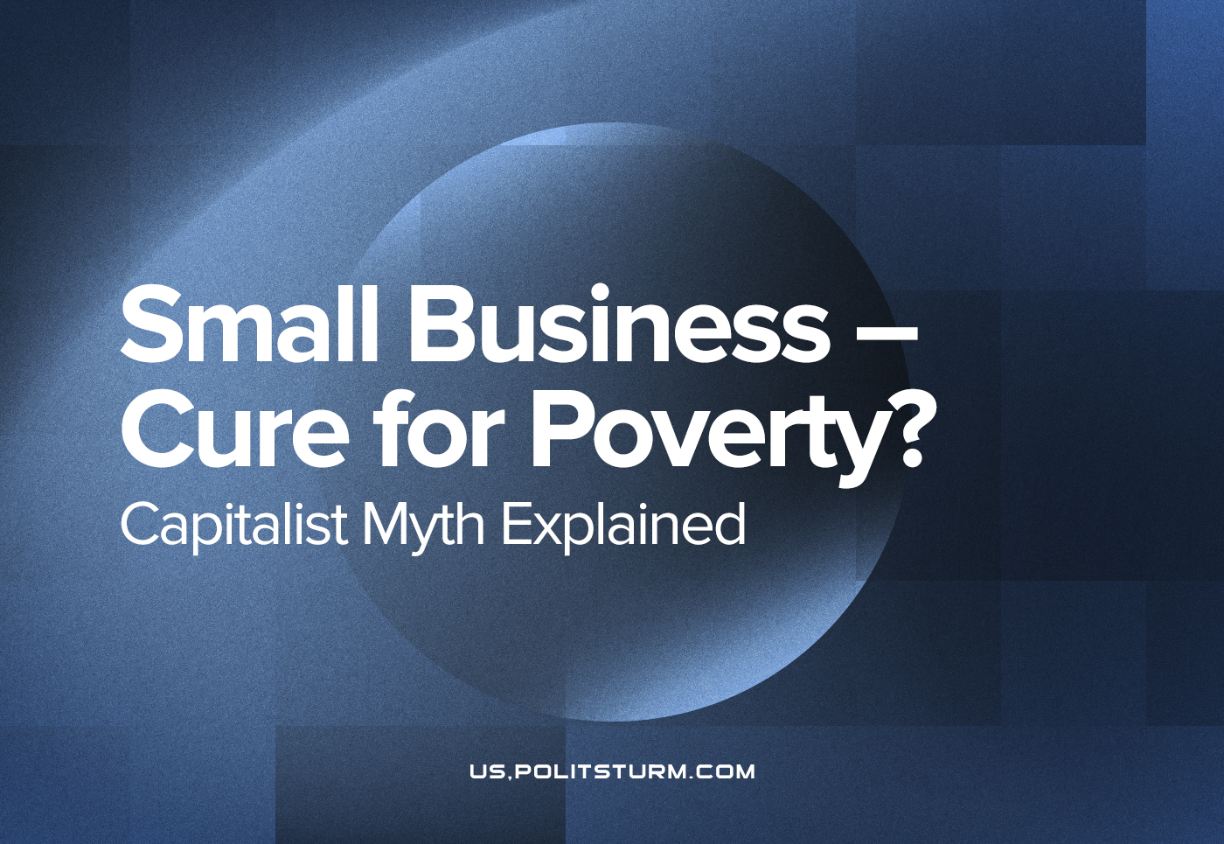

Original article
2022-06-15
11 min read

“Pull yourself up by the bootstraps. Just work harder. Cut expenses and save more. Start your own business and become your own boss”. Various other slogans are aimed at the workers in order to give them hope that they can get themselves out of poverty.
This makes sense according to bourgeois propaganda. Capitalism is the ideal form of society according to bourgeois ideology and due to the nature of Liberalism, places all of the burden for success and failure on the individual. Wealth and prosperity are awarded to those who have the most desired qualities: entrepreneurship, frugality, intelligence and shrewd business acumen. Those who are poor are poor due to their own bad choices. The origins of this philosophy are rooted in the development of bourgeois society in Europe as feudalism was entering its death spasms. In order to unshackle productive forces from feudal relations, property rights had to evolve for this to happen. The key to this was to privatise and commercialise land, trade and the means of production.
This had to have an ideological justification which was achieved by Enlightenment thinkers which posited that man is born free and as such is born with certain inalienable rights, the most important of which was the right to have property, that is: property was a private individual’s unalienable possession and could not be stolen, hindered or tampered in any way by a higher authority without explicit approval of the people. However, “the people” were understood not as broad masses, but as other land-owners and bourgeoisie.
As Marx and Engels elaborated, this was a progressive movement for the time, it liberated peasantry from cruel feudal dues and tithes, guaranteed certain legal protections for all citizens, led to an increase in the standard of living and increasing education for even the poorest of a bourgeois nation’s inhabitants. It is in this historical milieu that these maxims of capitalist society developed as humans were no longer shackled to toiling on the estates of the nobility and were theoretically free to either succeed in achieving wealth or to sink into poverty based on their actions.
However, as Marx and Engels noted in their world-historic discovery of the laws and forces that governed previous modes of production, this state of affairs was transitory. The idea that one could achieve wealth or contentment in life by escaping the rat-race by saving enough money to start your own business or simply to work harder mystifies and obfuscates the true reality of bourgeois relations.
Herein lies the fable of elbow-grease as a remedy for the poverty of a proletarian. Nobody can deny that production in our era has reached immeasurable heights: our modern world is supplied by the commodity-production on a scale that would leave all previous generations of humans speechless. Vast quantities of products drown out smaller producers as they can hardly compete with larger business that can produce more at less of a cost.
This is why it is next to impossible for the capitalist fable, that one can escape poverty by starting a business and becoming petty-bourgeois, to become a reality: there is a ceiling to success that can only be overcome by luck for an ordinary person. Stories of success usually hide factors that undermine this narrative, such as rich parents who work to ensure that their wealth can be passed on to their children, something the vast majority cannot do. As even the liberal magazine The Atlantic has noted:
‘When you have money, you spend less on the stuff that ensures you survive the day and more on the stuff that ensures that you (and your children, and your possessions, and your estate) survive and thrive for many years. Poverty is a chaos that screams in the present tense, and the anxiety of having no money forces poorer families to direct their attention to immediate concerns.’ (Thompson, D., 2015. Rich People Are Great at Spending Money to Make Their Kids Rich, Too.
Available at: https://www.theatlantic.com/business/archive/2015/04/being-rich-means-having-money-to-spend-on-being-richer/389871/)
The plight of the proletarian who wishes for a business of his own was spoken about by Stalin. He describes a small business owner ‘who is unable to withstand the competition of the big manufacturers, closed his workshop and took a job, say, at Adelkhanov’s shoe factory in Tiflis. He went to work at Adelkhanov’s factory not with the view to becoming a permanent wage-worker, but with the object of saving up some money, of accumulating a little capital to enable him to reopen his workshop.’ (Stalin, J., 1906. Anarchism or Socialism? Moscow: Foreign Languages Publishing House) He explains that the worker who opens his own business will inevitably find himself struggling to eke out a respectable life for himself as he competes with other petty-bourgeois owners and the large capitalists. The small business owner has to worry about thin profit margins which are at risk of disappearing when capitalism’s inevitable, periodic crises occur, in turn making the petty-bourgeois owner destitute and being driven back into the proletariat.
Our era is still one of monopolistic capitalism and as such the hypothetical example given is one that still holds true. Following the COVID-19 pandemic, small and medium-sized enterprises (SMEs) faced extraordinary economic pressure as they could not compete with large corporations which had the necessary capital and infrastructure to continue work under the many lockdowns. As such, the petty bourgeoisie was forced to take loans in order to keep their businesses afloat.
According to the Bank of England, outstanding corporate debt rose by £79bn between 2019 and the first quarter of 2021. This was described as a “moderate” increase, representing a rise of around 6% in total corporate debt compared with pre-pandemic levels. According to a report published by the House of Lords Library, the burden was overwhelmingly felt by the petty bourgeoisie, their SMEs’ debt growing by a quarter. It went on to reveal that:
- ‘The number of SMEs with any debt has more than doubled. Around 757,000 companies (out of the approximately 2m that have UK bank accounts) now have some debt, compared to 305,000 before Covid. The Bank said some of these “may not have previously met banks’ lending criteria”, i.e. may be less creditworthy and therefore less able to repay the loans.
- 33% of SMEs have debt levels more than 10 times their cash balance, or their cash balance is negative (i.e. they are using an overdraft). This has increased from 14% before Covid.
- 18% of SMEs have monthly debt repayments that are more than 15% of their income. This has increased from 3% before Covid.
- 10% of SMEs have both high debt levels and high debt repayments, using the definitions in the previous two bullet points.’ (Smith, C., 2022. UK corporate debt after Covid-19: what might the impact be? Available at: https://lordslibrary.parliament.uk/uk-corporate-debt-after-covid-19-what-might-the-impact-be/)
The report went on to summarise the Bank’s analysis as not seeing any ‘immediate vulnerabilities from an increase in interest rates for most companies.’ (Smith, 2022) This in effect was downplaying the ripple effects the impact of the pandemic was having on the UK’s economy.
The report was published on the 5th of January of this year, in just five months this prediction is being daily discredited as inflationary pressures, supply-chain issues and the on-going conflict in Ukraine causes the global economy to buckle under the weight of its contradictions.
Now media attention is increasingly being focused on the cost-of-living crisis as the British proletariat day by day faces the growing threat of death by starvation.
Similarly, this monstrous aspect of life under capitalism is beginning to rear its head in the United States of America. The rate of inflation in the United States has risen to a forty-year high and threatens to force the workers into destitution as the global situation marches unceasingly towards crisis. This will force the petty bourgeoisie into the ranks of the proletariat en masse as monopoly capitalism cannot sustain itself without increasing poverty.
It is clear then that starting a business is not a panacea to the woes inflicted on the worker by capitalism. The proletariat might well be able to rise into the ranks of the petty bourgeoisie but as revealed this is a precarious situation: debt, inflation and predatory monopolies all crash against the petty bourgeois owner threatening to capsize his means of living and drown him.
What then can be done about this? As mentioned before Marx and Engels discovered that modes of productions and consequently the societies that arise from this economic base are transitory and develop according to scientific laws. Their teachings demonstrate that capitalism is also but a temporally fleeting epoch that will give way to communism and the end of exploitation of man-by-man. The vast trade networks, the technological advances of capitalism and its socialisation of industry has developed to such a degree that socialism can be achieved once the proletariat emerges victorious and bring about a socialist society.
This is the real goal of the proletariat; this is its historic role: to end capitalism and usher in socialism. To entertain any other path for the workers is merely a diversionary policy meant to confuse and stave off a revolution and the liberation of the toiling masses. What is needed is a revolutionary, proletarian mindset; not a backwards petty-bourgeois one. This is built up by revealing to the worker the nature of his exploitation. Stalin explained this in the same text of the aforementioned narrative of the Tbilisi worker:
‘This proletarianised shoemaker goes on working, but finds that it is a very difficult matter to save money, because what he earns barely suffices to maintain an existence. Moreover, he realises that the opening of a private workshop is after all not so alluring: the rent he will have to pay for the premises, the caprices of customers, shortage of money, the competition of the big manufacturers and similar worries — such are the many troubles that torment the private workshop owner. On the other hand, the proletarian is relatively freer from such cares; he is not troubled by customers, or by having to pay rent for premises. He goes to the factory every morning, “calmly” goes home in the evening, and as calmly pockets his “pay” on Saturdays. Here, for the first time, the wings of our shoemaker’s petty-bourgeois dreams are clipped; here for the first time, proletarian strivings awaken in his soul.
Time passes and our shoemaker sees that he has not enough money to satisfy his most essential needs, that what he needs very badly is a rise in wages. At the same time, he hears his fellow-workers talking about unions and strikes. Here our shoemaker realises that in order to improve his conditions he must fight the masters and not open a workshop of his own. He joins the union, enters the strike movement, and soon becomes imbued with socialist ideas.’ (Stalin, 1906)
It is clear then, that it is nonsensical for the worker to strive towards the goal of saving up to open his own business as it has only a minute chance of succeeding in achieving him financial stability long-term and even less of a chance in winning him substantial wealth. Capitalism, in reality, puts but two options in front of the workers, continue working hard in the hopes that maybe one day, you could be a capitalist yourself or stand up with your fellow workers and fight back against: misery, starvation and exploitation.

Original article

