Should the Wealthy Pay a Luxury Tax?
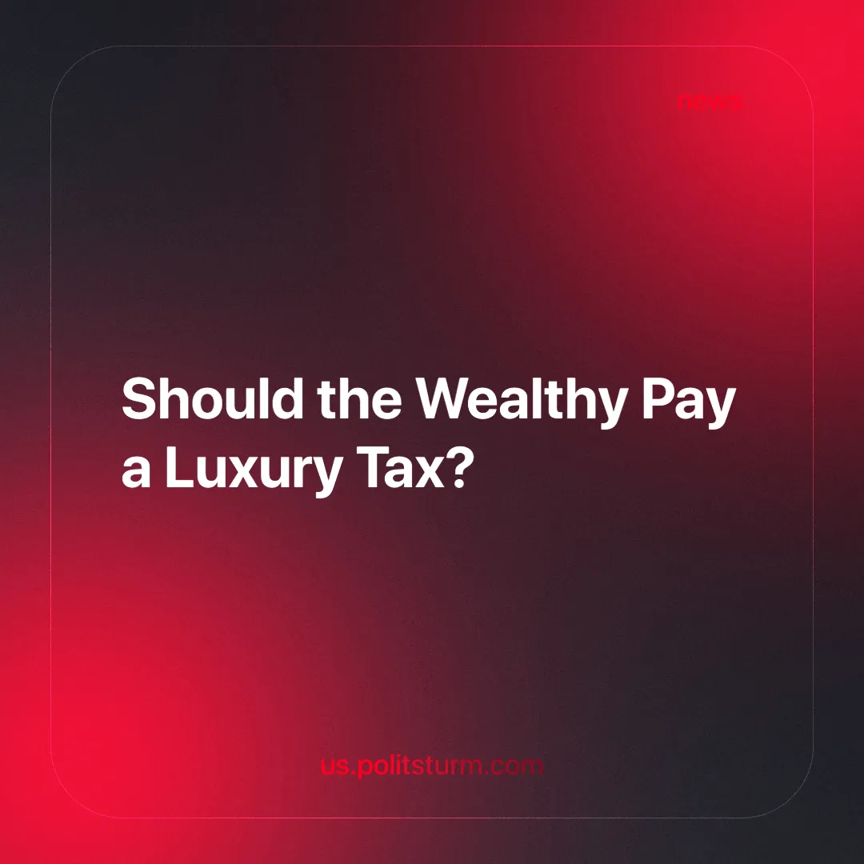

Original article
2025-05-30
5 min read

For several years now, the Russian government has been considering a tax on expensive property targeting the super-rich. At first glance, the objective seems noble — to reduce poverty in line with the so-called "May Decrees" [1]. Periodic surveys are conducted to assess public support for these new tax measures [2], followed by the adoption of relevant legislation [3].
But what exactly is a ‘luxury tax,’ and what would its impact be on Russians? Above all, it is crucial to recognize that ‘luxury taxes’ are cosmetic measures within the logic of capitalism. They neither challenge society’s foundations nor tackle the root causes of exploitation. Luxury is just a symptom of a deeper malaise, not its origin.
The tax policies currently in place do not eliminate the fundamental mechanisms that create excess wealth for some and deprivation for others. As long as private ownership of the means of production exists, luxury, poverty, and so-called "reforms" that stabilize rather than dismantle the system will persist.
The fundamental process of surplus value extraction — the capitalist drive for profit, which is baked into the very mode of capitalist production — remains untouched. Workers continue to sell their labor power as they always have. Speculators continue to profit from rents. The bourgeoisie maintains control over the agenda, regardless of tax policies.
How does this situation compare with the United States and Europe? For example, Connecticut and Massachusetts impose higher sales taxes on luxury goods [4], and the state of Washington levies an additional tax on expensive purchases [5]. Yet the US remains among the countries with the highest levels of social inequality globally. The richest 10% of Americans control over 70% of the nation’s wealth, while the bottom half of the population owns only 0.9% [6][7].
In France, a luxury tax applies to real estate valued above 1.3 million euros. The country employs a progressive income tax system that applies only to income exceeding 11,294 euros per year, with a top marginal rate of 45% on income above 177,106 euros annually [8].
Portugal, the United Kingdom, Norway, Italy, Germany, Spain, and Sweden already enforce progressive tax rates on income, property, and inheritance rights [9], [10].
Much like in the US, Europe experiences sharp wealth disparities: the richest 10% control most of the wealth — up to 67% — while half the population owns only about 3.2% (or according to other sources — 1.2%) of it [6] [11]. Key factors include rising housing prices, stagnant wages, and limited property access, particularly among young people. The housing crisis and bureaucratic barriers further exacerbate inequality [12], [13], [14].
What is a capitalist state? It is a power apparatus controlled by the ruling class. Under capitalism, the bourgeois state safeguards the interests of the dominant class — large private property owners who exploit wage labor and profit at the expense of ordinary people.
Inequality in such a society does not stem from inadequate taxation but from the very nature of the market economy, where a large portion of the population lives below the poverty line. Measures like those mentioned above are merely symbolic gestures, not genuine solutions. They fail to address the deep-seated class contradictions at the heart of capitalism.
Why do taxes exist under capitalism at all? Despite claims made by capitalism’s proponents, taxes in a capitalist state are far from a neutral tool for the "public good." Instead, they serve to appropriate the majority of the working population’s labor output through mandatory state contributions — such as payments to the Federal Tax Service, Pension Fund, Social Insurance Fund, and Social Fund for Rehabilitation—and through levies on income (income tax), profits (from property sales, inheritance), and consumption (excise taxes).
By burdening the working population, taxes finance the state apparatus and the military, and maintain monopolies. Wealth created by workers is redistributed, yet benefits capitalists, reinforcing their dominance.
Meanwhile, large business owners evade taxes by exploiting trade secrets, falsifying reports, and abusing loopholes to conceal their true incomes.
The market economy is characterized by the widespread use of both overt and covert state subsidies for monopolies, such as government contracts, national projects, and accelerated depreciation, which effectively return to them funds previously extracted through taxation.
The anti-worker nature of the tax system is evident in the extensive range of benefits granted to entrepreneurs: special discounts and significant deductions from taxable income, targeted tax breaks for corporations exploiting natural resources, exemptions for various funds (depreciation, reserve, charitable), and the use of tax credits.
Will a “luxury tax” actually improve people’s lives? Progressive taxes, luxury taxes, and environmental levies may, at first glance, appear as steps toward social justice. However, it is critical to understand that these measures are applied only insofar as they do not threaten the underlying pillars of the state system — private ownership of the means of production and market relations.
This functions as an ideological disarmament of the proletariat, implanting the belief that the state can regulate inequality without altering production relations. It creates the illusion that reforms within capitalism can lead to equality.
Taxation, as a superstructure of the bourgeois state, is nothing but a façade concealing the true nature of the market economy and private property — it is a tool of class oppression. Under the pretext of “social responsibility” and “redistribution,” it serves the oligarchic powers by masking the systemic exploitation and plundering of the working class, fostering a false impression of combating inequality.
Even progressive taxation, as a reformist half-measure, fails to eliminate the root cause of parasitism — private ownership of the means of production, condemning the proletariat to wage slavery.
The genuine path to improving life for all of society lies in fully expropriating private capitalist property and replacing it with social ownership, as initiated by the Great October Socialist Revolution of 1917. Only the establishment of the dictatorship of the working class, where power, wealth, and the means of production are controlled by the laboring masses, can dismantle capitalist domination and secure true social equality.
Sources:
[1] rbc.ru — “Authorities abandoned the progressive scale of personal income tax and sales tax” — June 7, 2018.
[2] Gazeta.ru — “Russians want more people to pay the luxury tax” — April 7, 2025.
[3] RIA Novosti — “Putin signed a law on raising taxes on expensive land plots and real estate” — July 12, 2024.
[4] DukeDocument — “Sales tax rates in the US: a detailed state-by-state overview” — April 19, 2025.
[5] 48north.com — “Washington State Legislature advancing bill that includes ‘luxury tax’ on boats, other vehicles” — April 4, 2025.
[6] World Inequality Database — Bottom 50% net personal wealth share — May 12, 2025
[7] Investing.com — “US wealth inequality hits new high as top 10% now now own 71.2% nation ofs wealth” — April 04, 2025
[8] Passportivity —“Taxes in France: everything you need to know when moving” — April 29, 2025.
[9] IMMIGRANT INVEST — “Real estate in Europe: prices, taxes, and maintenance costs” — May 5, 2025.
[10] YB Case — “Personal income tax in Europe in 2025” — December 11, 2024.
[11] Euronews — “Experts suggest that tax systems and home ownership rates play a significant role in the disparities of wealth between the rich and poor” — April 1, 2024.
[12] Gazeta.ru — “Social inequality grows amid rising housing costs in Europe” — November 2, 2023.
[13] Euro.news — “Housing crisis in Europe worsens: a multifaceted problem in Spain” — March 18, 2025.
[14] IA Realist — “Uneven wealth distribution in Germany worsens the country’s condition” — January 17, 2024.

Original article

