Several Hundred Workers at Risk of Redundancy in Scotland
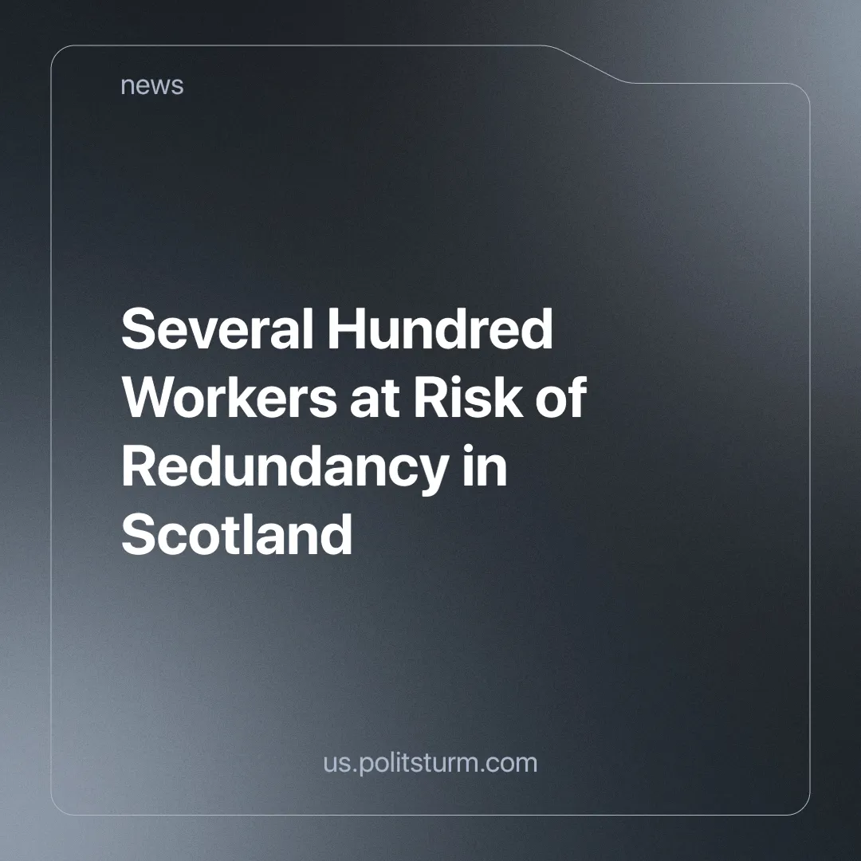

Original article
2024-10-09
5 min read

Nearly 400 jobs are at risk at Belfast-based shipbuilder Harland & Wolff's Scottish shipyards as the company enters administration for the second time in five years [1]. A further 443 jobs are at risk at a Mitsubishi heat pump plant due to 'short-term economic pressures' [2].
Harland & Wolff, which was responsible for building the Titanic and her sister ships, has shrunk massively since its peak. It once had 35,000 workers, but in 2019 it had a meagre 120. The number of employees grew after 2019 by 400% [3], but now it is likely to shrink again.
The company owns four shipbuilding yards, two of which are in Scotland. There were hopes of a revival in 2022 when it won a £1.6 billion contract to build three new support ships for the Royal Navy.
But Harland & Wolff has struggled to refinance expensive loans, and the UK government decided not to provide it with an additional £200m loan, saying it was too risky.
There are possible buyers for the shipyards, and the firm’s executive chairman, Russell Downs, said that the yards "together or separately have a credible future". However, two British unions, GMB and Unite, have said that nearly 400 jobs are at risk.
The Mitsubishi Electric factory, which makes air-source heat pumps and air conditioners, has seen a slight increase in UK sales. However, its main production is for mainland Europe, where demand has fallen, leading to a consultation process that puts 443 jobs at risk. The factory has been operating in Livingston for 30 years and currently employs 1,600 people.
A spokeswoman for Mitsubishi Electric stated:
“We remain committed to our facility in Livingston and manufacturing heat pumps at this site. We do not anticipate any effect on deliveries or supply."
Even when its own workers' livelihoods are at risk, capitalists ensure that everything is done to keep revenue flowing – clearly showing where their priorities lie.
The UK — like many other industrially powerful countries — has seen significant deindustrialisation, i.e. experienced a decline in the primary sector (industrial production) of the economy (even with this decline however, it remains the fifth largest exporter of goods in the world).
The UK is considered the birthplace of industrial capitalism and was once the most advanced country in the world. But as capitalism grows, it seeks new markets abroad. In the underdeveloped world, capitalists have found cheaper labour from which to extract a greater degree of surplus value (the value that a worker creates over and above what they are paid in wages, that is, a new value higher than that which the capitalist invested).
Only human labour is able to create surplus-value. Capital invested in machinery cannot create value by itself, it simply transfers the value imbued in it (by the labour it took to create them), into the new commodity (and can greatly enhance the productivity of each worker), but no surplus is added, and therefore no profit can be made by the selling of commodities until human labour acts upon it.
The more industrialised countries, with their ever-increasing use of machinery, cause the rate of profit to gradually fall as a greater percentage of the capital invested goes into machinery and equipment, which they do not directly profit from. And so the capitalists move to less industrialised countries where the rate of profit is higher. There they start the process again.
In this way, they hold back economic development. Where machines could produce a much higher volume of products to satisfy human needs, with less work needed, manual labour is maintained and the development of industrial production stalls.
This, combined with better worker protection laws that made labour even more expensive in the developed world, led to deindustrialisation in the UK and other countries like it.
This is not to say that workers shouldn't fight for employment protection laws. However, separated from a wider struggle to change the economic system to one that works in their favour, their struggle becomes massively limited in what it can achieve. As a result, they gain at most, temporary concessions from the capitalist class.
The workers should also not limit themselves to fighting for only national gains. There must be workers’ internationalism. As shown, a larger degree of exploitation in one country can impact the lives of workers in another country. Therefore, the proletariat must jointly struggle against capital in all countries.
Capitalism is characterised by its unplanned economy, with companies operating in their own interests, uncoordinated with the larger national economy or according to any rational plan. They seek those industries which are the most profitable, not the most needed, and their investment migrates from one industry to another as profitability fluctuates.
In combination with this, the capitalists, in their quest to cut costs, sack workers, pay them less in real terms (through inflation) and force the remaining workers to be more productive. But this leads to higher unemployment and therefore fewer consumers for their products, which further reduces demand.
A temporary fall in demand puts the livelihoods of several hundred workers at risk, as they are subject to the whims of an anarchistic market that does not care about their welfare. A company will make the necessary sacrifices to remain profitable for the capitalists who own it by finding ways to remain competitive – even when the livelihoods of thousands of workers are threatened.
And so the capitalist system closes down factories without worrying about how those who depend on the industry for their livelihoods should cope. This is what happened in the famous historic miners' strike in Britain, where thousands of workers and trade unions waged a determined struggle against the closure of the mines on which their livelihoods depended [4].
A more modern example is Tata Steel, which is replacing old furnaces with 'greener' electric furnaces that require fewer workers to operate. Making more than a thousand workers in South Wales lose their jobs [5]. We have previously written about this situation.
If an industry needs to change or simply isn't viable, in a planned socialist system the state would be able to effectively redeploy these workers to new industries, providing any necessary training free of charge. Labour-power in socialism is not a commodity, removing the need to cheapen it. Previous socialist countries were able to completely eliminate unemployment because of this.
In a socialist system, under the leadership of a truly communist party, the economy would be planned and directed to meet the needs of society. It wouldn't suffer from anarchy of production because there would be no private industries trying to exploit workers for individual interests. All industries would be linked to a national plan and would work together for the benefit of the people of that society.
Deindustrialisation wouldn't be a problem either. Because there wouldn't be any capitalists closing down factories in one country to move them to another where labour is cheaper. The more the workers produce for themselves, the easier they can satisfy their rising material and cultural desires.
In socialism, heavy industry is a central part of the planned economy. Producing essential equipment for all other industries to function properly, heavy industry would normally require a large investment with a small initial return, making it unprofitable to a capitalist.
This has been achieved in the socialist countries of the past and can be achieved again. But for this, we must build a new truly communist party again, as currently, there are none. Only then can the working class, under the leadership of this party, build socialism. Join Politsturm and help make this happen.
Sources:
[1] BBC — Fears for Scottish jobs as Harland & Wolff faces administration — 16/09/2024
[2] BBC — More than 440 Mitsubishi staff facing redundancy — 04/09/2024
[3] Harland & Wolff — Harland & Wolff Annual Report 2020/21 — 2021
[4] BBC — Miners' strike 1984: Why UK miners walked out and how it ended — 02/03/2024
[5] Sky News — Tata Steel: UK's biggest steelworks shuts down final furnace after more than 100 years — 30/09/2024

Original article

