Senate Tax Bill Attacks Obamacare
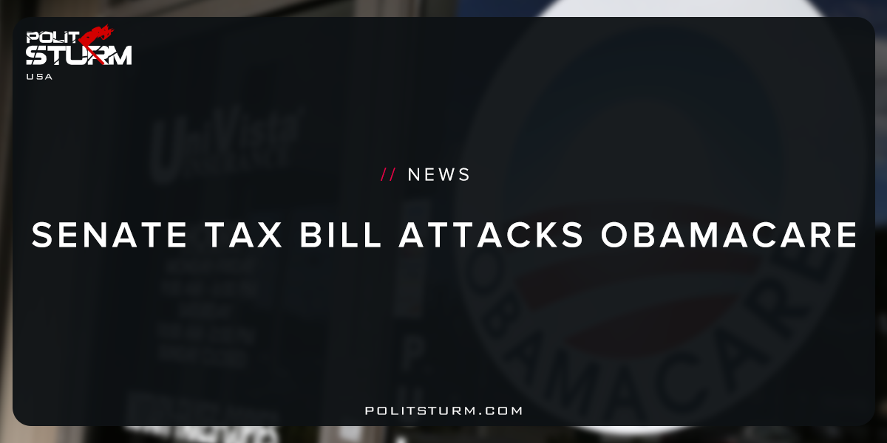

Original article
2017-11-18
1 min read

Senate Republicans have decided to include the repeal of the Affordable Care Act’s requirement that most people have health insurance into the sprawling tax rewrite, merging the fight over health care with the high-stakes effort to cut taxes.
The move to tuck the repeal of the so-called individual mandate into the tax overhaul is an attempt by Republicans to solve two problems: math and politics. Repealing the mandate, a longstanding Republican goal, would save hundreds of billions of dollars over the next decade. That would free up money that could be used to expand middle-class tax cuts or help pay for the overall cost of the bill, which can add no more than $1.5 trillion to the deficit over 10 years. It could also help secure the votes of the most conservative senators, enabling lawmakers to pass the bill along party lines.
Politsturm: The US Senate is attempting to merge tax reform with the repeal of “ObamaCare”. Let us not be confused as to what is really going on here. The reduction in expenditures on subsidizing the health insurance markets will allow for a subsequent tax reduction. As evidenced by Trump’s plans for tax reform, most of the benefits will go to the capitalist class. The reason for this is quite obvious. The capitalist class owns the majority of the traded shares of stocks and bonds, and own the means of production . As such, they receive their dividends, or the same thing, the unpaid labor of the working class. And with less spending on health care the bourgeois class can target reductions in dividend,capital gains, and corporate taxes. Capitalism steals from the poor to give to the rich.

Original article

