Senate Passes Tax Reform Bill
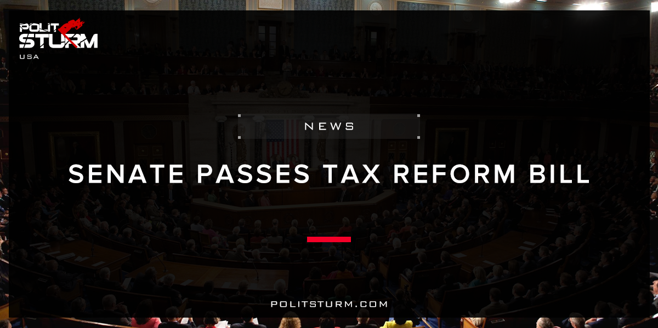

Original article
2017-12-07
2 min read

The Senate passed its tax reform bill in the early hour of Saturday morning, following a day full of Republican leaders making changes to bring enough members on board and a long night full of heated rhetoric on both sides of the aisle.
The vote was 51-49, mostly along party lines. Sen. Bob Corker of Tennessee was the only Republican to vote against the bill, citing concerns about growing the deficit.
Congressional negotiators continued to make changes to the bill — including handwriting alterations on to the document — up until just hours before the final vote, with Democrats sharply criticizing Republicans for not giving members enough time to read the sweeping legislation that would overhaul the US tax system.
The House of Representatives approved its own tax reform plan last month, and the two chambers are expected to go to conference to reconcile the two bills, but passing the legislation Saturday was a huge victory for Senate Republicans and President Donald Trump, both looking for significant legislative achievements.
Polisturm: The economic elites scored a large victory as the “Tax Cuts and Jobs Act” was passed in the Senate early Saturday morning. This bill is going to benefit the wealthy by increasing the deductions allowed for business income and also lowering the corporate tax rate. When this tax schedule is implemented it will reduce the tax revenues received by the government from corporations and the wealthy. This will likely mean a subsequent reduction in discretionary spending or an increase in taxes on the working class. This bill shows how the elected officials of the United States will always act in the interest of the economic elites and corporations.
This bill is clearly an affront to the working class, but it does clearly convey the ridiculous nature of the capitalist economic system. Tax cuts are given to the oligarchs which increases their ability to privately accumulate wealth. The working class is diligent and industrious while the bourgeois lives in leisure and decadence. The workers themselves lack universal health care, stable employment, and affordable housing. The elites are now going to lower their contributions and increase what they can extract in the form of rent, profit, and interest from the workers.
Our government is not able to fix the problems of capitalism because it inherently reflects the interest of the bourgeois class. No reform that is passed through the U.S legislature, court system, or by executive act will change this underlying, fundamental reality. This bill is just a microcosm of the contradictions of capitalism that are manifesting themselves economically, politically and socially in the United States. It is absurd to expect that a Congress full of millionaires would ever act in the interest of the working class. This bill proves this immutable fact.
Sources: 1, 2

Original article

