Second US-China Summit of 2026
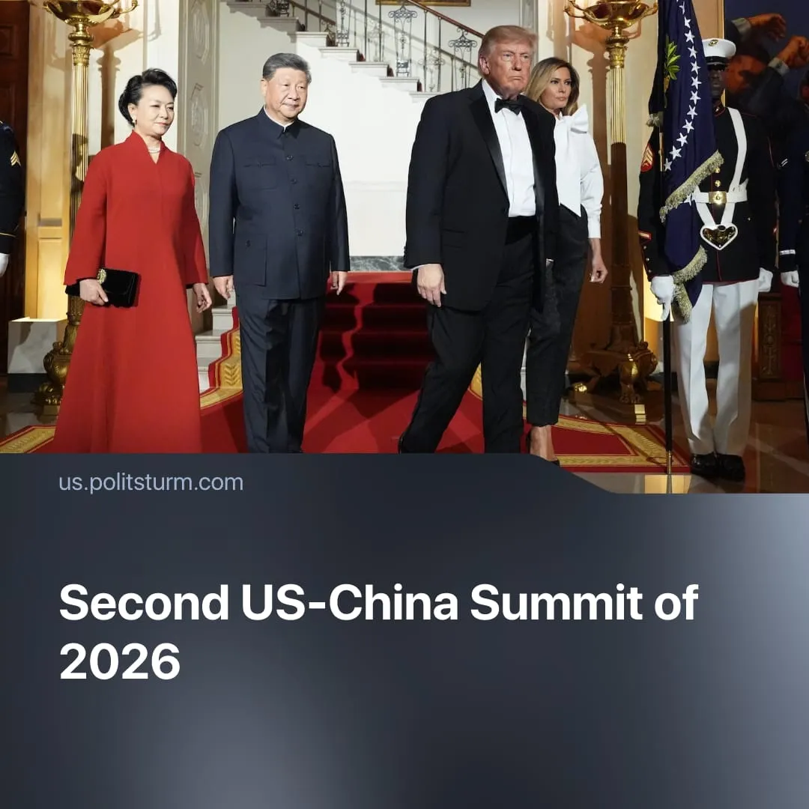

Original article
2026-10-07
2 min read

American and Chinese capitalists meet again in Washington to negotiate tariffs, AI, and escalating conflicts.
Details. From September 23–25, Trump hosted Chinese President Xi on an official state visit in Washington, following their meeting in Beijing in May. The talks covered ongoing trade disputes and escalating global conflicts.
► Xi received a lavish welcome, including a 100-foot red carpet. Trump also staged a military flyover featuring a nuclear bomber, attempting to outdo the reception he received in Beijing in May. Both sides have used military posturing to impress and intimidate one another, while diplomatic courtesy maintained a facade of inter-imperialist stability and harmony.
► American tech capitalists – including Musk, Zuckerberg, and Nvidia's Huang – attended the Trump-Xi meetings to discuss AI and semiconductor competition. Chinese capitalists from monopolies like BYD and Xiaomi also travelled to Washington, but were excluded from official meetings, participating only from the sidelines. Despite close dialogue between both countries' tech elites, they reached no substantive agreement on the AI race.
► Trump claimed "tremendous progress," and Xi called it "very successful", but there were no major breakthroughs. The two sides agreed to cut tariffs on $30 billion of goods (only a fraction of total trade volume) and extended their tariff war truce by two months. They also agreed that Iran should not develop nuclear weapons, and that no state should impose transit tolls on waterways like the Strait of Hormuz.
Context. Contradictions between the imperialist blocs headed by America and China are sharpening. Global conflicts are now at their highest level since WWII, with 65 active conflicts across 35 countries. The two powers are increasingly colliding directly: Iran reportedly used Chinese satellite imagery to strike American bases, and the US military nearly struck a Chinese ship in the Middle East after an AI targeting error. Trump is also considering a $14 billion arms package for Taiwan.
► Negotiations between the imperialist powers under Trump's second term have delivered little of substance. The US-China trade truce remains temporary, with disputes over tariffs, rare earth exports, and semiconductors still unresolved. Trump's negotiations with Putin have stalled, and the Iran conflict drags on – contradicting his claims that he would end the “SMO” in a day, or that the Middle East crisis would end "very soon."
► The trade war between the US and China was temporarily suspended last year, with a truce agreed to last until November 2026. This summit was supposed to produce a long-term solution, but it only extended the truce to January 2027.
► A month before the summit, China imposed sanctions on multiple American entities, after the US imposed multiple trade restrictions on China. Previously, the May summit in Beijing was preceded by China’s moves to consolidate its bloc, whilst the US attacked Chinese dependencies in Latin America.

Original article

