Russia's Agricultural Sector in Decline
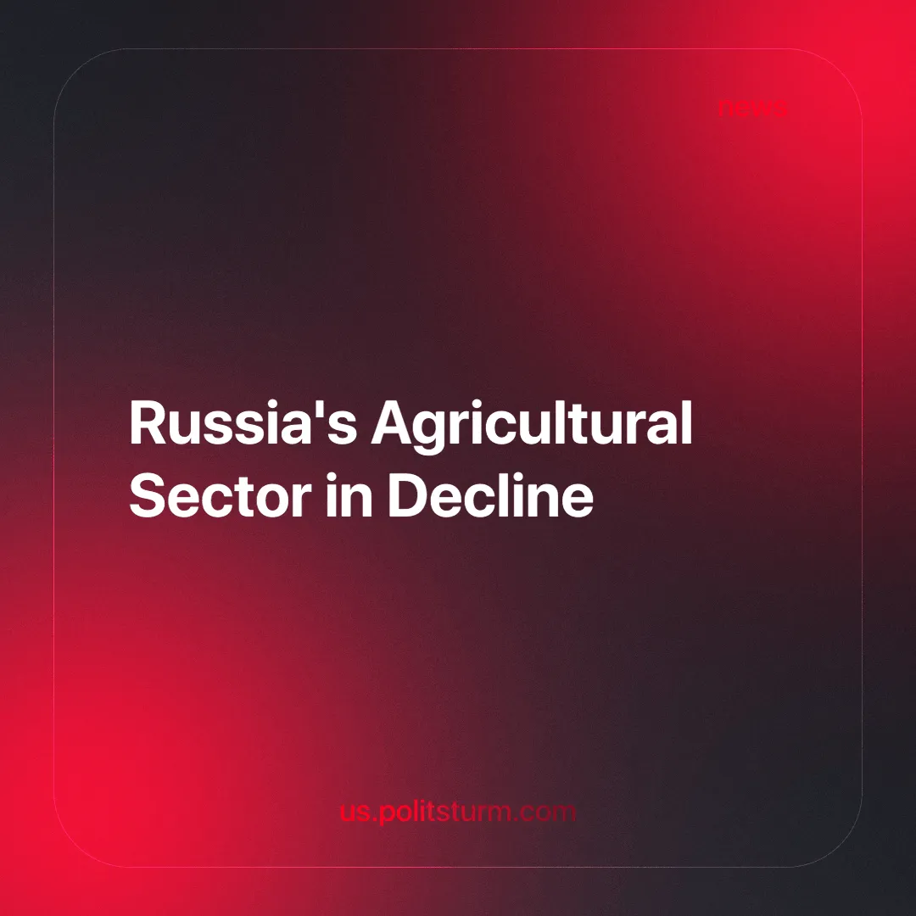

Original article
2024-12-26
3 min read

In 2023, a survey of major agricultural entrepreneurs [1] indicated that under the framework of the Food Security Doctrine of the Russian Federation, the country was reported to be self-sufficient in vegetable oil (221.1%), grain (185.5%), sugar (103.2%), meat (101.6%), and 85.7% self-sufficient in dairy products. Such figures are presented as evidence of the market system's success, but what really lies behind these numbers?
Representatives of agribusiness enthusiastically claimed: "Agriculture has become Russia's new oil," and "the level of food security is a matter of national pride." However, these slogans are designed to mask the sector's real issues and portray the capitalist system in a favorable light while ignoring the interests of ordinary agricultural workers.
At a recent agricultural workers' celebration, Vladimir Putin reiterated routine promises about "expanding production" and "entering foreign markets" [2]. The Minister of Agriculture, Oksana Lut, announced that the grain harvest would reach 130 million tons in 2024, describing this as one of the best results in modern Russian history [3]. However, this optimistic projection does not show the data, which indicate a 15% decrease in the harvest of major crops compared to 2023, with potatoes, grain, and wheat experiencing the largest reductions of 15%, 12%, and 11% respectively. This discrepancy highlights the tendency of capitalist states to use selective data to promote an image of economic success.
In reality, even if there are achievements in capitalism, they are temporary and often come at the cost of worker exploitation, small farm bankruptcies, and technological decline. For example, the record potato harvest of 8.5 million tons led to a price drop close to production costs in 2023. For capitalists, these are just numbers on a report, but for small farmers, they pose a threat to survival [4]. Workers may gain in the short term from food price decreases, but the long-term process of monopolization will erode those short-term advantages as well. After the small farmers are ruined, and the monopoly is dominant, then there is no barrier towards it price gouging.
The agricultural crisis is a direct result of the massive privatisation of production assets established during the Soviet era. Today, capitalists are neither capable nor willing to restore the lost potential. In 2023, the production of agricultural machinery fell by 2.5%, while dealer sales dropped by 10-20%, and by 40-50% in the summer [5].
Russian farmers find themselves in a desperate situation: spare parts for machinery are mostly imported, and their prices continue to rise. Tatiana Fadeeva, head of Optitech Agro, bluntly stated:
"Many farmers have simply stopped purchasing equipment. Transactions occur only in extreme cases. Significant growth in imports this year is unlikely."
Back in 2022, at the 33rd AKKOR Congress, there were promises to continue issuing preferential loans at 5%. It was claimed that small farms were developing better than large corporations. However, as reality shows, farmers face constant increases in resource costs.
For example, in the Rostov region, fertilizers were offered at 33,400 rubles per ton instead of the promised 21-23 thousand. In Crimea, the situation is even worse as most farmers conducted their sowing campaigns without fertilizers, which will lead to catastrophic yield declines in the coming years [6].
Contemporary Russia has become entirely dependent on imports. Up to 97% of sugar beet seeds, 80% of vegetable seeds, and 73% of sunflower seeds are purchased abroad [7]. Even basic technologies and equipment, including waste recycling machinery, are produced outside Russia.
These issues are a direct consequence of the capitalist approach: profit takes precedence over food independence, and market laws dictate the destruction of competition. Monopolies swallow small farms, driving farmers out of the market.
The market system, built on the ruins of the Soviet economy, has proven its inefficiency. While the 2024 harvest may indeed represent “one of the best results in modern history”, this apparent success masks deeper systemic inefficiencies. The market system may foster short-term increases in productivity, driven by new technologies and innovations. However, it also inherently slows the process of technological progress by prioritizing immediate profits over long-term investment in research and development. Instead of developing agriculture and ensuring food security, we see the exploitation of workers, the destruction of infrastructure, and increasing dependence on imports.
The true state of agriculture is characterized by outdated machinery, debts, and farmers' despair. While production figures may indeed reflect increases in output, claims of "records" and "successes" are narratives crafted for television that do not address pressing issues. These narratives fail to confront the fact that such increases in production are frequently driven by intensified exploitation of labor, environmental degradation, and the prioritization of short-term profits over long-term societal needs. Only a return to a planned economy and socialist principles can pull the agricultural sector come out of its crisis.
Sources:
[1] Kommersant — "Agriculture has become the locomotive of the economy" — December 20, 2023
[2] RIA Novosti — "Putin promises continued support for the agricultural sector" — October 13, 2024
[3] Rossiyskaya Gazeta — "Minister of Agriculture confirms 2024 grain harvest forecast of 130 million tons" — November 7, 2024
[4] Rossiyskaya Gazeta — "Ministry of Agriculture and Ministry of Economic Development to address potato imports from friendly countries" — November 14, 2024
[5] AgroInvestor — "Unaffordable: Purchasing new agricultural machinery becomes increasingly inaccessible" — September 25, 2024
[6] Komsomolskaya Pravda — "Russian farmers complain about state regulation of agriculture: 'They gave us 2 million rubles but took 63!'" — February 17, 2022
[7] RBC — "Farmers warn of crop risks due to seed import quotas" —September 19, 2022

Original article

