Russians Took Out A Record Number Of Loans
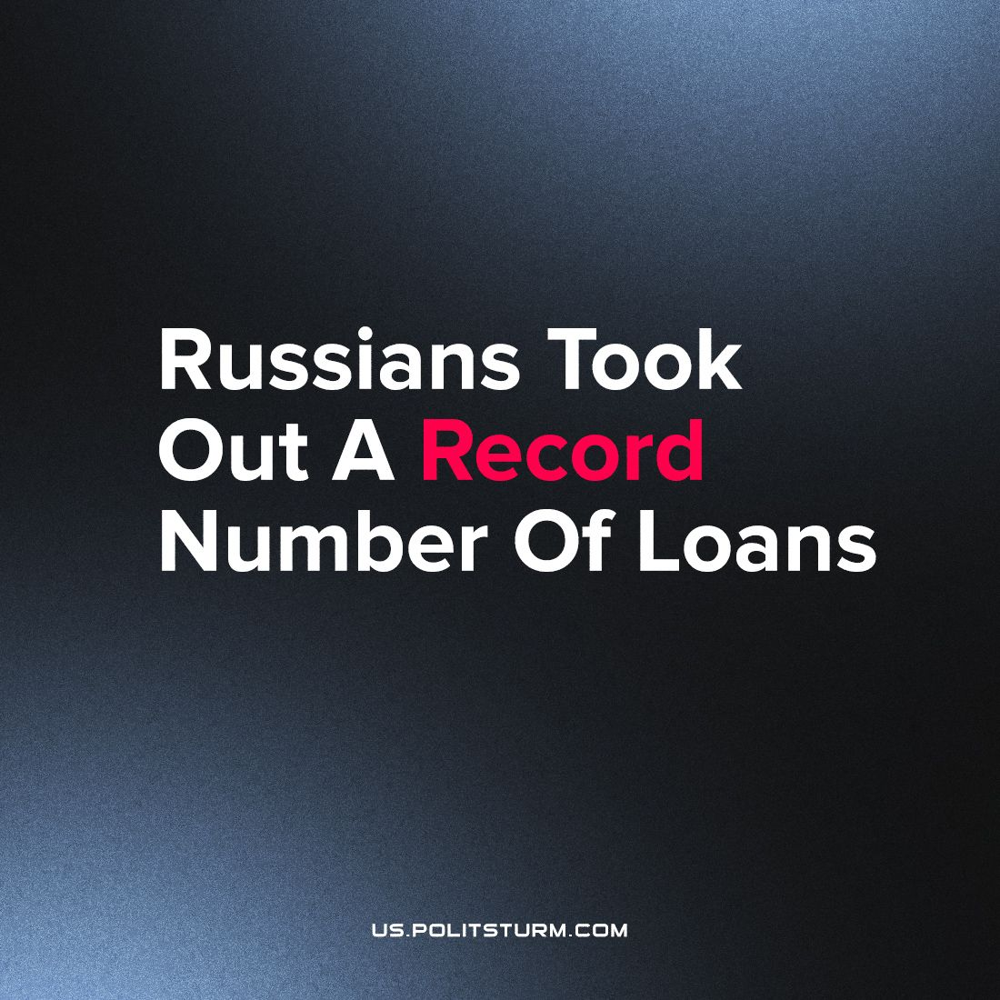

Original article
2023-10-06
2 min read

Nearing the end of 2023, the total amount of debt owed by Russian citizens has reached 32 trillion rubles. This year alone, there was a 3.3 trillion ruble increase in this debt, an all time record according to Izvestia.
Mortgage borrowing has increased the most. Home mortgages make up 51.9% of debt owed by Russians, while 43% are consumer loans and credit card debt, and 4.7% are car loans. The proportion of mortgages compared to other debt has increased by 4.3% since 2021. The growth in mortgage borrowing was mainly due to Russians rushing to take out preferential mortgages, fearing rising rates ahead of the preferential mortgage program closing its doors in July 2024.
As for the increase of debt load in general, experts attribute it to the fact that in 2022, due to uncertainty and problems with logistics and delivery of goods, Russians bought less than they wanted, and are now making up for it. In addition, many are expecting another price increase, so people are in a hurry to purchase goods before it happens.
A constant increase in prices for all kinds of goods and services, along with a stagnating or declining level of wages, often forces an increasing number of people to take out loans due to a lack of funds to make certain purchases, sometimes unplanned ones including payment for medical services and home repairs. Citizens often get deeply into debt and start to take out new loans to cover old ones, thus finding themselves on the “financial hook”.
The capitalist system makes this problem worse by promoting consumer culture and stimulating people’s desire to acquire as many new things as possible. Banking and credit institutions are not far behind, introducing endless advertising campaigns that persuade the population to borrow money at an extremely “favorable” rate.
Today, Russians who are working harder than ever to get their basic needs met find themselves trapped under mountains of debt. These financial shackles unite workers in their common interest - the struggle for liberation from exploitation, for socialism. The proletarians have nothing to lose but their chains. They have a world to win.
Source: Central trade union newspaper “Solidarnost” - “Russians took out a record number of loans”from September 5, 2023.

Original article

