The Number of Russians Receiving a Salary of More Than 100,000 Rubles Increased by a Third
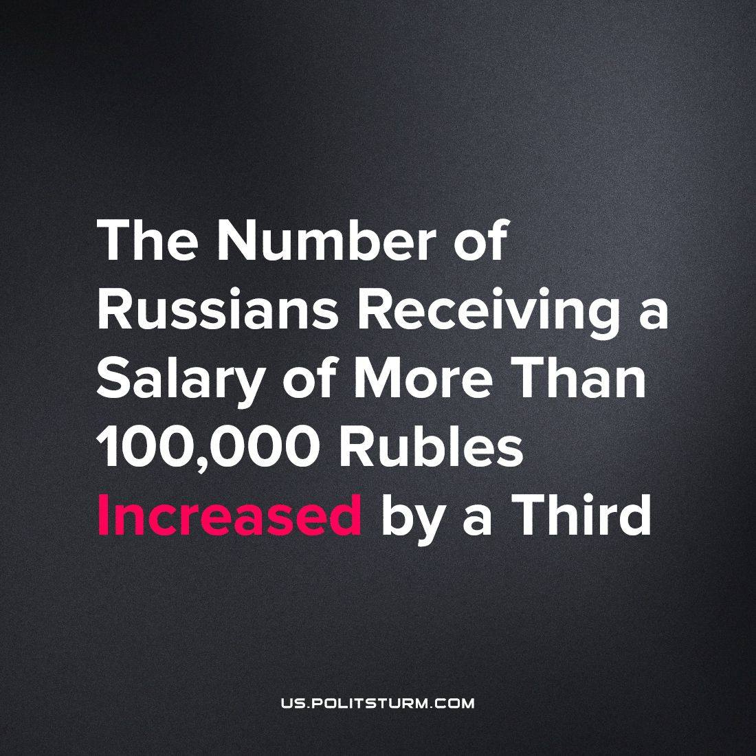

Original article
2023-10-10
2 min read

According to the calculations of FinExpertiza in 2022, the share of Russians receiving salaries over 100,000 rubles amounted to 7.4% or 10.9 million people. Compared to 2021, 2.5 million people have been added to it, which gives about a third of the increase. The calculation was made on the basis of Rosstat data.
The increase in the number of workers receiving the same salary is due to a shortage of personnel in some areas and an increase in payments to the mobilized.
The number of those who received salaries in the range from 45 to 60 thousand rubles also increased by 16.1%. The share of such Russians was 36% or 53 million people. This increase is caused by the indexation of payments and the growth of salaries.
The increase in the minimum wage had a positive effect on the incomes of the population, which in total gave a 20% increase, overtaking 11.9% inflation.
It seems that the state's policy, both external and internal, has a positive effect on the welfare of the working people. However, statistics suggest the opposite. In comparison with 2014, today's 100 thousand are equivalent to the then 60 thousand. In 2014, more than 8% received salaries over 60 thousand compared to today's 7.4%. Thus, over a long period of time, there is an absolute (the amount of material goods consumed compared to the labor expended) and relative (compared to businessmen and entrepreneurs) impoverishment of the working people.
Consequently, the increase in income against the background of “special events” in a neighboring state is an attempt to bribe the workers to ensure greater loyalty to the current regime. It is in the interests of the working class to receive a non-temporary handout from the bourgeois government and employers. It is in workers interests to create his own government, getting rid of the power of employers, entrepreneurs, businessmen, bankers…
Then the contradiction will be removed between the dependence of an individual on other members of society caused by the social division of labor (since people depend on each other, insofar as they need each other) and destructive wars that destroy human lives and destroy factories, factories, residential neighborhoods. Friendship of peoples and their cooperation will be established. And instead of temporary handouts, a systematic improvement of the material and cultural living conditions of all members of society, not just the working aristocracy, will be ensured.
Source: Izvestia - "Calculate by growth: Russians with an income of 100 thousand became a third more. Will this trend continue and will wages keep up with inflation" from August 14, 2023

Original article

