Personnel Crisis: Why is There No One to Work in Russia?


Original article
2024-08-25
22 min read

There has been talk of a labor shortage in Russia for the past six months. The Russian labor market is indeed experiencing a shortage of personnel in various fields. A number of factors caused this crisis, and its preconditions began to emerge long before 2024.
The shortage of personnel in the industrial and construction sectors was first mentioned in 2021. At that time, the shortage was attributed to the outflow of migrants due to the COVID-19 pandemic. However, after the start of the Ukrainian crisis, the situation worsened significantly and became a systemic crisis in 2023.
By the end of 2023, the labor shortage was estimated at 4.8 million jobs. This problem is confirmed by a decline in the HHI (Herfindahl-Hirschman Index), an increase in the number of unfilled vacancies (and the ratio of vacancies per job seeker), and a decline in the unemployment rate to a record low.
The reasons for the personnel shortage are the demographic crisis, the COVID-19 pandemic, the emigration of migrants, the departure of Russians from the country, and structural changes in the labor market.
So far, the shortage of personnel has not managed to cause significant damage to the Russian economy because its acute phase has only recently begun. However, the long-term consequences could be dire. The ongoing shortage of personnel can worsen the living conditions of the working class and result in reduced production.
The state plans to solve the problem through the national "Personnel" project (ru. национальный проект Кадры), importing migrants from Africa and Asia and attracting pensioners to work.

I. Estimating the Deficit
In 2021, the Russian media gradually began to report on the shortage of personnel in industry and construction due to the outflow of migrants and structural changes in the labor market. At the same time, albeit cautiously, they began to talk about the labor shortage as a new persistent trend in the Russian economy.
The start of the Ukrainian crisis aggravated the trend. In the first half of 2022, about 420 thousand people left the country, and another six months later the number of those who emigrated already approached 800-900 thousand.
In 2023, both the media and the Russian government began to speak openly and frequently about the labor shortage issues in the country. For example, the Chairman of the Central Bank of Russia, Elvira Nabiullina, stated that Russia "has almost fully utilized the available labor resources and is left without free working hands". Deputy Prime Minister Golikova suggested that by 2030, the shortage of personnel in Russia could reach 2 million people.
To assess the extent and depth of the staff shortage, we will analyze such indicators as HHI, unemployment rate, number of vacancies available across the country, and number of vacancies per job seeker. HHI is an indicator derived by hh.ru, one of the largest Russian job search services. The index assesses the state of the labor market based on the number of submitted resumes per vacancy.
Herfindahl-Hirschman Index — These are the benchmark HHI values:
2.0-3.9 — shortage of job seekers;
4.0-7.9 — moderate competition for jobs.
As of June 2024, the total HHI is 3.1 for all industries in Russia, which means a pronounced deficit of job seekers. It is notable that at the beginning of 2023, the index had a value of 4.5, a moderate ratio of employers to job seekers. If we take into account that the index 4.5 is close to the lower threshold of the interval, we can safely assume that the trend towards a deficit of job seekers appeared before 2024.
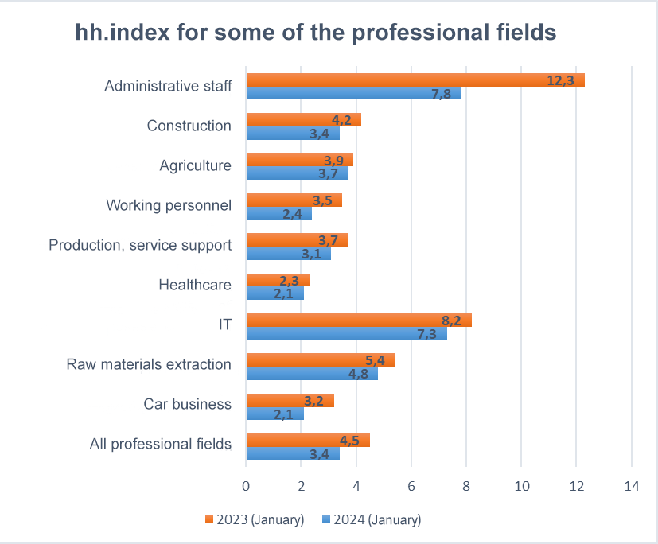
Data for the graph is taken from hh.statistics
Unemployment and the number of job openings. Although the unemployment rate is a proxy indicator, it is the unemployment rate that illustrates an important characteristic of the capitalist labor market — the amount of free labor, i.e., potential workers. The higher the unemployment rate, the greater the amount of available labor.
This indicator is supported by vacancies reports submitted by companies to employment services. The number of vacancies not increasing from year to year indicates that companies are managing recruitment at the usual level. If the indicator shows an upward tendency, it means that the labor market has problems with recruitment — that there are fewer candidates for open positions.
The trend of an increasing number of vacancies and a decreasing unemployment rate in the Russian labor market has been a warning about the approaching shortage of personnel for several years.
Since 2017, we can observe a steady decline in the unemployment rate — from 5.1% in December 2017 to 3% in December 2023. Only 2020 is an exception, showing an unemployment rate of 5.9% in December, with a peak of 6.4% in August. According to the data for April 2024, the unemployment rate continues to fall and is already at 2.58%.
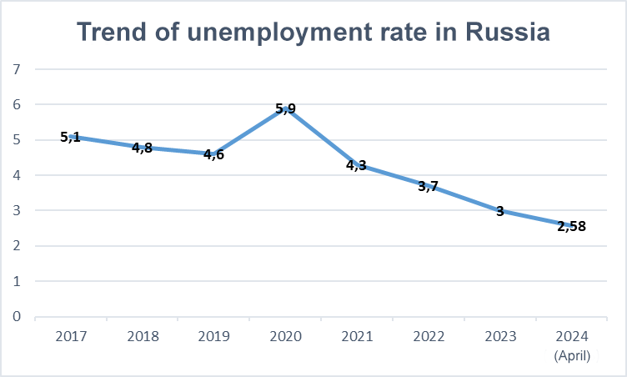
Data for the graph was taken from the Unified Interdepartmental Information and Statistics System website
At the same time, the number of job vacancies is increasing. For example, the number of unfilled positions has nearly doubled from 1 to 2 million between 2020 and 2023.
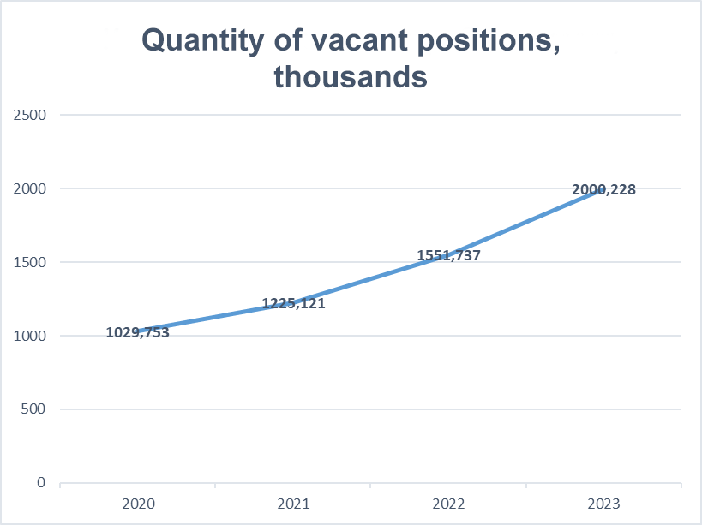
Data for the graph is taken from the Rosstat website — Labor Market, Employment and Wages.
At the same time, the number of vacancies per job seeker is growing. According to the FinExpertiza auditing agency, this figure reached 2.5 vacancies in the fourth quarter of 2022.
The following conclusions can be drawn:
1. In 2020-2021, the Russian labor market was affected by factors that, if persistent, threatened labor shortage.
2. The personnel shortage itself began at the turn of 2023 and 2024.
In this situation, it becomes more difficult for the ruling class to dictate conditions in the labor market. When labor is abundant, several people apply for one job and the employer is likely to choose the one willing to work for lower wages. In the opposite situation, when there are several vacancies for each employee, he/she has the option to choose a higher-paying job.
Of course, this situation is extremely unfavorable for most organizations, as they aim to increase profits by reducing all kinds of costs.
According to a study by the Institute of Economics of the Russian Academy of Sciences, a total shortage of 4.8 million workers affects the country. The estimate was for the end of 2023. Taking into account the above-mentioned trends, it can be safely assumed that this number has already increased.
Which sectors are the most affected by the shortage?
Industry. According to the results of regular surveys conducted by the Central Bank of Russia, in the first half of 2023, the need for labor in the industrial sector has increased significantly. The main reasons for this are the active development of import-substituting industries and the growing number of state contracts against the backdrop of foreign companies withdrawing from the market. The most acute shortage of qualified specialists is felt in the automotive industry, the production of vehicles, electrical equipment, and petroleum products.
Construction. In March 2024, the head of the Ministry of Construction stated that the construction industry of the Russian Federation lacks 1 million people for sustainable development. The number of vacancies in this sector in 2023, per some estimates, increased by 31%, and according to others, they tripled.
Healthcare. The shortage of medical personnel began long before Russia began to talk about a general labor shortage. Nevertheless, the situation in this area is not improving. By 2023 there was a shortage of 26.5 thousand doctors and 58 thousand nurses. In addition, doctors of rare specialties can not be found in some regions of the country at all.
Agriculture. During 2023, the shortage of qualified personnel in this sector reached 200 thousand people. Besides the shortage of ordinary workers, there is a shortage of educated specialists and scientific associates. It is quite understandable — the salaries of agricultural workers remain among the lowest in the country since the collapse of the USSR.

II. Causes
The shortage of personnel in the Russian Federation in 2023-2024 is the result of long-term factors that were formed much earlier. Their impact on the labor market became noticeable years later and led to the current problem.

Declining Birth Rate
Since 1992, the trend of negative natural population growth, decreasing birth rate, and increasing death rate has been firmly established in Russia. These ratios show how many people are born/die per thousand.
Based on the presented data, we can see that for 30 years, the death rate of the population regularly and quite strongly exceeded the birth rate. People not only left the economy but also did not produce their replacements.
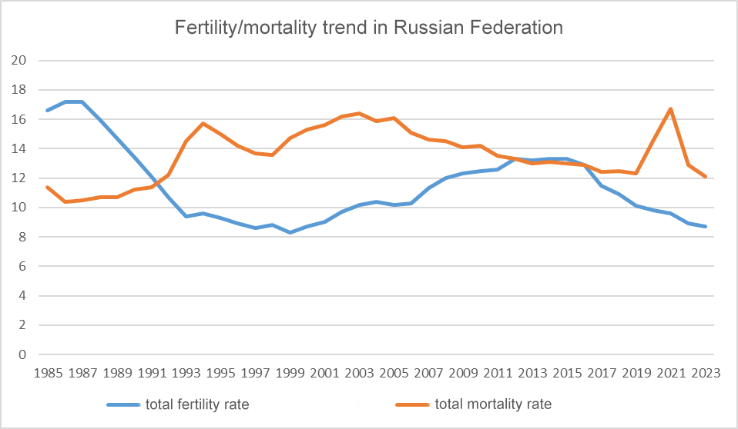
The graph is based on data from the archive of the Federal State Statistics Service and the Rosstat —Demography resource.
According to analysts, Russia has lost 25 million people as a result of the demographic crisis, which is a third of the workforce for 2023 (75 million). It is the people born in the 90s and 00s who are now the young specialists. It is they who will have to replace the aging generation born and raised in the USSR - in the 70s and 80s. But they will not be able to do it completely as there are simply less of them.

COVID-19
The COVID-19 pandemic has aggravated the demographic situation in Russia, causing excess mortality in the population. According to different estimates, this amounted to 288-340 thousand people in 2020. For 2020 and 2021, excess mortality is estimated at 715 thousand people, with a higher rate in older age groups.
Excess mortality is not easy to calculate, but the data presented in the graph show that the mortality rate was stable and even decreased until 2020.
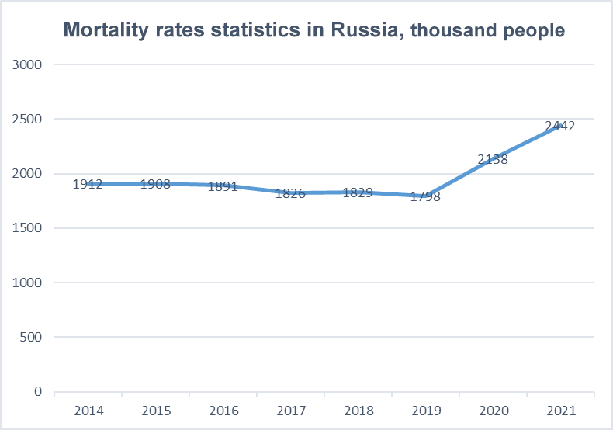
Data for the graph was taken from the website Rosstat - Demographics.
The country lost several hundred thousand workers in a short period. Although the death rate from COVID-19 is higher among people of retirement age, many of them could still be participating in the labor market today, taking into account the pension reform, which we will look into later. But, it was not only the elderly who contributed to the excess mortality statistics: young and middle-aged workers also died from the effects of the COVID-19 pandemic.

Migration
The flow of low-skilled migrants from the CIS (Commonwealth of Independent States) countries began to increase sharply in the 2000s and steadily compensated for Russia's natural population decline until 2020. At the same time, the influx of migrants severely distorted the capitalist labor market with an excess of cheap labor while production stagnated. As a result, the price of labor power was undervalued, and it became more profitable for capitalists to hire more low-skilled workers than to introduce modern technologies to increase labor productivity.
Starting in 2020, the inflow of migrants began to decrease due to the restrictions and the crisis. Due to the weakening of the ruble in 2022 and the many sanctions imposed on the Russian Federation, migrants began to leave the country in search of a more comfortable place to apply their labor. In addition, the beginning of the Ukrainian crisis caused a flow of emigration of Russian citizens. The overall population growth became negative.
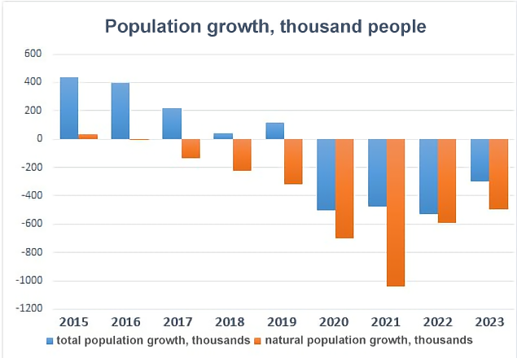
Data for the graph was taken from the Rosstat website — Demographics.
This created two problems at once:
1. In principle, there are fewer working hands.
2. Until 2020, capitalists did not need highly qualified personnel capable of introducing automation into production and increasing labor productivity. And now, when the outflow of migrants has created a need for such specialists, it has turned out that there are not enough of them.
It should be said that demographic losses are one of the most acute and key factors for this development of the labor market. Every citizen not born or lost due to excess mortality affects the economy. The narrowing of the demographic base due to lower birth rates and increased mortality or emigration reduces the opportunities for expansion and replenishment of the labor market.
Structural changes in the labor market
At present, young professionals generally do not want to be trained in professions that are needed by the country's economy.
In the 1990s, production cutbacks and privatization led to serious unemployment among workers. Many went into the service sector or became self-employed. In addition, as mentioned above, the price of labor was undervalued for years due to the surplus of migrants.
Now, even young specialists who have completed their professional training are mostly avoiding industrial production, opting for the service sector instead. At the same time, the share of students studying working professions in colleges is only 20%.
The link between education and production, well-developed in the USSR, has been broken in modern Russia. The state has done little to attract young people to the industrial sector of the economy. On the contrary, labor and engineering professions have lost their prestige due to the undervaluation of labor costs and the dismissal of highly qualified specialists.
Now that the Russian economy has set the course for import substitution, it turned out that there was no one to carry out the grandiose plans for developing domestic production. Many migrants have left the country and the population has shrunk, young people are mostly employed in the service sector, and graduate specialists require additional practical training.

III. Impact on the Economy
Recruitment company Get Experts surveyed 2.4 thousand employers and it turned out that the majority (71%) will increase the salaries of their employees in 2024. However, in almost half of the cases, the increase will be only 5-10% to compensate for inflation.
Despite the labor shortage, employers are ready to increase salaries above inflation only for key specialists. No significant increases are expected for other employees. Private companies are trying to minimize labor costs, while state organizations are limited by already-optimized budgets.
As the problem of the labor shortage emerged only a year ago, it has not yet had a strong impact on the economy. However, we still do not have the data for 2024.
If we talk about the period that brought the economy to the current state, for 2023, GDP grew both in nominal and real terms. The production index of goods and services of the basic types grew slightly or remained at the same level. In addition, the real disposable income of the population grew.
It is notable that in 2023, agriculture, even though already experiencing a severe personnel shortage, showed 99.7% of the 2022 production index result. At the same time, the industrial production index grew, along with the results of the construction industry. However, the data is taken from Rosstat, which tends to take a more optimistic approach to calculating indicators of the country's economic development.
Speaking of technological development, the GDP share of domestic spending on research and development had a slight decrease of 0.6 percentage points in 2022. The GDP share of products of high-tech and knowledge-intensive industries in 2022 remained at the level of 2019.
So far, companies have managed, albeit with some difficulty, to mitigate the current problem. In the long run, however, the labor shortage will have increasingly negative consequences.

IV. What are the Actions of the State?
The authorities tried to solve the problem of the demographic pit with the help of the national project "Demography", the goal of which was to increase the birth rate to 1.7 by 2024. This goal was not met — in 2023 this indicator amounted to 1.41.
The pension reform, which increased the working population by 200 thousand people in 2020 and by 500 thousand people in 2021, helped to alleviate the looming shortage of personnel by raising the retirement age. However, this measure was not enough to save the labor market from the lack of workers.
As the birth rate in Russia still does not provide a reproduction of the current population level, in the long term, the pension reform will not be able to solve the personnel shortage. Besides, the specialty and capacity for labor of older workers often does not meet modern requirements.
Some bourgeois "researchers" think differently. They obligingly suggest that people over 50 should be even more involved in the economy. According to their estimates, 5 million of Russia's 7.5 million internal labor reserves belong to this older age group. Therefore, they propose to focus on their employment as a solution to the personnel shortage.
The national project "Personnel", aimed at eliminating this worker shortage in the country, is planned to launch in 2025. The main task is to transform vocational education so that qualified specialists enter the labor market in time.
The national project includes four federal projects:
- Improving the efficiency of the employment process for graduates. In addition to the development of industrial practices (which still exist), it is also aimed at optimizing professional standards and other classifiers in the field of work and education. It is not clear how this optimization will contribute to attracting young people to the sectors of the economy where there is a shortage of personnel.
- Helping citizens to improve their skills and retraining.
- Reduce the number of occupational accidents and improve the occupational health and safety system.
- Attract young people to entrepreneurship.
Taking into account that none of the federal projects mentioned above solves the root causes of the current shortage, it is obvious that the national project "Personnel" won’t be a solution to the issue. The Russian government responds to many problems in the socio-economic field with national projects. The answer to the question of the feasibility of their goals has long been known.
Of course, in conditions where the population shows negative growth from year to year, the state is increasingly trying to attract migrants. In the past, the economy was mainly supplied with labor from the CIS countries, but now, the labor is imported from some African and Asian countries. Russia has already agreed to receive 10 thousand workers from Kenya, and negotiations are underway with Vietnam.
In addition, the state is doing its best to keep pensioners working in the economy. The State Duma has already passed a law according to which from February 1, 2025 pensions will be indexed not only for those who have already retired but also for those who are still working.

V. Prospects
It is likely that the prices of goods and services provided by industries that experience a shortage of personnel will continue to rise. Thus, the inaccessibility of quality products, housing, and medicine will only worsen.
The state, trying to save the situation, may continue to pass laws aimed at increasing the participation of potential workers in the economy. In addition, the very concept of the "potential labor force" (unemployed people who are interested in working, but for one reason or another do not start working) can be expanded by lowering the minimum working age. The fact that this is possible is confirmed by the recent changes in legislation aimed at simplifying the process of employing minors.
The State Duma is already considering the possibility of eliminating the list of professions forbidden to women.
It can be assumed that, for the near future, certain categories of highly qualified specialists will feel quite comfortable in the labor market. Companies will fight for them by all means, raise salaries, and offer a large number of bonuses. All this is because they are more difficult to train, requiring a lot of time and resources.
However, it is obvious that the shortage of personnel in the economy will eventually threaten to reduce production. At the moment, the ruling class of the Russian Federation is interested in increasing the turnover of import substitution. However, it will be extremely difficult to expand production because there aren’t enough specialists to also build new enterprises and introduce new technologies.
Sources
1. Fontanka.ru — They will be instantly grabbed. Industrial enterprises are short of workers, especially young workers. — December 27, 2021;
2. Forbes — Almost 420,000 people left Russia in the first half of the year — September 6, 2022;
3. Novie izvestia — The Economist: Since the beginning of the Ukrainian crisis, a record number of people have left Russia in 100 years — August 24, 2023
4. Vedomosti — Why staff shortage has become the main problem of the Russian economy — November 10, 2023
5. RG.RU - Golikova says Russia may lack 2 million specialists by 2030 — November 28, 2023
6. hh.statistics — hh.index
7. EMISS — Unemployment rate (according to the methodology of the International Labor Organization) (operational data)
8. Rosstat — Labor resources, employment and unemployment
9. FinExpertiza — The Russian labor market has a record shortage of job seekers — March 1, 2023
10. Forbes — Economists of the Russian Academy of Sciences estimated the shortage of personnel in Russia at almost 5 million people — December 24, 2023.
11. RBC — Employers are caught in a gap — October 6, 2023
12. Interfax — The head of the Ministry of Construction estimated the need for personnel in the construction industry at 1 million specialists — March 13, 2024.
13. RBC Otrasli — How to overcome the shortage of medical professionals — November 28, 2023
14. TASS — The Ministry of Agriculture estimated the shortage of personnel in the agricultural industry at 200 thousand people — November 8, 2023
15. Federal State Statistics Service — Demographics [web archive]
16. Vedomosti — After the collapse of the USSR demographic losses in Russia amounted to 25 million people — December 27, 2021
17. Korhmazov T.V. — Excess mortality associated with the COVID-19 pandemic — 2022
18. Novye Izvestia — Three Years of the Coronavirus: Who and How Much Russia Lost — March 1, 2023
19. Rosstat — Demography
20. Report of the HSE University — Graduates of Secondary Vocational Education in the Russian Labor Market — 2023
21. RBC — Staff Hunger and Salary Growth: How the Labor Market Has Changed and What's Waiting for It — January 5, 2024
22. Rosstat — National Accounts
23. Rosstat — Efficiency of the Russian Economy
24. RBC — Rosstat reveals the average number of children per woman in Russia — March 26, 2024
25. Kapelyushnikov R. I. — Russian Labor Market: Statistical Portrait on the Background of Crises — 2023, p. 10
26. AKRA and Strategy Partners — Silver Resource: Reserves of the Russian Labor Market — July 5, 2024, p. 3.
27. Vedomosti — Golikova revealed details of the implementation of the new national project “Personnel” — April 12, 2024.
28. Analytical Center under the Government of the Russian Federation — The national project “Personnel” will include four federal projects — June 25, 2024.
29. Politsturm — 20 Years of Putin's Economy — December 10, 2022
30. RG.RU — Migrants from Africa and Asia will come to work in Russia — January 17, 2024
31. Interfax — The law on indexation of pensions for working pensioners adopted by the State Duma — June 26, 2024
32. State Duma — The procedure for employment of minors will be simplified — November 9, 2022
33. RG.RU — What women will be able to work as after the abolition of gender restrictions on work — January 26, 2023

Original article

