Russian Orthodox Patriarch Demands from Journalists ‘Not to Spread Sin’
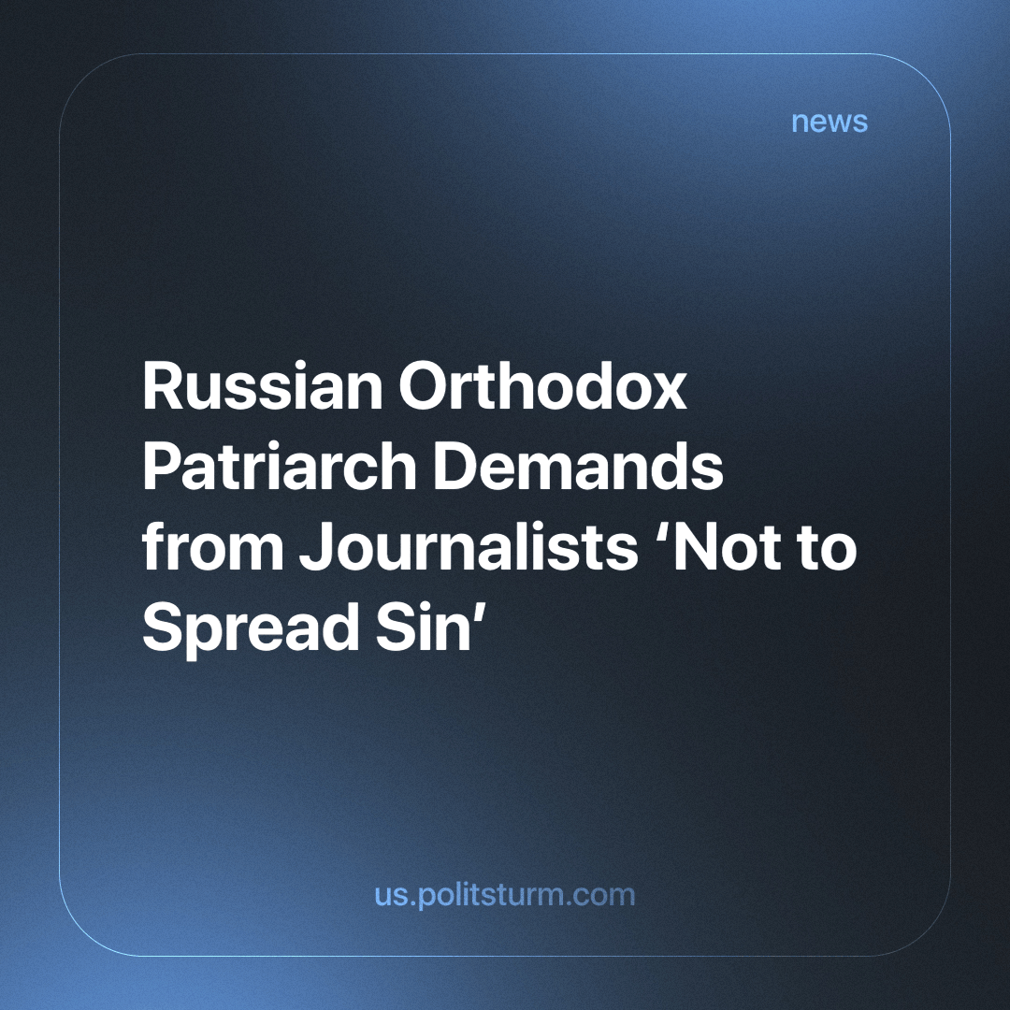

Original article
2024-02-20
1 min read

Patriarch of Moscow and All Rus' Kirill instructed journalists not to “spread sins.”
On January 18, the head of the Russian Orthodox Church, Patriarch Kirill, performed the rite of the great consecration of water after the divine liturgy at the Transfiguration Church in the Cathedral of Christ the Savior in the capital for Epiphany. While speaking about the power of holy water, the patriarch emphasized that it allows us to feel the touch of divine grace.
Surprisingly, 'the touch of divine grace on us' could not solve the huge number of public and social problems, crises, and poverty. Through practice, we can prove what works and what doesn't. Despite centuries of practicing holy rituals, we can see clearly that rituals and holy water will bring no peace to the working class.
Religion has historically been a tool utilised by the ruling classes and the bourgeoisie, currently sharpened with huge funding and 'benefits,' such as tax breaks. Religious institutions use this funding to dull our thinking and introduce ideas convenient to ruling class dominance, making oppression seem natural and temporary, while telling us that a better life comes only after death.
The only way to eliminate contradictions and crises will be the elimination of the market system, which has lost its progressive role and which can only collapse under the blows of crises, claiming human lives.
From practice we know, that only through the formation of a socialist society can we overcome the crises and contradictions within the capitalist system, which has nothing progressive left to offer, only death and misery.
Source: BUSINESS Online - “Patriarch Kirill sprinkled journalists with holy water: “So as not to spread sin” from January 18, 2024

Original article

