Russian Oligarchs are Losing Their Fortunes
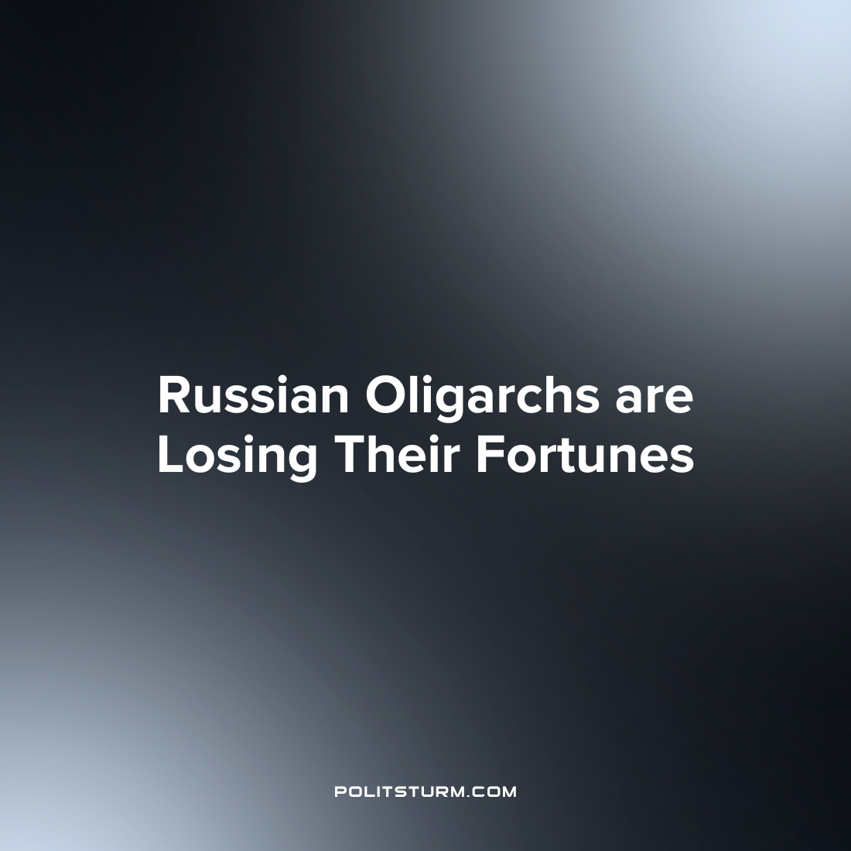

Original article
2022-06-08
1 min read

Russia’s richest entrepreneurs have lost $41.48 billion since the beginning of the year, according to data from the Bloomberg Billionaires Index (BBI) rating.
Gennady Timchenko, the co-owner of Novatek and Sibur, lost the most, whose fortune decreased by almost $7.06 billion. The fortune of the co—owner of Novatek Leonid Mikhelson, who ranks second in the rating, has significantly decreased by $6.65 billion, to $25.8 billion. NLMK beneficiary Vladimir Lisin, who ranks third, has been impoverished by $4.05 billion since the beginning of the year (the fortune is estimated at $24 billion).
The index is calculated based on the value of the shares of companies in which billionaires own shares. For some companies, the calculation is based on the ratio of their capitalization to EBITDA or the share price to earnings per share. In total, the BBI rating includes the 500 richest people in the world, and it now includes 25 citizens of the Russian Federation.
Despite the loss of profits, the bourgeoisie still has huge funds looted from the workers and will want to restore its wealth by worsening living conditions for the workers, as well as raising the prices of essential goods. In the end, all this will affect the welfare of the working class, because at its expense the oligarchs will return what they have lost.

Original article

