Russian Oil Exports to India Reach Nine-Month High
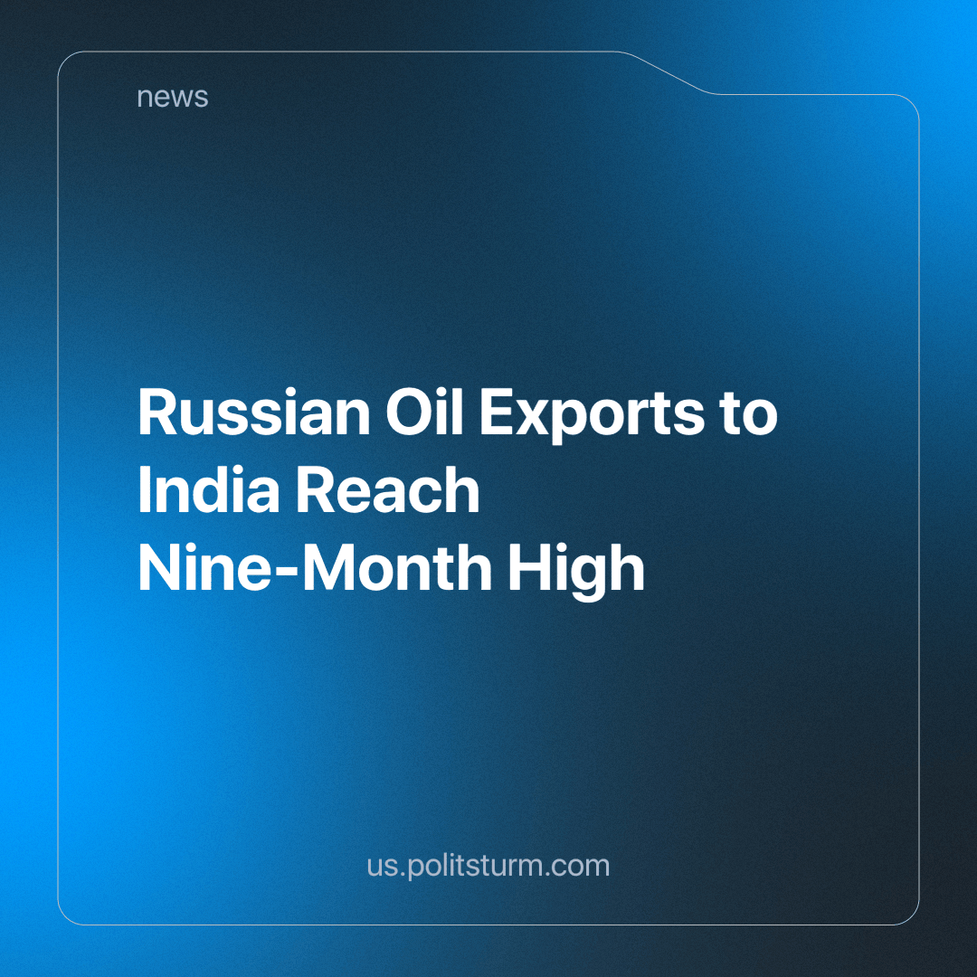

Original article
2024-06-07
1 min read

Russian oil exports to India have surged by 19%, reaching a new peak of 1.96 million barrels per day. This record figure shows increased resource consumption despite global challenges and strict restrictions imposed by the US and G7 countries. This growth has been driven by heightened demand and decreased industrial refining capacity.
According to media reports, recent Ukrainian strikes on Russia's oil refining infrastructure have led to a lack of domestic crude oil processing capacity. Consequently, Russian entrepreneurs have increased maritime crude oil exports to 3.8 million barrels per day in total, of which India's total imports account for 40.3% of their total of 4.86 million from Russia.
Despite restrictions and sanctions, as well as the escalating economic crisis in the global economy, businesses continue to seek new opportunities for profit. Meanwhile, the state, which consistently supports them, remains intent in its deafness to the problems and concerns of ordinary people.
The events outlined above demonstrate that economic crises have a minimal impact on the activity and profit margins of oil market monopolies. However, ordinary citizens are left out in the cold. Amid rising inflation and increasing political instability, their situation rapidly deteriorates. Unfortunately, capitalism can offer nothing to the working class - the wealth of corporations is built on the misery and hardship of the working class.
Until socialism is established, there is no hope of stopping such attacks on the average person. Socialism brings with it the end of austerity and a stable growing economy that doesn't serve capitalist profits but instead serves to enrich the lives of the working people.
Source: RBC - "Russian Oil Imports to India Reach Nine-Month High" from May 3, 2024.

Original article

