Russian Mercenaries: How Many, and What They Do?
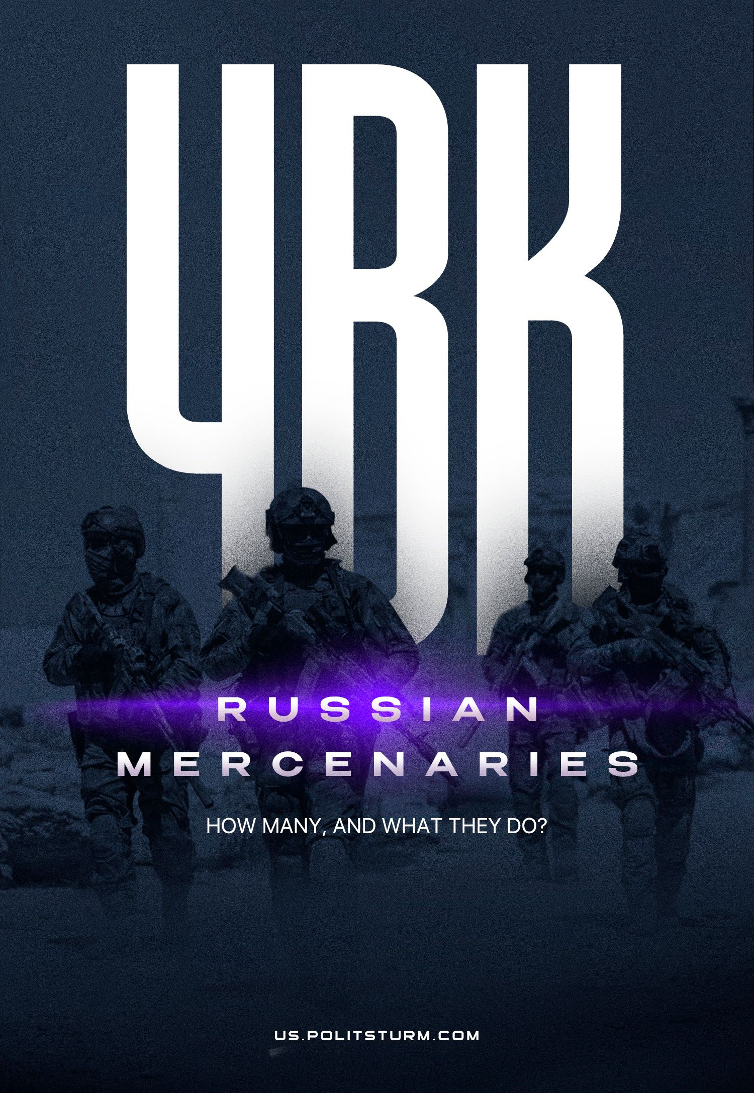

Original article
2023-10-28
42 min read

In Russian, "ЧВК" means PMC – private military company. Mercenaries are prohibited by the UN international convention and the legislation of most countries, including the Russian Federation, but at the same time they have wide application throughout the world. This contradiction is explained quite simply: private armies bring enormous benefits to capital, and therefore it violates its own laws.
What is the role of PMCs for the Russian capital? How many private armies are there in Russia and who owns them? Does it mean that with the death of Prigozhin, Wagner and other PMCs will cease to exist? Read our material.

1. What PMCs Exist In Russia?
On the evening of August 23, it became known about the death of Yevgeny Prigozhin and other leaders of the Wagner PMC. Prigozhin’s political ambitions, loud statements about the successes of his private army on the fronts of the Russia's ‘SMO’, the actions of the Wagner Group in Syria and African countries – and, finally, the armed rebellion of the “musicians” – all these events attracted enormous attention to PMCs and revealed the important economic and political role which private armies play in Russia.
Private military companies perform a wide range of tasks: from direct combat operations to servicing units of the regular army (repair of military equipment, communications, logistics, supply of food to army units, etc.), as well as training of military and police, guarding convoys, sea vessels, mine clearance terrain and objects, etc.
For example, it is known that the US Army used so many “contractors” in its operations in Iraq and Afghanistan that the number of their employees exceeded the contingent of US troops themselves in the regions.
“As of March 2011, the contractor personnel involved in the operation of the US contingents in Afghanistan and Iraq numbered 155 thousand people (more than the number of military personnel of both contingents consisting of 145 thousand people), in 2012-2013 - 250 thousand (50 % of the number of American military contingents). Since December 2009, the number of employees of contractor firms has consistently exceeded the number of military personnel.” [1]
Private military companies often change their names, rebrand, set up front companies, merge with other companies or split into smaller ones, and use thousands of other tricks to hide their activities. This is especially true for Russian PMCs, whose activities are not yet regulated by Russian legislation.
Taking advantage of this, the leadership of PMCs often declares their non-involvement in certain events and their affiliation with PMCs in general. For example, one of the leaders of the Redoubt PMC claims that there are 8 different “Redoubts” that are supposedly unrelated to each other, and the head of RSB-Group Krinitsyn talks about a certain twin company that was engaged in the repair of aircraft in Libya under the name of RSB-Group, because of which Krinitsyn himself undeservedly (according to his version) came under US sanctions.
Knowing these conventions, let us proceed to a specific consideration of PMCs in the Russian Federation.

Wagner group
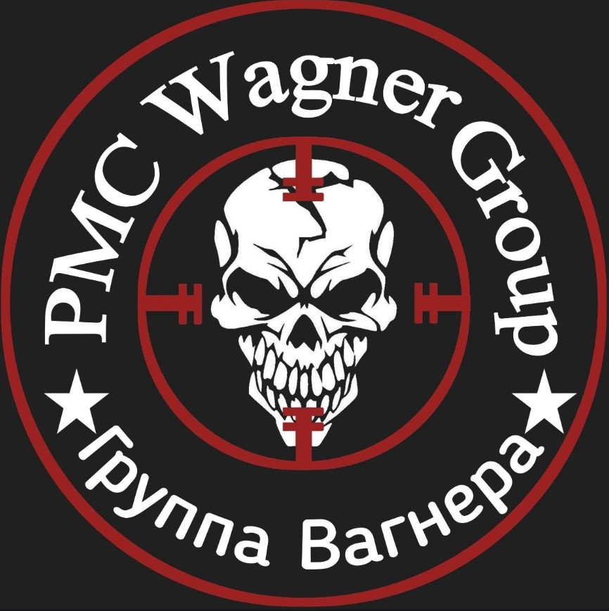
Emblem of the PMC "Wagner Group"
The largest and most active Russian PMC is the Wagner Group. The PMC had not previously been officially registered anywhere; only other companies associated with its director Yevgeny Prigozhin were registered. After the events of June 23–24, the Wagner Group was registered in Belarus as an organization providing educational services.
Wagner was formed in 2013–2014. based on the “Slavic Corps” detachment, which was part of the Slavonic Corps Limited PMC, registered in Hong Kong. It, in turn, is a subsidiary of another PMC - Moran Security Group (still exists today).
The commander of the Wagner PMC was Dmitry Utkin, a former commander of the GRU special forces detachment, with the call sign “Wagner”. After leaving government service in 2013, he began working at the Moran Security Group, where he headed one of the two companies of the “Slavic Corps” formed in the same year. The first use of the Slavic Corps was unsuccessful. When hired, the fighters were promised work guarding warehouses and an oil pipeline in Syria, but instead, 267 mercenaries were used in the combat operation. The units did not have the necessary equipment and were armed with outdated weapons. After this operation, the entire composition of the Slavic Corps was sent to Russia, and two leaders were sentenced to 3 years in prison for mercenarism [6].
Most likely, the operation took place in the interests of the Russian government, since the detachments still had equipment and heavy weapons (albeit without ammunition), and private companies had no direct interest in offensive operations against militants.
Nevertheless, the Russian capital remained in need of armed units that were outwardly unrelated to the government of the Russian Federation, but acted on its instructions. And the fighters of the former “Slavic Corps” were organized into a new structure - “PMC Wagner”.
From the very beginning of its existence, the Wagner Group was used in various areas, including:
— support for the government of Bashar al-Assad in Syria since 2014 - here PMCs are used for ground operations, providing assistance to the Syrian army;
— participation in the conflict in Ukraine since 2014 against the armed forces of Ukraine.
Next, the Wagner Group's focus shifts to Africa, where PMCs are present in many countries. In all these military conflicts, the official authorities denied the participation of PMCs until recently. Before the military mutiny, Wagner PMC units were actively used in the Northern Military District.
During Russia's ‘Special Military Operation’, the staff of PMC Wagner began to grow sharply. PMCs are recruiting a large number of prisoners, and the standards for selecting candidates for mercenaries are being lowered. At the moment, this private army consists of tens of thousands of fighters. The private army uses heavy weapons, armored vehicles, aviation, artillery, etc. The main source of all this equipment, weapons and ammunition is the Ministry of Defense of the Russian Federation. The strength of this private army is comparable to that of a small country.
The Wagner Group is closely associated with the name of billionaire Yevgeny Prigozhin, who was its owner and leader. Prigozhin, in turn, was connected with companies making profits in the territories seized by PMCs by pumping out natural resources, which was confirmed by the President of the Russian Federation.
Thus, the Europolis company, associated with Prigozhin, entered into a contract with the Syrian government to develop the country’s oil and gas fields in exchange for their liberation from militants. In 2020, the profit of Europolis amounted to $90 million. Another Prigozhin company, Mercury, also operating in the oil and gas sector of Syria, received $67 million in profit in 3 years.
The President of the Russian Federation also confirmed that Prigozhin was involved in mineral resources in Africa:
“I dealt with oil, gas, precious metals and stones there.” [10]
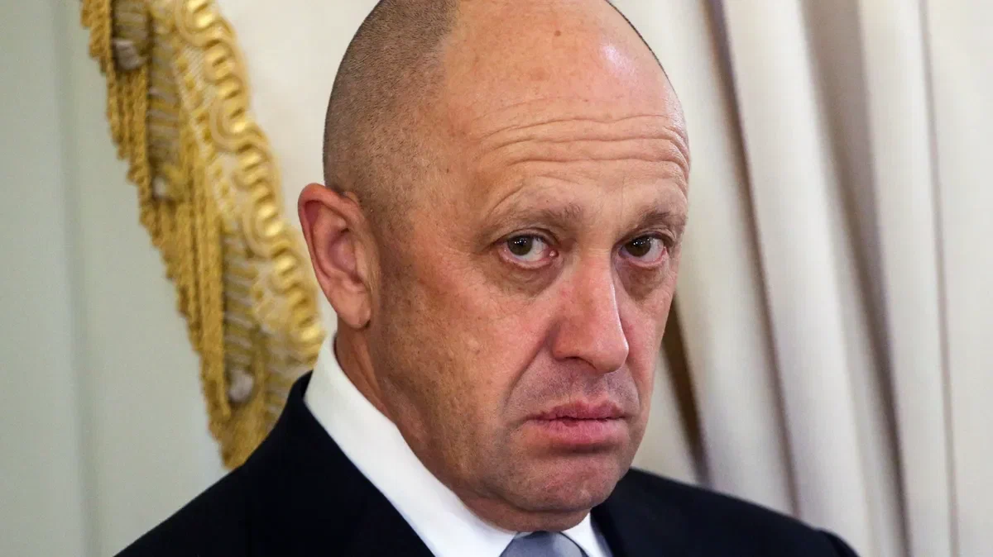
Evgeny Prigozhin
However, the main profit of Prigozhin’s company came from government orders. Despite open political ambitions and even an attempted armed uprising, Prigozhin was firmly woven into the structure of Russian capital.
Thus, in the first month after the rebellion, companies associated with Prigozhin received government contracts worth 2 billion rubles. Moreover, the President of the Russian Federation openly admitted that PMCs are financed from the budget of the Russian Federation, and in the last year alone the private army received 86 billion rubles, and Prigozhin’s Concord group of companies received 80 billion rubles in government orders for the supply of food products to various government agencies during the same period. institutions. In total, the PMC received 858 billion rubles from the budget, and Concord received 845 billion.
It is ironic that information about state funding for Prigozhin’s companies was disclosed only after the rebellion. Before this, Prigozhin claimed that he took all the money “out of his own pocket,” which contributed well to his image of a “people’s hero” who supposedly had nothing to do with the authorities.
Prigozhin’s firms received contracts worth tens of billions of rubles for construction, repairs, maintenance, and cleaning of military camps and military units. Naturally, this did not happen without violating antimonopoly laws: Prigozhin organized fictitious companies to win tenders, and also entered into cartel agreements. However, the Federal Antimonopoly Service, which discovered the cartel conspiracy, refused to initiate an administrative case and released Prigozhin’s companies from the fine.
Thus, Prigozhin’s structures were a classic PMC, engaged in both combat operations and servicing army units.
Among other things, Prigozhin owned large media companies united in “Fabrika Media”, and later in the “Patriot” holding. The holding, closed in July 2023, was engaged in promoting a “patriotic” agenda to the masses, discrediting the opposition, etc. Before the closure, General Director Evgeny Zubarev assessed the scale of the holding as follows:
“The total traffic of the media group is now 300 million unique visitors per day. This is the largest media group in the country"
Prigozhin also ran the “Internet Research Agency”, known as the “Troll Factory”. The workers of this factory were engaged in writing comments online, organizing a network of Telegram channels, campaigns to denigrate objectionable opposition politicians, etc. manipulative activities. A separate item of Prigozhin’s expenses is the bribery of both “patriotic” and “opposition”-minded bloggers, military correspondents, and public figures. Thus, Yuri Podolyaka, Maxim Fomin (Vladlen Tatarsky), Mikhail Zvinchuk (Rybar), Boris Rozhin (ColonnelCassad), Daria Dugina and others worked directly in Prigozhin’s companies or received money through them.
Prigozhin’s structures were very ramified. This oligarch possessed powerful instruments of both military and political violence; his income was associated both with government orders within the Russian Federation and with the exploitation of mineral resources in other countries. As a politician, Prigozhin had a certain weight both in the Russian Federation and abroad. The activities of the Wagner Group and Prigozhin were closely connected with the interests of Russian capital.
The revolt of the Wagner Group in this regard can be considered, among other things, as a political move by Prigozhin in order to take a more advantageous place in the structure of the ruling group of the ruling class. Judging by how quickly and practically without consequences for Prigozhin and Wagner as a whole the rebellion ended, both opposing sides, in principle, were not irreconcilable opponents and were able to easily come to an agreement.
However, Prigozhin and the top of the PMC in the person of commander Dmitry Utkin and Valery Chekalov, who was responsible for logistics and support for the Wagner Group, were eliminated as a result of a plane crash on August 23. Most likely, the contradictions within the ruling class, one of the groups of which Prigozhin represented, reached a new level, and the ruling group nevertheless decided to get rid of its main political competitor.
Prigozhin’s structures and his private army were part and parcel of the Russian capital, acted exclusively in the interests of this capital, and were mostly financed by the state. Despite all the odious actions of Prigozhin, the real owner of PMC Wagner was the state. Without the state, mercenaries would quickly be left without a training base, equipment, fuel, weapons, ammunition, supplies, etc. But the most important thing is that without the state, mercenaries would be left without the money for which they became mercenaries.
After the destruction of the top of the Wagner PMC, different options for the future fate of the organization itself are possible: transformation under the control of a new commander more loyal to the authorities; complete subordination of the PMC to the Ministry of Defense or, ultimately, the dissolution of this PMC and the infusion of former Wagner Group fighters into other private armies. However, no matter which option is implemented, one thing is clear: the state will not refuse such a convenient tool as a private army.

RSB-Group
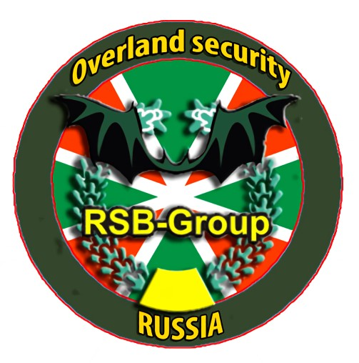
The company was founded in 2005 and registered in Moscow. The RSB-Group website talks about the following services provided by the company: maritime operations, land operations, security and escort of convoys, competitive intelligence, military consulting (military training), etc. According to the head of the company Oleg Krinitsyn, the PMC employs up to 2 thousand .fighters.
Oleg Krinitsyn, a former border guard officer, speaks negatively about the Wagner PMC, which, in his opinion, spoils the image of mercenaries. Unlike the eccentric Prigozhin, the head of RSB-Group is trying to create an image of a law-abiding, exemplary company of mercenaries, abandoning even the very name “PMC”:
We are not officially called PMCs, so as not to disturb the public, and have chosen a neutral wording - “a private military consulting company.”
At the same time, it is also stated that RSB-Group is not involved in hostilities. However, in reality, under the words of “raising its image,” RSB-Group acts as a typical example of mercenaries.
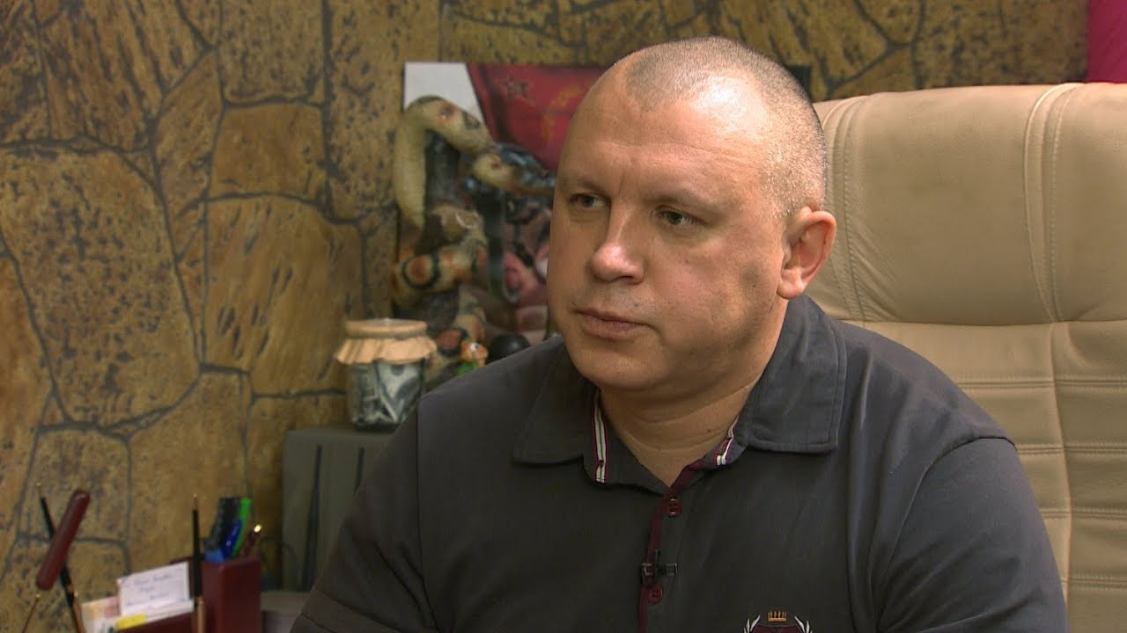
Oleg Krinitsyn
For example, in 2020, the company provided security for the Libyan embassy in Minsk. There is a civil war in Libya, and the country is represented by two governments: the Government of National Accord (GNA) of Fayez al-Sarraj, and the government of Field Marshal Haftar, who heads the Libyan National Army (LNA).
The Libyan embassy in Minsk, guarded until October 2020 by RSB-Group employees, represents only the Haftar government. The mercenaries even repelled an attack on the embassy organized by Faiz al-Sarraj's allies. But already in December 2020, according to some sources, they themselves organized a raid on the embassy, already in favor of those very people supporting Sarraj.
The words of Krinitsyn, who cares about the image of mercenaries, refute his own actions as an exemplary mercenary. The story deserves special mention when RSB-Group was caught using photographs of foreign mercenaries passing off as their own.
Another well-known operation carried out by RSB-Group is the demining of a cement plant in Libya. It is also known that Krinitsyn was included in the US sanctions list for repairing military aircraft of Haftar’s army in Libya. However, Krinitsyn himself claims that he had nothing to do with it: there were scammers working in Libya who took the name “RSB-Group”.
This PMC is a more or less independent commercial organization, the scope of which is determined precisely by the commercial interests of its private owners, and not by the state policy of the Russian Federation. At least, such an appearance is being created, but it is possible that Krinitsyn is also carrying out orders from the state.
RSB-Group differs significantly from Wagner Group in terms of numbers, weapons and the nature of its missions. The market for mercenary services is so wide that there is a fairly developed division of labor among PMCs.

PMC Redoubt
Formed in 2008 by the merger of several groups of Russian special forces veterans. The leaders are Konstantin Mirzayants (former military man, businessman) and Sergey Salivanov (former military man).
The PMC is financed by oligarch Oleg Deripaska, who purchased equipment and equipment for the unit. The PMC includes up to 7 thousand fighters. Before the special military operation, the organization operated abroad. For example, in Syria, this PMC protected a large gas processing plant (design capacity of 1.3 billion cubic meters of purified gas) and phosphate mines (the profit from which could amount to $200 per year). Both enterprises belong to the oligarch Timchenko.
Now Redoubt units are actively used during Russia's ‘Special Military Operation’.
Despite the fact that “Redut” is at the expense of the Russian Ministry of Defense, the oligarch Deripaska, who previously spoke negatively about Russia's ‘Special Military Operation’, nevertheless pays certain sums to the salaries of PMC members. Truly, the words of the owners of capital are contrary to their deeds.
The first Redoubt units were created on the basis of former fighters of the Wagner PMC. Now this structure is a definite replacement for the Wagner Group on the fronts of the Northern Military District: streams of volunteers are pouring into it, and other, smaller PMCs are joining it. Probably, after the death of the leadership of the Wagner Group, we can expect a strengthening of the Redoubt PMC and other private armies.

PMCs "Potok" and "Fakel"
Both of these companies are financed by the Gazprom corporation. The personnel are also represented by Gazprom employees. “Fakel” recruits volunteers, including those from outside the corporation.
Both PMCs have the status of volunteer battalions. There are few personnel in these companies, so they do not fight as separate formations, but are attached to the larger Redut PMC.

PMC "Ural"
Following the example of Gazprom, other corporations are also collecting their own PMCs. Thus, the Ural battalion is financed by the oligarch Altushkin, the owner of the “Russian Copper Company” (RMK). The division was created in 2022.
Altushkin has the image of an “Orthodox oligarch”: he regularly builds churches and gives expensive gifts to the Russian Orthodox Church. Russia's ‘Special Military Operation’. gave him the opportunity to create his own armed detachment. Previously, Altushkin had to use only the services of hand-to-hand combat masters: activists who opposed the construction of a temple on the site of a park in Yekaterinburg were dispersed by fighters from the RMK Martial Arts Academy. The oligarch also has his own shooting club, Archangel Michael.
Vladimir Solovyov advertised the “Ural” in his program and stated that all military equipment for the battalion was supplied exclusively at the expense of entrepreneurs. The story with PMC Wagner has already shown how much you can trust this information.

PMC "Convoy"
Created in 2022 as one of the units subordinate to the head of Crimea Sergei Aksenov. Like many other similar organizations, it is funded by the state and oligarchs. So, in a month and a half, the company received 437.5 million rubles through various charitable foundations, of which: 200 million from VTB Bank and 120 million from a company owned by the oligarch Rotenberg.
The head of the PMC is Konstantin Pikalov, a former private security guard, who has experience working for the Wagner PMC. The backbone of the organization also consisted of fighters from Wagner. The organization has several hundred fighters.
Aksenov also organized other combat units: the “Tavrida”, “Livadia” battalions, etc. Cossack volunteers gather in these detachments, they preach the ideology of the Cossacks, glorify imperial times, etc. Even the name “Convoy” was taken in honor a special formation of the royal army that guarded the king: “His Imperial Majesty’s Own Convoy.”

Other formations
In addition to private military companies, many other units were formed in Russia during the Northern Military District. Formally, they are not PMCs, but given the role and nature of PMCs themselves in the Russian Federation as private armies and paramilitary forces in the service of the elite, they are not much different from them.
These include “registered” battalions: PMC Aksenov, “Akhmaty” Kadyrov: West, East, North, South; regional battalions (about 50 units in total) and various other voluntary formations, like the DSRG “Rusich”, “Somali”, etc.
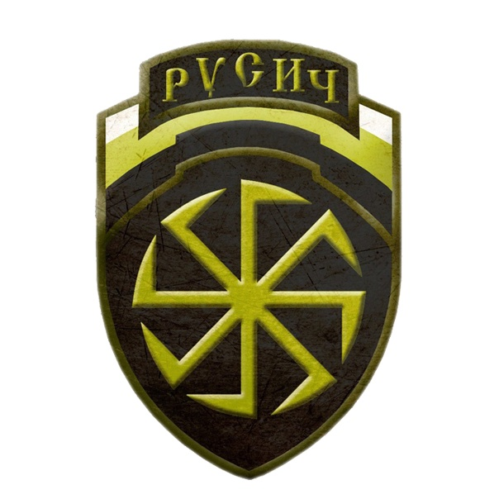
Emblem of DSHRG "Rusich"
The status of these volunteer units is not entirely clear. Many of them have Army Combat Reserve (BARS) status. In total, about 20 BARS were created and each has its own number and name.
All fighters of BARS and volunteer battalions have signed contracts with the Ministry of Defense, but often receive additional payments from their owners or from regional budgets. In case of controversial issues, unit fighters turn to the heads of regions or their “owners” for help, and not to the Ministry of Defense. It is also difficult to estimate the total number of such units. In total they include tens of thousands of fighters.
Of course, there are many PMCs operating in Russia, in addition to those listed above. However, to analyze the activities of these organizations, those already listed are sufficient, since they represent almost the entire spectrum of mercenaries.

2. What Role Do PMCs Play In Politics?

PMC Wagner in Africa
PMC Wagner is an instrument of Russian imperialism. At the moment, this tool is most actively used on the African continent. Let's take a closer look at the activities of the Wagner Group in African countries.

Sudan
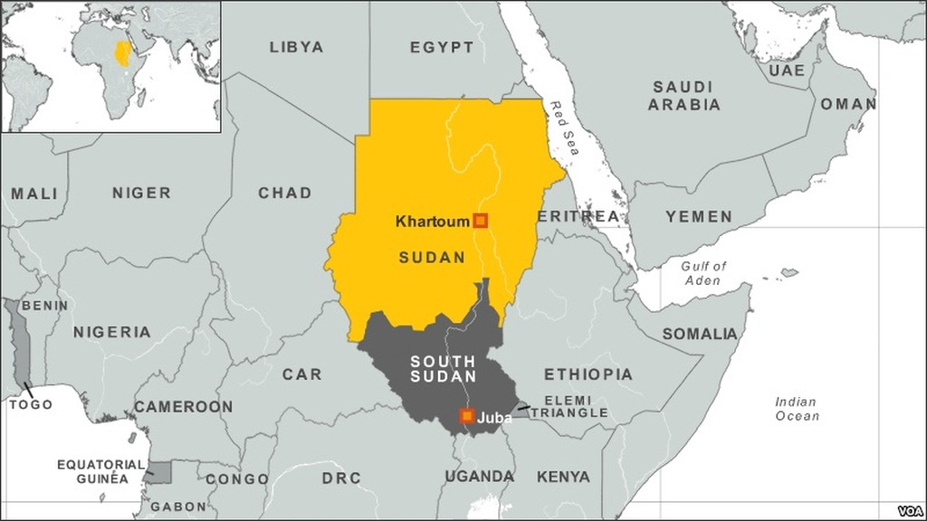
Prigozhin received two Sudanese government awards. There are companies associated with Prigozhin in this country. “M Invest”, which mines gold in Sudan under a concession agreement, received $2.6 million in revenue for 2021; the revenue of two unnamed companies in the Central African Republic and Sudan for the same year amounted to $6 million. Due to gold smuggling, the main profits from gold mining will remain unknown to us.
PMC Wagner has been present in the country since 2017. In 2018, “M Invest” sent a group of geologists to the country to study gold mining sites, while PMC forces protected the company’s facilities. In April 2023, a military rebellion and clashes began in Sudan between the Sudan Armed Forces (SAF) and the Rapid Reaction Force (RRF). According to Prigozhin’s recent statement, PMC fighters are not present in Sudan now, and the gold mining sites are abandoned. Mentions of the Wagner Group in connection with events in Sudan are so frequent that Prigozhin’s press service issued an official letter denying Wagner’s assistance to any of the parties.
To believe this gentleman or not, who has already repeatedly refuted his own statements, is a rhetorical question.
Among other things, Prigozhin sent an open letter in which he offered himself as a mediator for an agreement between the parties and announced his desire to send humanitarian aid to the country “at his own expense.”
For the Russian government, Sudan is of interest primarily as a base of influence on the Red Sea. A Russian naval base is being built on Sudanese territory near the city of Port Sudan. In May of this year, the Sudanese Ambassador confirmed the agreement on the construction of the base, despite the political instability in the country. The base can serve as a “gateway” to Africa for the Russian Federation, and will also provide an opportunity to carry out maintenance and rotate the crew of ships without a long voyage to the shores of the Russian Federation.
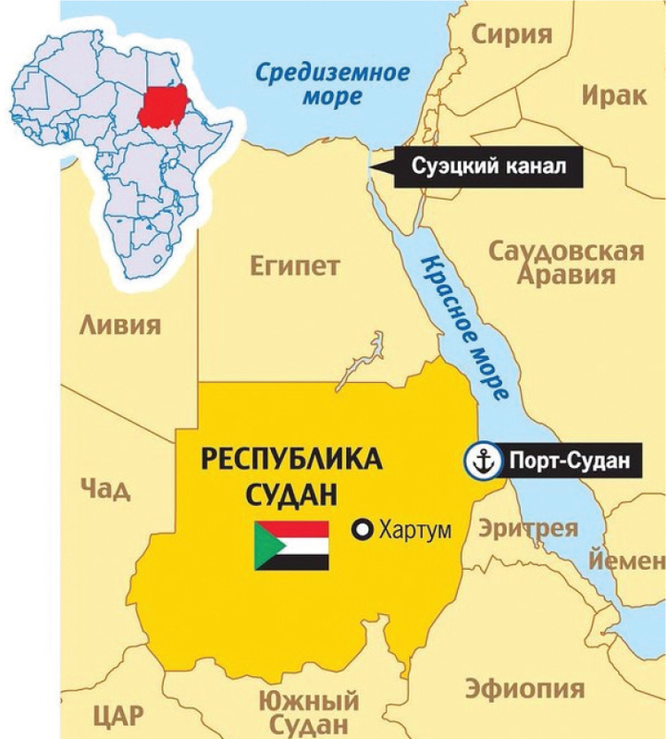
There are also known plans for the joint construction of an oil refinery in the city of Port Sudan by the Russian Federation and Sudan, however, due to internal conflicts in the country, the status of this project is not clear.

Central African Republic
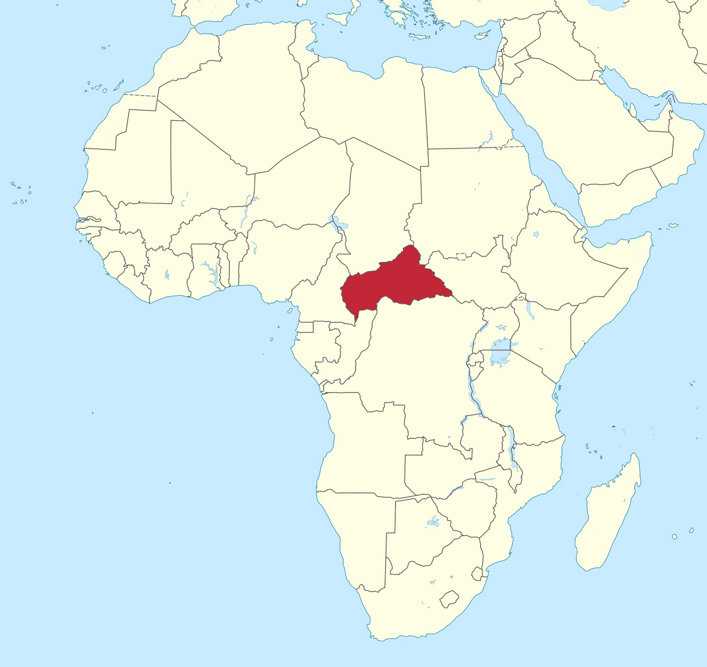
The CAR, like Sudan, is one of the main activities of the Wagner group, which has been present in the country since 2018. Prigozhin and his PMCs had close contacts with the government of the CAR. Thus, Prigozhin had four government awards of the republic, met with officials of the Central African Republic, and the Wagner Group trains the armed forces and police of the republic. As in Sudan, PMCs in the CAR operate in full accordance with the policies of the Russian Federation. Russia is actively supplying the country with weapons and sending instructors:
To begin with, Russia supplied the CAR army with 900 Makarov pistols, 5,200 machine guns and 840 Kalashnikov machine guns, 140 sniper rifles, 270 hand-held anti-tank grenade launchers and 20 MANPADS, as well as ammunition for them. Next, 175 military instructors went to the country. According to the Russian Foreign Ministry, only 5 of them were career military personnel, the rest were civilians who were supposed to train locals to use Russian weapons.
There are currently 1,890 Russian military instructors in the country. Military equipment is also supplied to the CAR.
In the capital of the country, the city of Bangui, a “Russian House” was opened, and the Russian language has recently become a compulsory subject in schools and universities of the republic. A monument to Russian military instructors was erected in the country.
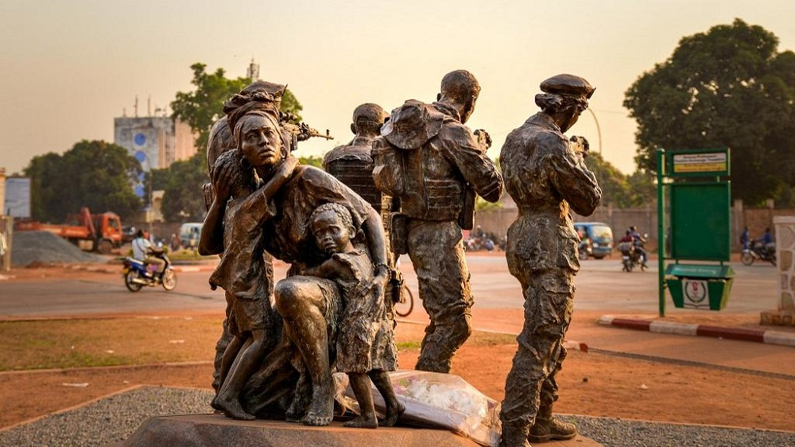
The CAR ambassador expresses the country's desire to establish a Russian military base in the republic.
Officials of the Russian Federation talk about interest in the natural resources of the republic: uranium, gold, diamonds, etc. The Russian Federation and the Central African Republic already have an agreement on the development of local gold mines. The development is carried out by the company Lobaye Invest, established by the already familiar company “M Invest”, owned by Prigozhin. The security of mining enterprises is provided by PMC Wagner. Prigozhin has habitually denied his ties to gold development.
There is no accurate information about the activities of the Wagner group in this country, and journalists who came to the republic to film a documentary about PMCs were killed. A characteristic feature is evidence of the kidnapping and torture of local residents by Wagner fighters - the actions of the mercenaries are not limited to fighting with armed groups and training security forces.
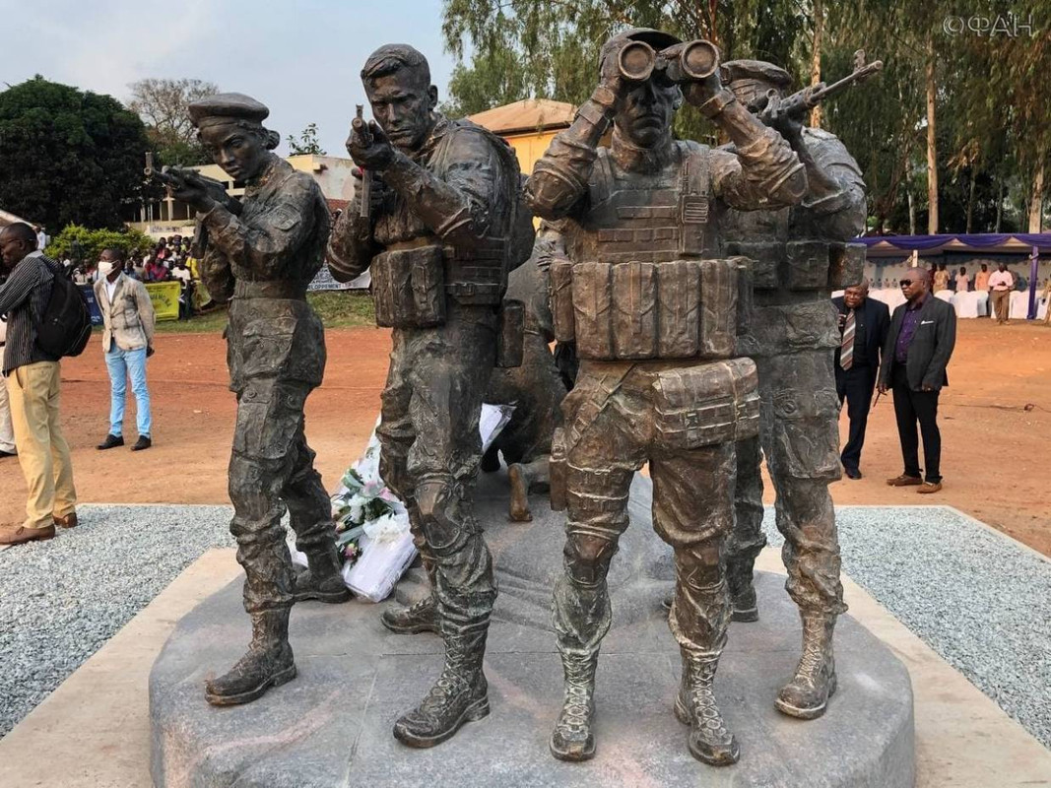

Other countries
PMC Wagner is present or was previously present in many other African countries: Libya, Mali, Burkina Faso, Mauritania, Chad, Mozambique, DRC, Madagascar, Senegal, Niger, Cote d’Ivoire.
These countries have the following common features:
- Many of these countries have experienced recent coups, civil wars, and many are still in a state of political instability (which, in principle, is a characteristic feature of most African countries). In all cases, Prigozhin is nearby and, with words about “restoring order,” supports one of the parties to the conflict.
- Rich natural resources. The entry of PMCs into a country is usually accompanied by agreements on concessions and mining in these countries. While Prigozhin and the Russian authorities are talking about the plunder of Africa by Western countries, African countries are beginning to be plundered by Russian capital, naturally, this did not happen without benefit for Prigozhin’s pocket.
- Military support of the Russian Federation. Along with the introduction of PMCs into the country, the Russian government supplies the supported side with equipment, weapons and military advisers. Moreover, the majority of these advisers are “civilian instructors” - read “mercenaries”.
- Turning these countries away from Western influence. Where PMC Wagner managed to gain a foothold, there is a winding down of the military presence of Western countries. The French military has reduced its presence in Mali, the Central African Republic, Burkina Faso, and Niger. Naturally, Russian capital seeks to fill the resulting void.
- Attempts at ideological pressure. African rallies and performances with symbols of the Russian Federation and Wagner PMC are known. Prigozhin also uses ideological tools used in the Russian Federation in African countries, with the aim of whitening the reputation of PMCs and the interests of the Russian Federation, as well as denigrating competitors.
Although the Wagner PMC is a conduit of Russian capital to African countries, and many “patriotically” minded citizens are already rushing to announce Russian expansion on the black continent, about how the PMC is displacing the USA, France and other Western countries from Africa, nevertheless, the successes of domestic capitalists are far behind the successes of the capitalists of the European Union, the USA and China. Chinese goods and investments are the real battering ram driving Western capital out of Africa. The Russian Federation is limited to much more modest successes, associated more with its military presence than with its economic one.
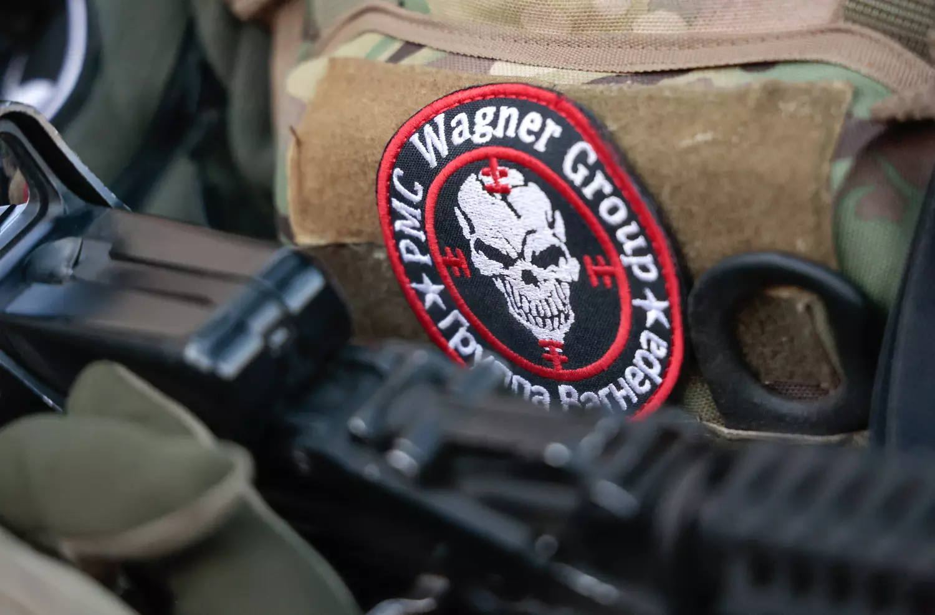
In this regard, the connection between Chinese capital and the Russian military presence in certain African countries is interesting, but proving the presence or absence of this connection is a matter for future research.
It is also worth noting that the successes of PMCs in Africa are due to the fact that mercenaries and the forces they support only encounter local, African armed units, often not related to the regular army. Sooner or later, this situation will change, and PMCs will encounter more serious opposition from the United States and European Union countries. Thus, the White House has already requested $200 million from the US Congress to counter the Wagner PMC in Africa.
Among other things, it is worth noting the difficulty of finding information about the activities of PMCs abroad. The presence of the Wagner Group in a particular country is denied by both the government of that country and the government of the Russian Federation, Prigozhin himself denied everything, until the presence of mercenaries in the country becomes obvious to the whole world.
All of the above clearly refutes the theses of “patriotic” opportunists about the absence of imperialism in the Russian Federation. In addition to the fact that the entire capitalist system is at the stage of imperialism, and Russia is its integral part, arguments about the kindly face of Russian capital, supposedly fighting colonialism in Africa, as well as its weakness in comparison with the capitals of the United States and the People's Republic of China.
Even if the capital of the Russian Federation is weaker than the capital of some other “great powers”, its methods of work do not change because of this: exploitation, pumping out natural resources, violence against local residents. Even from the opportunist point of view, according to which imperialism is determined by a country's foreign policy, Russia is an imperialist.

3. The Role of PMCs in the Internal Politics of the Russian Federation
The rebellion of PMC Wagner revealed the role it played in the state mechanism of the Russian Federation. A private company under the patronage of the state grew to the level of a separate law enforcement agency, the head of which, Prigozhin, could quite openly conflict with the Ministry of Defense.
As is known, the rebellion was caused by the reluctance of the leadership of the Wagner PMC to join the Russian Armed Forces. Prigozhin could not allow PMC fighters to sign contracts with the Russian Defense Ministry for several reasons.
Firstly, this would be the loss of the influence and independence that Prigozhin had - he would become an employee subordinate to the Ministry of Defense, and the flow of public funds for the former PMC, passing through Prigozhin, would probably decrease.
Secondly, signing contracts with the Ministry of Defense means that Prigozhin’s mercenaries (at least most of them) become military personnel of the Russian Armed Forces, and this makes it difficult to use them abroad, which, in turn, seriously undermines Prigozhin’s monopoly as a conductor of interests and Russian capital to Africa, and blocks a significant flow of money from gold and diamond mines going into the pocket of the PMC manager.
Economic and political motives, connected with each other, led to the armed action of the mercenaries. However, not all Russian politicians immediately opposed Prigozhin’s actions. For example, the head of Crimea Aksyonov and the armed groups under his control took a wait-and-see attitude and expressed support for the government only after the speech of the President of the Russian Federation. Such a hesitation by the head of Crimea is not surprising: he previously had close ties with Prigozhin, and the commander of the Konvoy PMC under his control and the backbone of its personnel come from the Wagner PMC.
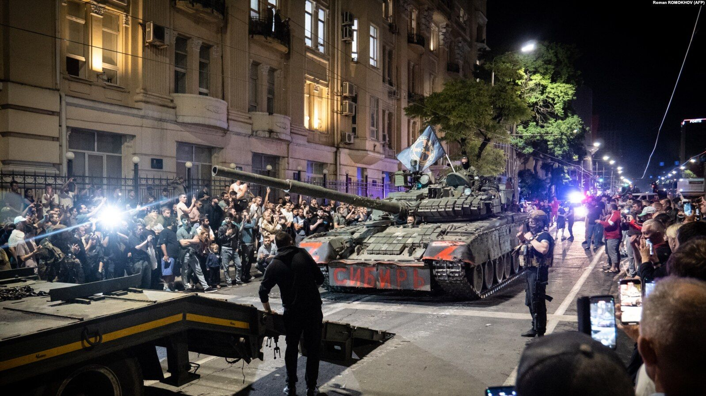
Rebels of the PMC "Wagner Group" in Rostov-on-Don, June 24, 2023
As a result of the rebellion, Prigozhin defended his “African” positions, retained a private army, in which there were even more fighters than before the participation of the Wagner Group in Russia's ‘Special Military Operation’, and his companies continued to receive lucrative government contracts. The “found” funds and property were even returned to the owner of the PMC.
The Department of Defense, in turn, got rid of a very inconvenient ally and its main critic, and also received some influx of people into its ranks. Among other things, the Russian Guard received the right to use heavy weapons and military equipment - that is, the tool for suppressing unrest in the country has become much stronger.
These events once again show that the ruling class is guided exclusively by selfish interests, and even fundamental conflicts are quite possible to resolve with a simple agreement.
In turn, the death of the head of the Wagner Group also shows how capitalists easily violate established agreements for the sake of their interests. Prigozhin’s death eliminates the lion’s share of the reasons why PMC Wagner was in some opposition to the state: now the PMC is not headed by an odious figure with great political ambitions and his own economic interests, and all African connections that previously passed through Prigozhin will now pass through more loyal people representing the dominant faction of the ruling class. What happened is what has been happening throughout the history of capitalism: stronger capital beat and took over the weaker one.
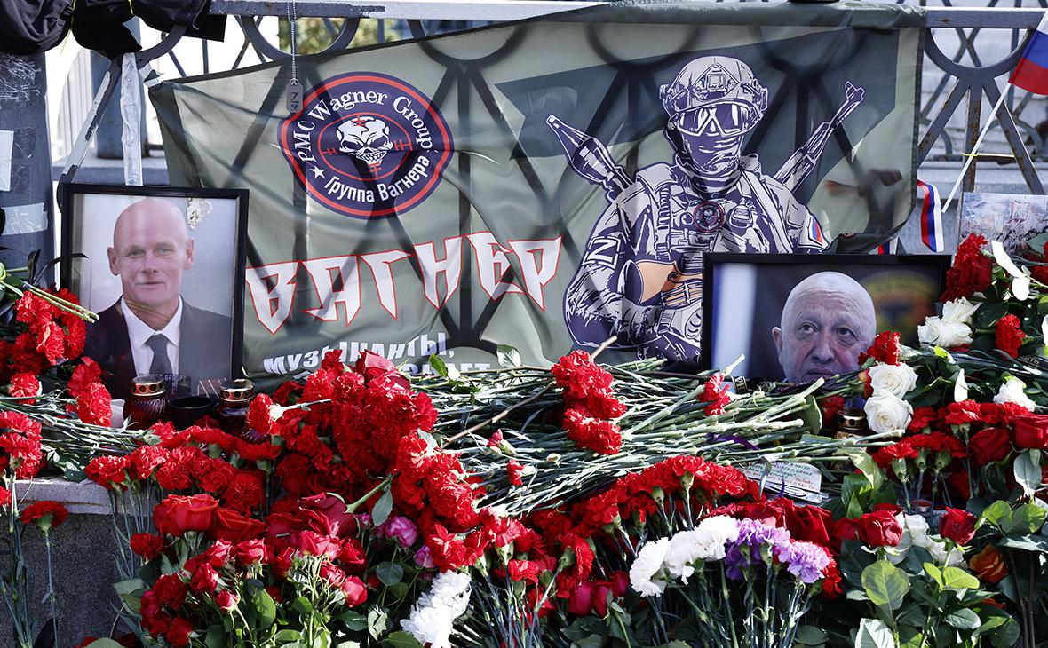
No matter how the Wagner Group itself has changed now, the tools of private armies have already become firmly established in the practice of the Russian state. It is obvious that the role of PMCs in foreign, and over time, in domestic politics, will only increase. Who will lead these PMCs, what slogans will they use, how their structure will change - these are all secondary questions. The main thing here is that the state is, in principle, interested in the use of these private armies.
***
In Russia there are a great many different private military units. All of them can be divided into the following groups:
- State organizations (Wagner, Redut). Such companies are financed from the state budget, but the company's management remains more or less isolated from the official armed forces. PMC status allows the state to use such units abroad without political consequences;
- Commercial companies (“RSB-Group”, “Moran Security Group”, etc.). The main goal of such organizations is to generate profit for their owner. They are not financed from the Russian budget, but they can take government orders, and fighters from such companies rarely participate in direct combat. The main activities of such PMCs: protection of objects and individuals, escort of ships and convoys, etc. Such PMCs, as a rule, do not have heavy weapons;
- Corporate PMCs (Fakel, Potok, Ural, etc.). These companies are owned by large corporations and oligarchs. Accordingly, these units are used for corporate purposes;
- Regional armed groups (“Akhmat”, “Convoy”, etc.). Among them, Crimean and Chechen groups stand out, surpassing other regions in the number of fighters;
- Various volunteer associations united along different lines: football fans of Espanyol, adherents of the Nazi ideology of the DSRG Rusich, etc.
Why do corporations and oligarchs need PMCs? They pursue several goals:
- show your loyalty to the current government;
- protect your employees from mobilization by independently forming volunteer units;
- receive armed and trained troops, which in the future can be used for corporate purposes.
Why are regional armed groups needed? This way, the heads of the regions get small armies at their disposal, and the Ministry of Defense gets the opportunity to delay mobilization, which is negatively perceived by the people due to the influx of volunteers into regional and private detachments.
The events of recent years show that the unity of the people and the ruling class is imaginary. Citizens of the Russian Federation are not ready to voluntarily die en masse for the interests of capital, so the ruling class has to resort to hidden forms of mobilization: the formation of many small detachments of volunteers and private companies with large salaries for fighters (at least in words), conscription of prisoners and migrants . But such formations are not capable of creating any kind of massive army; they are recruited either by adventurers seeking good earnings, as well as by people who have not found themselves in peaceful life and who have nothing to lose, or by naive citizens deceived by bourgeois propaganda.
In addition, there is no unity among the ruling class. At the first opportunity, officials and oligarchs are ready to get at each other’s throats for the sake of redistributing property and power. In the event of a serious internal crisis, all these private armies will be pitted against each other, and if the proletariat shows itself in these events, then all these detachments will unanimously direct their weapons to suppress it.
The moral character of a mercenary will allow him to commit any outrages. Nevertheless, the media and the mercenaries themselves are trying to create a certain pretentious, romantic image of a private army fighter. So, for example, one of the commanders of the PMC Wagner says about his organization:
“PMC “Wagner” is not just a structure that unites people, it is an ideology. Have you heard the story about King Arthur and the Knights of the Round Table? So, all the commanders of the Wagner PMC are knights, and our leader is the Director.”
Nevertheless, the “knightly” appearance did not prevent the former Wagner commander Dmitry Utkin from being a lover of the symbols of Nazi Germany. All the bright images of mercenaries that patriotic bloggers and the media are trying to create are smashed against the harsh reality with a bloody sledgehammer.
If earlier oligarch Altushkin used squads of athletes to disperse the dissatisfied, now he has a much more effective combat squad. If earlier the Nazis, National Bolsheviks, monarchists, fascists and others could only wage an ideological struggle, now they are armed and organized into units. The Cossacks, who previously relied on the whip, now have military weapons. You don’t need to be a rocket scientist to understand where all this armed mass will ultimately be directed.
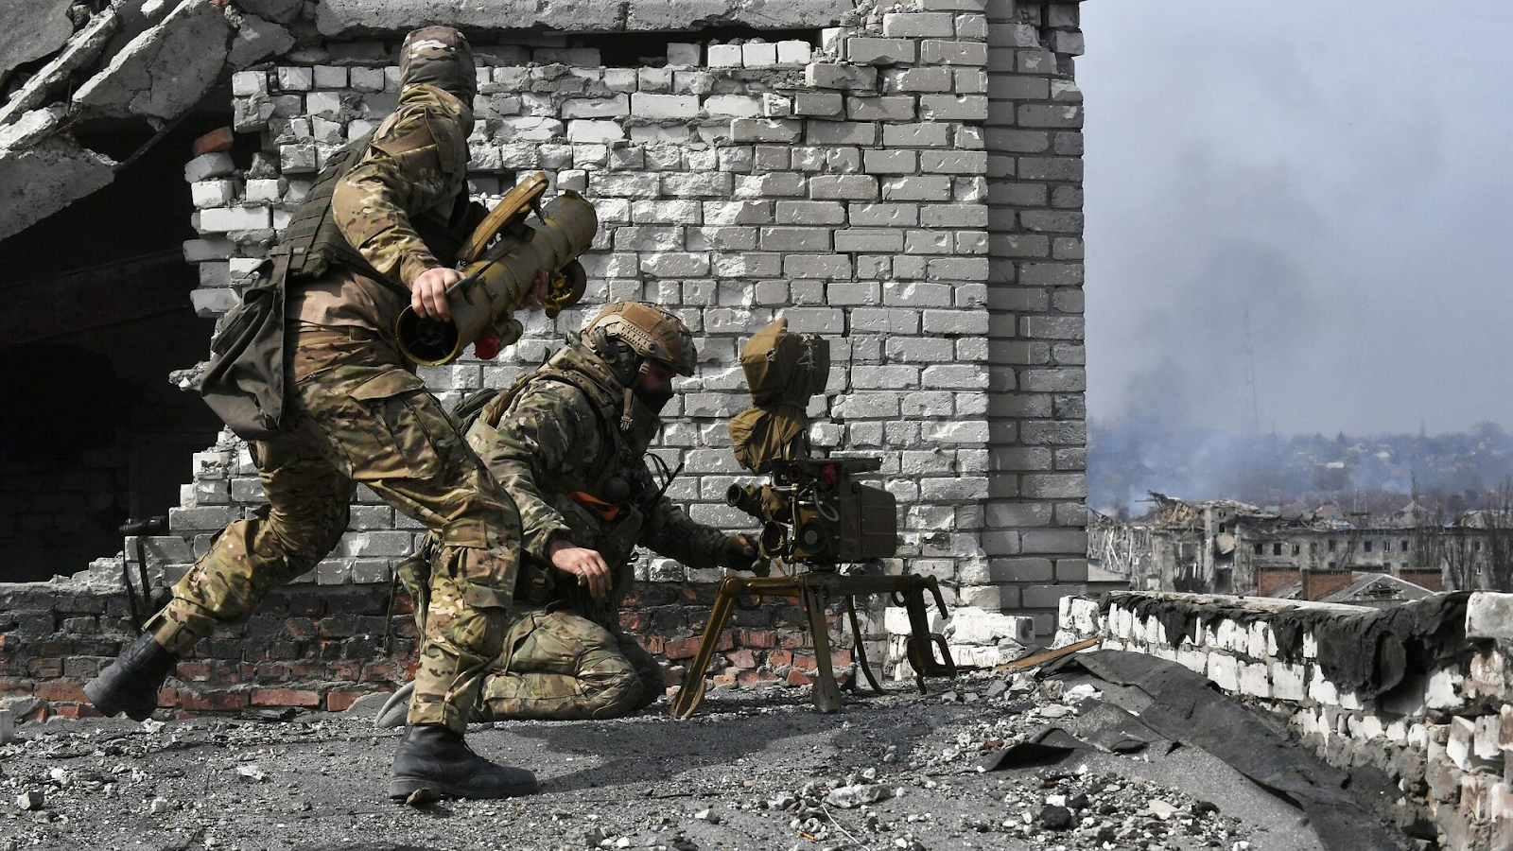
PMCs are an instrument of capital, the cutting edge of which becomes sharper and sharper with every military conflict. Since the main historical enemy of capital is the revolutionary working class, it is only a matter of time before Russian workers are faced with such an unprincipled enemy as mercenaries from private armies.

Conclusion
Let's summarize all of the above:
- At the moment, there is a sharp increase in the number of a wide variety of private armed groups. The structure, management, and interaction of these detachments will still change, but the trend of using such detachments for the state to solve certain problems will continue;
- Most PMCs are woven into the structure of the Ministry of Defense, but are often financed by corporations, oligarchs or regional politicians;
- PMCs are a convenient tool for the ruling class both abroad and within the country. Private armies actively interfere in political processes in different countries, suppressing unwanted forces and even acting against civilians. Sooner or later, PMCs will be used for the same purposes within the Russian Federation;
- Corporate private armies supported by oligarchs (Fakel, Potok, Ural, etc.) are growing, arming themselves and will most likely be used by the oligarchs for their own personal purposes. Thus, Gazprom already has a number of armed units, which over time can grow into the strongest corporate army in Russia;
- The presence of private armies demonstrates the intensification of conflicts within the ruling class; it is expected that they will play the role of an instrument in the redistribution of capital, property and power.

Sources
- Data from the site Pentagonus.ru — Bashkirov N. “Experience of using private military companies during military conflicts in Iraq and Afghanistan (2013)”
- YouTube channel "Gulagu-net Official Channel" * — Reduta leak: revelations of Colonel Sergei "Saleh" Salivanov about the connection between PMCs, Airborne Forces and oligarch Deripaska
- YouTube channel "Gulagu-net Official Channel"* — Secret unit of the GRU "PMC Redut" consisting of the 45th Special Operations Brigade of the Ministry of Defense of the Russian Federation, finances of Oleg Deripaska
- YouTube channel “RTVI News” — PMCs: what are they, why are they needed, who hires them, will they be legalized in Russia and what will happen to Wagner
- RIA Novosti — “Wagner” in Belarus was registered as an educational services center from 08/16/2023
- RBC - Ghosts of war: how the Russian private army appeared in Syria from 08/25/2016
- RBC — African enclave of PMCs What are the prospects for foreign missions of the Wagner group from 06.28.2023
- Telegram channel “Unloading Wagner” — Member of the Council of Commanders of PMC Wagner, Chief of Staff of MARKS... from 07.20.2023
- Online publication “New Izvestia on-line” — He will not die of hunger: what the head of the PMC Evgeny Prigozhin owns from 07/27/2023
- RBC — What Putin said about Prigozhin’s plane crash. Video from 28/24/2023
- RBC — Putin named budget expenses for the maintenance of PMC "Wagner" from July 27, 2023
- News agency Avia.pro — Companies associated with Prigozhin, in the month following the attempted rebellion, entered into government contracts worth at least 2 billion rubles from 08/03/2023
- Telegram channel “BILD in Russian” — PMC “Wagner” received more than 858 billion rubles within the framework of government contracts, and the Concord holding received 845 billion rubles from 07/02/2023
- Rambler News — Prigozhin told who finances the Wagner PMC from 21/26/2023
- “Dossier” — Government contracts of the Ministry of Defense Maintenance of military units and military camps
- Data from the FAS website fas.gov.ru (web archive) — FAS Russia stopped a cartel conspiracy at the Ministry of Defense auction from May 22, 2017
- Database of FAS decisions br.fas.gov.ru — Ruling No. 22/77547/17 Ruling on refusal to initiate administrative proceedings... from November 8, 2017
- Before closing, RBC — FAN told the story of the “media factory” from 07/01/2023
- “Dossier” — Prigozhin’s Cyber Troops How the IT infrastructure of “Wagner”, “Troll Factory” and “Concord” is structured from 03/18/2023
- Data from the RSB-Group website rsb-group.ru
- Komsomolskaya Pravda — How a Komsomolskaya Pravda correspondent got a job in a private military company from November 14, 2018
- Vesiskitim online publication — “Executions with a sledgehammer are banditry” The head of RSB-Group, Oleg Krinitsyn, on the work of PMCs: how does the company differ from mercenaries, from whom does it receive weapons - what will happen to Wagner? from 07/20/2023
- Online publication RT —“We will raise the image of the country”: the founder of the first Russian private military company gave an interview to RT from January 25, 2018
- Telegram channel Abbas Djuma — On the night from Saturday to Sunday at 2:30, the Libyan Embassy in Minsk was again stormed from 12.22.2020
- News site News2.ru — Reputation games: how RSB-Group imitates the activities of PMCs from December 22, 2017
- RBC — The Libyan army explained the invitation of the Russian PMC from March 25, 2017
- Researchgate — Russian Use of Private Military and Security Companies-the implications for European and Norwegian Security FFI-RAPPORT from 10.2018
- Blue News— Die Spur einer Söldnerbande führt auch in die Schweiz from 01/30/2023
- RBC — Timchenko's company will mine phosphates in Syria with the support of PMC from June 27, 2017
- Soldat.pro — Gennady Timchenko’s company will conduct business in Syria under the protection of a Russian PMC
- IA "ANTIFASCHIST" — Deripaska on the conduct of the Russia’s ‘Special Military Operation’: “the destruction of Ukraine would be a colossal mistake” from 06/29/22
- The Bell* — FT learned details about the Gazprom-sponsored PMCs Potok and Fakel from 06/02/2023
- The Moscow Times — Ural billionaire Altushkin, who escaped sanctions, finances the assault battalion of the Ministry of Defense from 08/13/2023
- Newsland — Who were the athletic men who, instead of the police, dispersed the townspeople in Yekaterinburg from 05/14/2019
- Group VK "SOLOVYOV LIVE" — The Urals are superbly prepared - they will bring peace to Ukraine from 12/07/2022
- “Dossier” — Cossacks, elf and Arkady Rotenberg How the PMC “Convoy” is structured and who finances it from 08/14/2023
- Fontanka.Ru — Benefit, honor and glory of Evgeny Prigozhin. We look at the orders of the rebellious founder of the Wagner PMC from 07/06/2023
- RBC — FT assessed Prigozhin’s income from companies in Africa and the Middle East from 02/21/2023
- RBC — In Sudan, a Russian was accused of smuggling gold “associated with PMCs” from 04/12/2023
- Telegram channel “Prigozhina’s Cap” — We are publishing a request from the editors of the magazine Jeune Afrique and the answer... from 04/18/2023
- Telegram channel “Prigozhin’s Cap” - Post from 04/21/2023
- TASS — Sudanese transit: why does Russia need a naval base in Africa? from 11/12/2020
- Izvestia — The Ambassador of Sudan confirmed the agreement on the construction of a Russian Navy base from May 12, 2023
- RBC — Sytyy showed a photo of Prigozhin’s meeting with the Ambassador of the Central African Republic in St. Petersburg from 27.27.2023
- Arguments and facts — Why do we need CAR? What Russia is looking for in one of the poorest countries in the world from 12/30/2020
- RIA Novosti — The Ambassador to Bangui spoke about Russian instructors in the CAR from 06/27/2023
- RBC — The Ministry of Defense explained the supply of armored vehicles to the Central African Republic dated December 27, 2020
- RBC — The Ambassador of the Central African Republic announced the country’s desire to host a Russian military base from May 29, 2023
- RBC — What is known about the murder of Russian journalists in the center of Africa from 08/01/2018
- “Dossier” — The murder of journalists was just the beginning How the “Wagnerites” are terrorizing the CAR from 06/18/2023
- RBC — How the coup attempts in West Africa ended. Map from 08/12/2023
- Newsland — Prigozhin finally speaks harshly about what happened in Niger from 08/05/2023
- Overclockers — Activists who took part in protests in support of Niger, Russia and PMC Wagner were arrested in Ghana from 08/14/2023
- RBC — What Russia offers in the global competition for Africa from 07/27/2023
- Rambler News — The White House has asked Congress for $200 million to counter the Wagner PMC in Africa. Rambler reports this. from 08/10/2023
- Kont — Exclusive interview with Lotus: what awaits PMC "Wagner" from 07/07/2023
- “Dossier” — The story of Dmitry Utkin - the man who gave the Wagner group its name from 04/10/2023
*The creator of materials on the resource “Gulagu.net” Vladimir Osechkin and the publication “The Bell” are recognized as foreign agents in Russia.

Original article

