Russian EMERCOM: Increase in Child Mortality from Fires
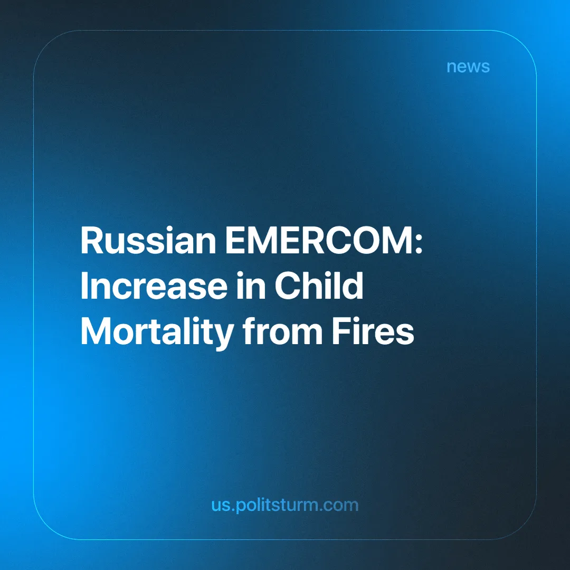

Original article
2025-05-26
5 min read

"Unfortunately, there is a noted rise in the number of children who have died. The overwhelming majority of these incidents occur in residential fires,” said the head of Russia’s Ministry of Emergency Situations (EMERCOM) [1].
On its official website, EMERCOM states that the ministry consistently places special emphasis on child safety [2]. For example, the Minister of the Russian Federation for Civil Defense, Emergencies, and Elimination of Consequences of Natural Disasters, Alexander Kurenkov, believes it is necessary to “get the message through to every adult,” since if an adult is “nearby, no misfortune will happen.” But are there causes of fires that cannot be resolved simply by having adults present?
According to EMERCOM data [3], the main causes of fires are linked to violations of the rules governing the use of electrical appliances, such as leaving them unattended. Only one item refers specifically to faulty electrical wiring. This creates the impression that residents’ safety truly depends primarily on their own vigilance.
For instance, the First Cassation Court of General Jurisdiction rejected a complaint from a resident affected by an electrical wiring fire [4]. The wiring malfunction led to a fire in a cordless screwdriver while the owner was absent. The fire spread from one part of the building to the entire structure, including the neighbors’ property. Given the extensive material damage requiring compensation, the authorities ordered the citizen to pay 2.9 million rubles (around $36,000):
“As explained by the First Cassation Court of General Jurisdiction, conscientious maintenance of one’s property implies control over the proper condition of electrical devices and wiring. Consequently, one must take responsibility for sparks emitted through negligence.”
When discussing such governmental decisions, it is worth mentioning the responsibilities of housing management companies. The authorities should be quite surprised, since according to the Russian Housing Code, these companies are obliged to “ensure the normal functioning of the common property of apartment buildings, including electrical systems,” and they must “identify the cause of any malfunction and inform the apartment owner about further steps to resolve the issue” [5].
Driven by profit motives, capitalists dictate a continuous rise in utility tariffs, plunging the working population into deeper financial bondage [6]. For example, penalties on overdue payments in 2025 will increase from 21% to 58% annually. Russian citizens’ debt on utility bills is projected to exceed 1.5 trillion rubles in 2025, up from 625 billion rubles in 2021.
It is important to highlight that housing safety declines with age. In an interview, an EMERCOM colonel shared which types of buildings have become unsafe to live in [7]. Existing “Stalinkas” (pre-1950s Stalin-era buildings) still feature highly flammable wooden ceilings, and “Khrushchyovkas” (1960s mass-produced housing blocks) receive only weak supervision regarding the condition of wooden structures.
It has been observed that fire hatch doors on balconies in nine-story buildings are often non-functional. In some buildings, there is either no fire escape at all or only one for the entire building, along with a smoke removal system, but “no one checks whether the fire safety systems are operational”:
According to the EMERCOM Colonel Yevgeny Nikitin, the country's high-rise buildings face alarming fire safety risks:
“Recently, residents of a certain high-rise asked me, as an expert, to check the ventilation. It turned out that all ventilation shafts had been vandalized, with wires torn out. No system would activate in case of fire… Over the course of a year, only 3–5 buildings undergo inspection,” the expert said. “For example, consider 16-story and taller buildings. They fall into the medium-risk category and are inspected no more frequently than once every five years. That’s the minimum interval — no more often, and less often if possible. You see? In fact, inspections may never happen at all.”
Capitalist authorities have reiterated their pledge to include the accessibility of new housing developments among the “national” objectives [8]. They also claim record levels of housing construction and improved welfare for a certain number of families. But the statistics tell a different story: out of 102.7 million square meters, nearly 70 million square meters (or 72%) of new housing remains unsold [9].
Legislative authorities are unable to authorize the demolition of Khrushchyovkas — there is strong demand for these buildings [10]. Much of this demand stems from the “financial accessibility” of the apartments to citizens, even if only through mortgages. Through their policies, capitalists force workers to live in fire-prone, and sometimes entirely uninhabitable, dwellings. At the same time, the workers themselves become perpetual debtors: from suffocating loans and mortgages to rising utility costs coupled with penalties for non-payment.
The condition of the EMERCOM itself also leaves much to be desired. News reports mention an allocation of 1.121 billion rubles “for equipping the territorial bodies and organizations of EMERCOM Russia with unmanned aerial systems to carry out tasks related to population protection” [11]. But are these the only threats to the working population worthy of funding by the bourgeois government?
While the president “has promised EMERCOM employees continued salary indexation” [12], firefighters in the Urals are quitting. According to an interview [13], supervisors abuse their authority, documents are forged when firefighters are fined for “fuel consumption,” and they are even forced to pay for repairs to their workplaces out of their own pockets. Similar reasons caused their colleagues in the city of Perm to resign, which we have already reported on [14].
In the modern system, the state’s neglect of ordinary people is blatant. Extracting the last crumbs from workers’ pockets into the state budget, the bourgeoisie and their representatives primarily squander these funds in their own interest, for military purposes aimed at defending and expanding their holdings. “Costs” and similar expenses (wages, benefits, allowances) for workers’ welfare wither away against the backdrop of rising taxes and prices.
To change this, it is not enough to stage a rally or write a petition. Nor is it sufficient to improve the population’s “legal literacy.” To change this, it is necessary to raise the class consciousness of the population — to foster an understanding of the productive, material, rather than legal, moral, or spiritual, causes of contemporary crimes and hardships. To change workers’ material conditions, it is essential to transform the relations of production — to put capitalists and their cohorts in their place and establish new relations — socialist ones — instead of the current economic slavery.
In order to cast off the shackles of wage slavery, workers must first recognize themselves as a class, as a social force in the struggle for their own power, for their class interests. And for this, they need neither a talented entrepreneur nor a “spiritually strong” ruler.
“The slave who is aware of his slavish condition and fights it is a revolutionary,” — V. Lenin.
Sources:
[1] TASS — “EMERCOM noted an increase in the number of children who died in fires” — February 12, 2025.
[2] EMERCOM — “EMERCOM: Since the beginning of the year, 46 children have already died in fires in Russia” — February 1, 2024.
[3] EMERCOM — “Causes of residential fires. Rules of conduct during a fire.” Accessed March 6, 2025.
[4] Rossiyskaya Gazeta — “Cassation court obliged citizens to monitor the condition of wiring in their apartments” — February 12, 2025.
[5] Pravio — “Faulty wiring in an apartment: responsibilities of the management company and electrician’s liability” — October 7, 2022.
[6] Novye Izvestia — “Penalties on utility debts have increased several times: the government helps management companies at the expense of citizens” — January 30, 2025.
[7] NGS.RU — “Nine-story buildings, Khrushchevs or new buildings? A firefighter explained in which houses it is most dangerous for Russians to live” — September 3, 2021.
[8] RIA — “Putin included increasing the availability of new buildings in national goals” — May 7, 2024.
[9] RBC — “Putin spoke about the ‘overstocking’ of the real estate market” — April 11, 2023.
[10] RBC — “Khrushchevs versus new buildings: which housing competes with Moscow’s five-story buildings” — March 31, 2017.
[11] RIA — “Government allocated funds for equipping EMERCOM units with drones” — September 20, 2024.
[12] RIA — “Putin promised EMERCOM employees to continue salary indexation” — February 14, 2024.
[13] 66.RU — “‘You are all scoundrels, failures!’ Ural firefighters are quitting and blame their chief for everything” — September 9, 2021.
[14] Politsturm — “Mass resignation of EMERCOM employees in the Perm Krai” — May 10, 2024.

Original article

