Russian Healthcare Workers Complain about Pay Cuts
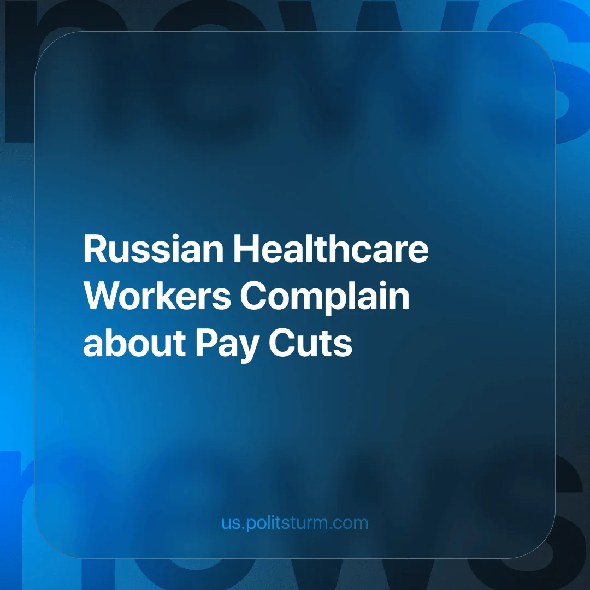

Original article
2024-10-23
4 min read

In the Amur region, during a live broadcast with the governor, several tough questions were raised regarding the salaries of healthcare workers and the condition of hospitals in the region. One of the citizens complained that her family member, employed at a hospital, would have her salary reduced as of October 1 [1]. The governor replied that the issue was partly caused by the hospitals' financial debts. The budget is limited, and if funds are allocated to raise salaries, there would be no money left to buy medicine and carry out maintenance.
After complaints that there was no money, the governor nevertheless added that he would "personally try to address this issue with the Ministry of Health" [1]. All this is happening against the backdrop of the president's February statement that individual regions should increase the base salary of medical workers by 50% while maintaining all additional payments [2].
Earlier, healthcare workers in Novosibirsk also complained about a decrease in income. They told reporters that the promised pay increases were being carried out by cutting bonuses, resulting in them earning even less than before the formal raise [3]. We covered this in more detail: "Bonuses Cut to Raise Doctors' Base Salaries". All of this seems absurd in light of the ongoing news of personnel shortages in healthcare facilities. Salary cuts will only worsen the problem: medical graduates have the alternative of working in private clinics, where working conditions are more attractive. Moreover, according to experts from the Higher School of Economics, only 40% of medical school graduates continue to work in public hospitals [4].
In the spring of 2024, the Ministry of Health estimates that there will be a shortage of 29,000 specialists [5]. Meanwhile, the increased workload from every vacancy in the healthcare system is shared among existing doctors and junior medical staff. Hospital workloads are increasing and doctors are being forced to work overtime. According to surveys, this leads to increased burnout, and emotional and physical exhaustion [6].
The main reasons cited for working overtime are attempts to increase income (38%) and shortages of medical staff (37%). While the standard workload is 160 hours per month, many are forced to work up to 250 hours, and there are cases of 320 hours [6]. That's 16 hours a day during a five-day workweek or almost 13 hours with a single day off. This means that a person whose actions determine the health and lives of others is literally forced to live at work, with no time for proper rest and recovery. There are studies that confirm that overwork and burnout lead to increased medical errors [7].
High workloads force medical staff to quit: 26% of respondents said they want to leave their jobs due to a lack of rest [6]. Therefore, hospital management's attempts to "plug the gaps" caused by staff shortages with the existing personnel only aggravate the overall problem. The need forces doctors to take on additional work because, despite the assurances and promises of high-ranking officials, their real incomes have been declining year by year.
For example, considering how entrepreneurs raise prices for basic goods and services, the increase in the key interest rate, and rising taxes [9], it becomes clear that no increase in salaries and wages for workers will improve their difficult situation. It is also unlikely that the new pay structure for healthcare workers [10] will significantly improve the lives of doctors and their attitudes toward their work.
Everything is becoming more expensive, and ordinary people have just enough money to survive. They have no opportunity to satisfy their needs for housing, living conditions, leisure, education, or culture, let alone their hobbies. The living and working conditions of hired workers are constantly deteriorating. There is no reason for optimism as long as capitalism prevails and our economy is based on market principles.
Healthcare is a primary need of citizens. It was the development and accessibility of healthcare in the first half of the 20th century that significantly reduced infant mortality and increased life expectancy. In the 1920s, the USSR instituted a system of universal free medical care. It provided access to medical care for all Soviet citizens, including not only treatment but also prevention and health education. The state developed healthcare in parallel with industrialization, the establishment of defense production, and a program to eliminate illiteracy, among many other things. All this was done after the devastating First World War and Civil War.
Where did the state get the resources for all these initiatives? The fact is, the USSR was a socialist state where all means of production — land and factories — belonged to the working people, whose interests the state represented. Therefore, all resources were directed toward the needs of workers: education, healthcare, and culture. There were no private owners seeking to increase their profits through others' labor and spend it on another luxury mansion or personal jet.
Today, we live in a market economy where the average citizen is merely an employee of the entrepreneurs. The current government is the representative of the interests of the wealthiest business owners, not the majority of citizens. For such a state, the social sphere is a "burden" and an inefficient expenditure. It is only necessary to the extent that a person can survive and work for them until retirement. Improving the quality of life is not in the interest of the proponents of a market economy. That is why health care and education are now suffering so much.
A state based on a planned economy and socialist principles is completely different: all wealth and production are the property of the workers. In such a state, there is no exploitation or speculation, and all citizens have equal rights and opportunities for growth; there are no poor or immensely rich. It is only under socialism that the professions of teacher and doctor are respected and honored, and bring benefits to the people. Their work aims to nurture worthy citizens and to ensure the welfare of the working people.
Sources:
[1] Amur.life "Residents of the Amur region complained to the governor about salary cuts for medical workers. What did he say?" — October 3, 2024.
[2] TASS "Putin announced an increase in the base salaries of all medical workers starting April 1" — February 14, 2024.
[3] NGS.RU "We were let down": Novosibirsk medical workers reported a decrease in payments despite Putin's directives — July 8, 2024.
[4] Gazeta.ru "Why doctors in some regions complain about the reduction of wages" — June 26, 2021.
[5] RIA Novosti "The Ministry of Health estimated the shortage of medical personnel at 29,000" from March 26, 2024.
[6] Kommersant "Russian doctors are suffering from overwork" — December 25, 2023.
[7] Cyberleninka "Emotional burnout in doctors and medical errors. Is there a connection?" — 2016.
[8] Gazeta.ru "Why doctors in some regions complain about salary cuts" — June 26, 2021.
[9] NGS24.ru "As personal income tax increases, workers' salaries decrease" — July 24, 2024
[10] TASS "Murashko named the main principle of the new payment system for medical workers" — October 1, 2024.

Original article

