Russian Government Will Continue To Issue Fines For Liking Content On Social Media
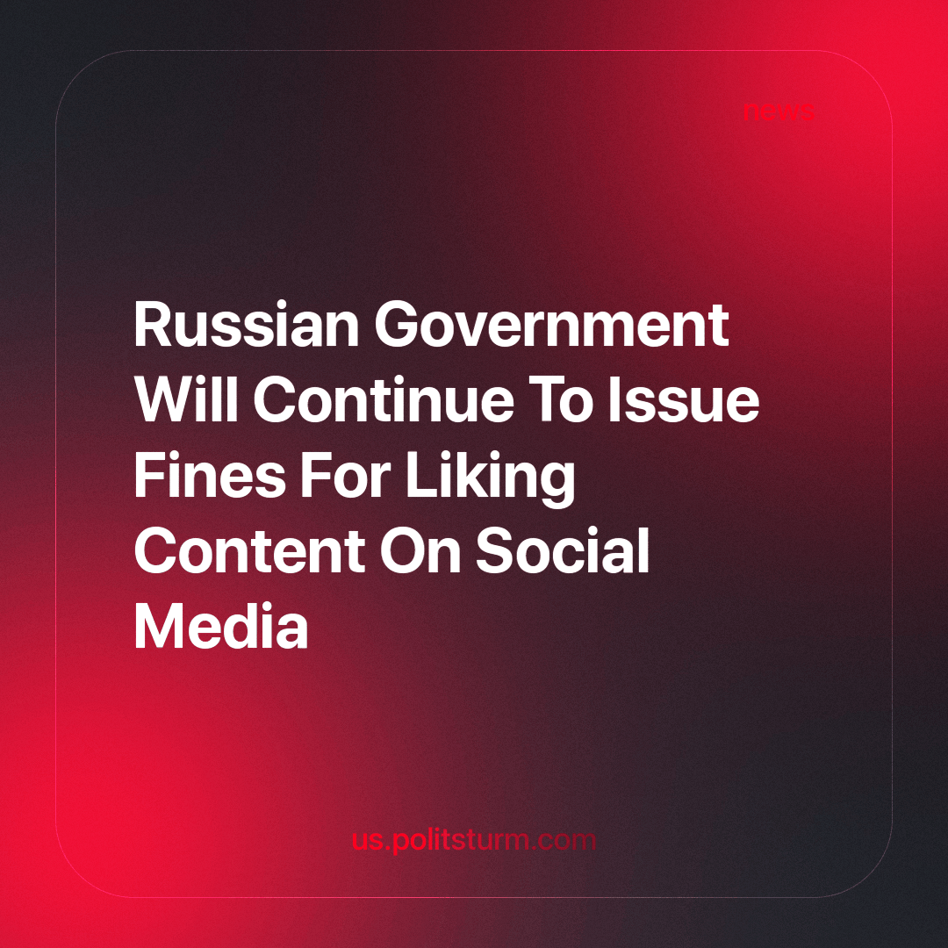

Original article
2023-10-27
2 min read

According to a TASS news agency report, the government did not support a potential law proposed by the “New People” party faction in the State Duma. The bill would ban the practice of the government issuing fines for liking posts on social media.
The bill proposes to amend the Administrative Code on inciting hatred and discrediting the Russian army, specifying that this does not apply to the expression of emotions in the form of tagging publications on social networks.
In a review of the draft bill, the Putin-controlled Cabinet of Ministers pointed out that the bill “does not contain statistical data or other information indicating the presence of systemic problems of law enforcement and confirming the need to make the proposed changes.”
“In addition, the concepts of ‘expressing emotions’ and ‘marking publications’ used in the bill are not defined by the legislation of the Russian Federation, and therefore the draft norms do not meet the requirements of clarity and certainty and may lead to ambiguous interpretation in practice,” the draft review states.
The Government also reminds that for such administrative offenses, the Supreme Court of the Russian Federation has the job of “taking into account all circumstances of the offense when determining the presence or absence of a person’s direct intent and the purpose of inciting hatred or enmity, as well as humiliation of human dignity when posting materials, which may be applicable on the Internet or other information and telecommunications network.”
In this regard, the Cabinet of Ministers points out that the issue of the presence of signs of administrative offenses “in each individual case must be decided taking into account the circumstances of the particular case.”
Will the Chamber of Deputies pass the bill in spite of the government’s opposition to it? Probably not. As crises grow, the ruling class increasingly exposes its dictatorship. When it comes to business, the conversation is centered around exemptions from inspections, issuing subsidies, etc. When it comes to citizens on the internet, the conversation immediately swings to things like “extremists!”, “ban!”, “punish!” etc. And as a cherry on top, the government raises interest rates and reduces welfare spending.
Source: TASS – “The Russian government did not support the bill banning fining citizens for pгеештп likes on social networks” from September 11, 2023.

Original article

