Russian Capitalists Make Profits from Ukrainian Conflict
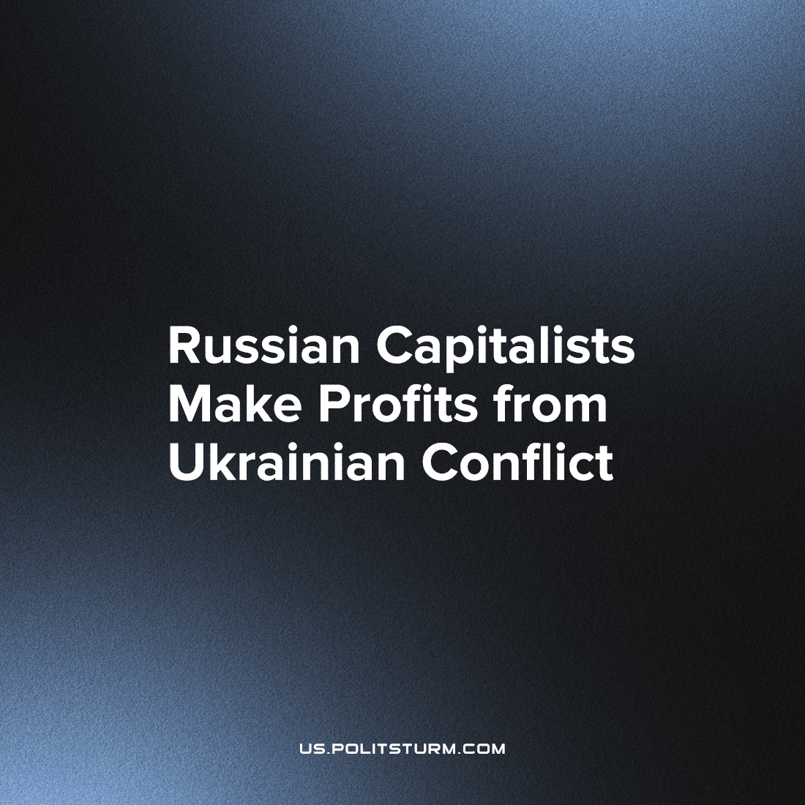

Original article
2022-06-16
2 min read

Despite the sanctions, trade restrictions and the loss of profits of some oligarchs, the jump in prices for oil and gas products after the start of the special operation makes it possible here and now to earn much more than in peacetime. According to Bloomberg, Russia’s oil and gas revenues this year will grow by 20% and amount to $285 billion and taking into account the export of metals, profits will reach about $300 billion.
According to the RBC chart, one can see a sharp jump in oil prices in March and May due to a decrease in the trading volume.

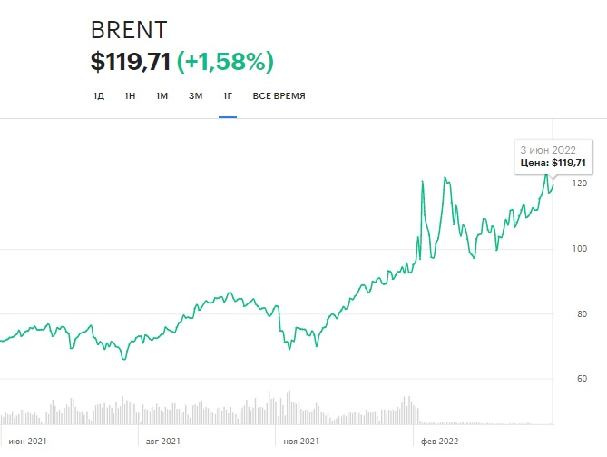
Robert Rapier calculated for the OilPrice site that in April Russia earned 1.8 trillion rubles from oil and gas, while in March the amount was 1.2 trillion.
Perhaps in the future, we should expect a recession in the Russian economy due to the sixth package of sanctions adopted by European countries. According to this the delivery of raw materials by sea will be limited, but pipeline supplies will not be affected. Such measures are aimed at reducing the funding of the Russian army and the cessation of hostilities.
Alexander Titov, a senior expert at the Russian Institute of Energy and Finance, notes that in 2021, the oil and gas supply to Europe through the pipeline amounted to about 800,000 barrels per day. In total, 5 million barrels per day are exported from the Russian Federation to the world market by all possible means, and about 2.5 million barrels per day fell to European countries.
The sixth package imposes restrictions on 68% of crude oil supplies to EU countries or 34% of all exports. Thus, the total export of petroleum products will amount to 3.24 million barrels per day, which is 41.2% worldwide and 80.2% in European countries. According to preliminary estimates, the country may miss out on about 50-57 billion dollars. One can only guess at whose expense these losses will be compensated.
It will be possible to make up part of the sales through grey exports through Israel, Turkey and Azerbaijan, as Lithuania is already buying Russian gas through Qatar, but at the same time, the government risks running into new sanctions.
If we look at the graph of changes in the price of a barrel of oil, we can conclude that the special operation is fully justified. The Russian treasury is replenished, and Russian and Ukrainian military personnel continue to die for the sake of the profits of the oligarchs.
The Russian media will continue to tell the population about the liberation of the residents of Donbas and Luhansk, about “denazification”, but the real reason lies in one aspect – profit. As homeless people seek shelter and food, oil and gas price charts have skyrocketed.
Parallels arise with WWI, where the heads of the warring states shouted about the protection of national interests when they themselves were chasing personal gain. The classic of Marxism once spoke about this:

“…while the capitalists gain, making fortunes out of the war, aggravating national prejudices and intensifying reaction, which has raised its head in all countries. even in the freest and most republican.”
V. Lenin, “Socialism and War”

“…interests of the greedy bourgeoisie, the interests of capital, which is prepared to sell and ruin its own country in its drive for profit.”
V. Lenin, “To the Russian Proletariat”

Original article

