Russian Aircraft Violate NATO Airspace
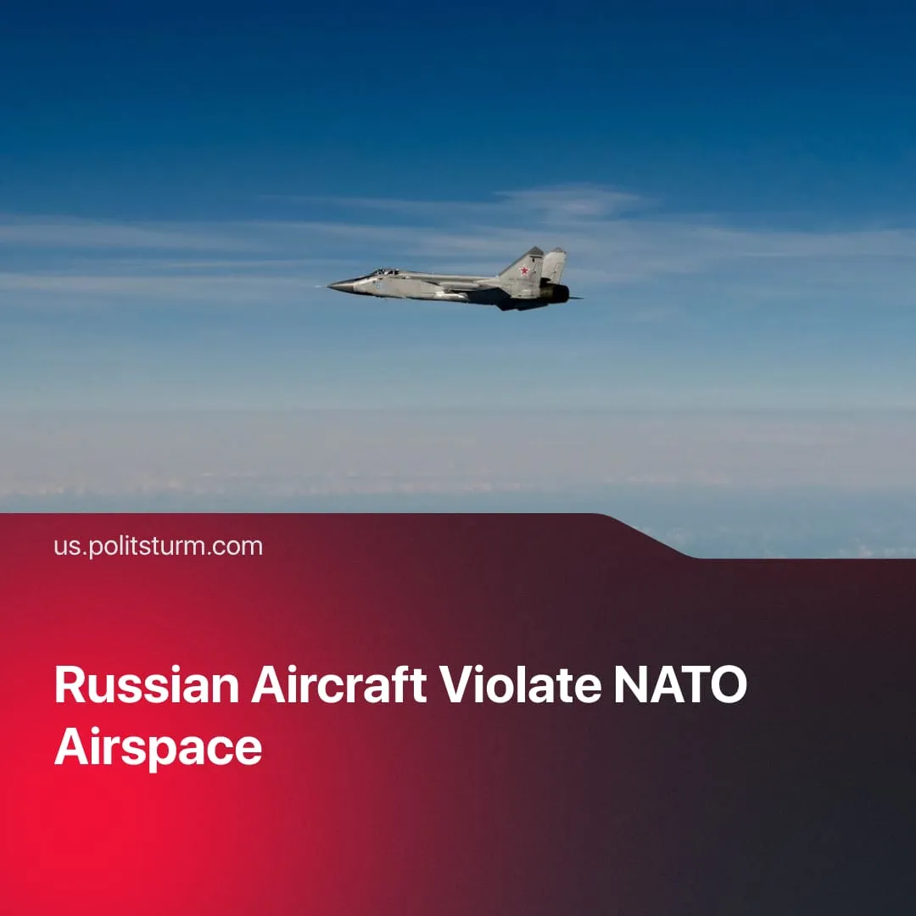

Original article
2025-09-28
2 min read

Russian aircraft repeatedly violated NATO airspace, giving the alliance grounds to justify its militarisation.
Details. On the night of 9–10 September, Russian drones violated Polish airspace. Days later, another drone crossed into Romania during an attack on Ukraine near the border. On 20 September, three Russian MiG-31 jets entered Estonian airspace.
► In response, Poland, Romania, and Estonia deployed fighter jets with the support of NATO air defences. Poland and Estonia also invoked allied consultations under NATO Article 4.
► The Russian Defence Ministry claimed the drones were targeting Ukrainian military sites and “not intended” to enter NATO airspace, and dismissed Estonia’s accusations by saying its jets were flying legally to Kaliningrad.
► Zelenskyy insisted the violations were deliberate, a view echoed by several European leaders. NATO’s General Secretary warned they are “dangerous” regardless of intent. Trump voiced support for shooting down Russian aircraft that enter allied airspace.
► In response, NATO announced operation “Eastern Sentry”. It is mobilising more troops, aircraft, and air defence assets to its eastern flank. NATO Secretary General and other officials have emphasised that air violations are unacceptable and that every member state has the right to defend itself.
Context. Despite failed negotiations, Ukraine and Russia are preparing for peacetime as both the Russian and Ukrainian economies are struggling and risk further dependence on larger imperialists.
► Despite recent claims, airspace violations have been quite common. In 2024, Russian air forces were intercepted by NATO air patrols over 300 times while approaching allied territory. The highest number of interceptions occurred in 2022, the year that the special military operation began, with 570 interceptions taking place.
► The conditions of workers in Europe have been worsening. Overall unemployment in the EU is around 6.2%, and in 2024, around 21% of the population, approximately 93.3 million people, are living on the brink of poverty and social exclusion. Against this backdrop, militarisation costs must be justified.
► Both NATO and European countries are investing in defence at levels close to those seen at the end of the Cold War. NATO members have pledged to raise defence spending to 5% of GDP, up from 2%. This recent scandal over airspace violations serves as a convenient pretext to ramp up arms production. Such stories serve to uphold the image of an "enemy at the gates".

Original article

