Russia Has Written Off Debts To African Countries
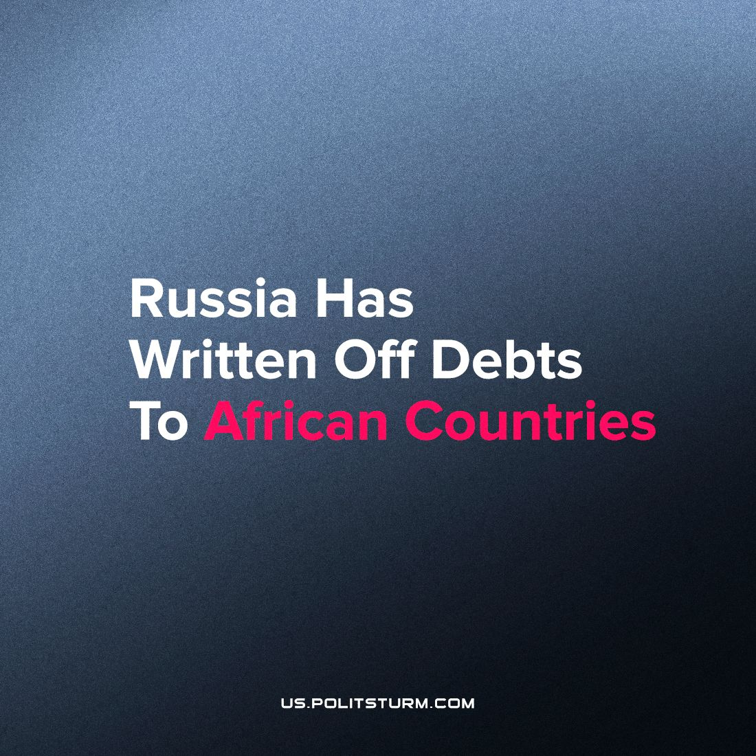

Original article
2023-09-29
1 min read

At the recent Russia-Africa summit held in St. Petersburg, President Vladimir Putin announced a significant debt forgiveness of $23 billion, owed by African countries. In addition to this, he committed over $90 million for the development of these nations.
Putin emphasized Russia's commitment to expanding agricultural exports to Africa, recognizing its role in promoting socio-economic development and maintaining political stability in the region. Despite facing international sanctions, Russia has been steadfast in its support for African nations, dispatching substantial quantities of grain in recent years, with plans for continued assistance in the future.
Putin also highlighted Russia's ongoing support during the COVID-19 pandemic. Russia was among the early contributors, offering millions of free test systems, deploying mobile medical laboratories, and establishing a specialized infection research center.
To further support the development of African nations, Russia will continue supplying agricultural products without charge.
While Russian propaganda portrays this move as an expression of the authorities' humanistic aspirations and their commitment to combatting hunger in Africa, it's essential to scrutinize this seemingly altruistic gesture within a broader geopolitical context. The cancellation of $23 billion in debts, equivalent to approximately 2 trillion Rubles, should be considered alongside other priorities. For instance, in 2023, Russia allocated1.2 trillion Rubles for science funding. this debt forgiveness may not solely be driven by humanitarian motives but rather by geopolitical necessity.
Following the imposition of sanctions and the de facto rupture of many political relations with Western countries, the Russian authorities are compelled to seek new allies in different regions of the world. This move appears to be part of a strategy to establish closer ties with the bourgeois of African nations, employing a common technique – debt cancellation.
However, it's essential to acknowledge that these funds will eventually need to be replenished, and the burden of such actions may fall on the working class within the Russian Federation. This could manifest through tax increases, inflation, and potential budget cuts affecting social services.
Sources:
· RBC - "Putin named the amount of written-off debts of African countries to Russia" dated July 28, 2023.
· Kommersant - "Spending on science in Russia will amount to 1.2 trillion rubles in 2023" dated February 15, 2023.

Original article

