Russia Under Attack: Ukrainian Troops in Kursk Region
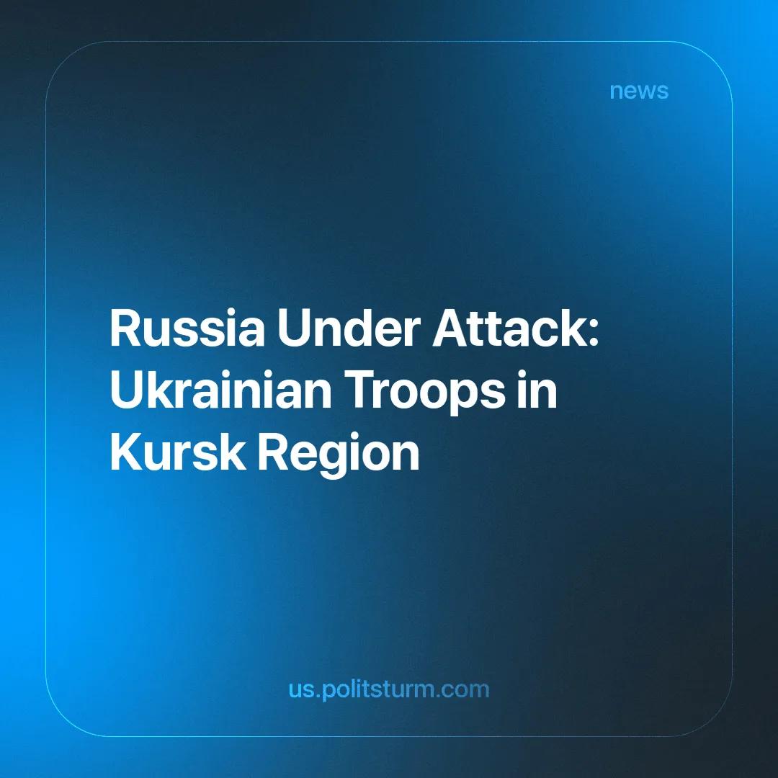

Original article
2024-08-09
2 min read

On Tuesday, August 6th, the Ukrainian Armed Forces began an offensive in the border areas of the Russian Kursk region. Reports indicate that Ukrainian troops have taken control of a gas metering station in the city of Sudzha, through which Russia transits gas to Europe.
- The AFU's incursion marks the first time since World War II that foreign troops have occupied central Russian territory. Ukrainian forces continue to operate within the Kursk region, carrying out drone attacks. Russian state media report about strikes on Ukrainian forces in the Sudzha district.
- The evacuation of civilians from affected areas in the Kursk region is being conducted haphazardly. Residents of the Sudzha district have recorded a plea for help addressed to the President of Russia. Videos have surfaced online showing residents evacuating under fire. The regional authorities declared a state of emergency only two days after the invasion began. Russia's Ministry of Emergency Situations (EMERCOM) has acknowledged the situation in the Kursk region as a federal-level emergency. Additionally, President Putin has promised payments of 10,000 rubles ($112.87) to the refugees. EMERCOM announced a one-time payment of 15,000 rubles ($169.30).
- It seems that the Ukrainian forces are pursuing several objectives:
- To stretch the front and divert some of the Russian Armed Forces from other areas of combat.
- To increase pressure on the Russian leadership and strengthen Ukrainian position ahead of potential negotiations in the fall or winter.
- To improve their media reputation and boost ratings amid news of growing resistance to mobilization and setbacks on the front.
- Despite the fighting near the Sudzha Gas Metering Station, gas transit supplies through Ukraine on this route have not been halted. In 2023, 14.65 billion cubic meters of Russian gas were exported to Europe through this section.
- The battle is taking place on the territory of the former Soviet Union, a socialist state defended by Russians, Ukrainians, and other peoples in the fight against capitalism and the fascism produced by it. Now, the battle takes place between the armies of bourgeois states.
- This event is occurring against a backdrop of increasing international tension and escalating conflict between imperialist blocs: the rise of far-right forces in Europe, unrest in Venezuela, conflicts in the Middle East, Africa, and Southeast Asia, and the presidential race in the United States.
- The struggle for the redivision of the world is intensifying. Regardless of human casualties and destruction, capitalists continue to make profits. Under the guise of lofty slogans about justice, progress, democracy, and a "multipolar world," they ignite military conflicts without considering the interests of workers.
In the context of the growing economic crisis and increasing tensions, communists must continue their current work on building a communist party, taking into account the circumstances. This work involves strengthening the existing organizational structure, training and expanding its ranks, retaining personnel, systematically interacting with labor collectives, agitating them and fighting against all forms of opportunism and revisionism, especially against social-chauvinism.

Original article

