Update on the Situation in Russia and Ukraine
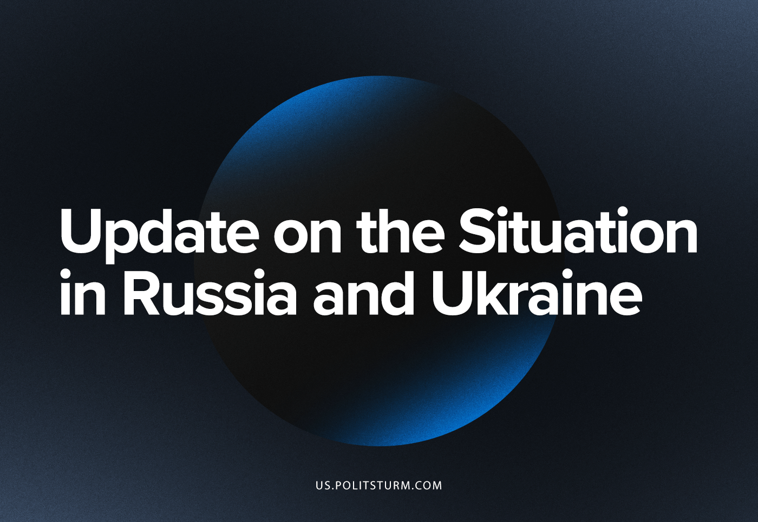

Original article
2022-10-25
4 min read

It’s been 8 months since the escalation of the Russia-Ukraine crisis, and events build up from week to week. Due to the development of the situation, we have assembled a digest of reporting recent updates on the battlefield, the politics of Russia and Ukraine, and the current state of the working classes there for our international audience.
Military actions:
After the successful counter-offensive in the beginning of September in the Kharkiv region of northern Ukraine, Ukrainian Armed Forces shifted focus to the South front. The main active hostilities are currently in the region around Kherson. After several failed attempts to advance at the beginning of the week, MFU began active artillery preparations in the region, on the 19th of October. At the same time, Russia announced an evacuation of citizens from Kherson and Nikolaev, which is ongoing.
Since Friday, infantry fighting has broken out along the frontline as each side attempts to advance and capture strongholds or cut off supply lines.
In Donbas, Russian Forces try to advance. The main places of the clash are Soledar, Artemovsk and Mariinka. Both sides actively use missile weapons and artillery to destroy the infrastructure and enemy positions.
Error loading image
Although hostilities in these regions took place all this time, the Russian government announced martial law in newly “joined” lands (LPR, DPR, Kherson and Zaporozhye) only on Friday.
Russia continues its general strategy of disabling the Ukrainian energy infrastructure for the upcoming winter, doubling down on the hope of victory through attrition. Ukrainian officials confirm the destruction of 30% of the country’s power stations.
Politics:
Error loading image
Ukraine refuses to negotiate with Russia. Now, they accuses Iran of supporting Russia and providing drones, demanding sanctions be put against them. The European Union has asked the UN for an investigation on the topic, which may end in nothing as usual.
Russian officials continue to claim that they are open to dialogue. However, on Sunday, the ambassador of Russia refused to listen to the speech of the Ukrainian colleague. The loss of initiative on the battlefield shows that the game of nobility is meaningless. The Ukrainian ambassador expressed his satisfaction that efforts to remove Russia from the UN are bearing fruit.
Ukrainian politicians made an astonishing ‘scientific’ discovery that Kievan prince Volodymyr converted Ukraine to Christianity and and therefore decided that Ukraine had to join the EU even in the Middle Ages. Russian Patriarch Kirill, at the same time, calls confused intellectuals to “accept the faith which rescued our fathers” and claims that the West wants to destroy Russia because of its “alternative view on the world, the God and the human, which doesn’t fit the frames of the programmed system where the God is excluded from human lives…”.
Working Class:
The general situation in both countries only brings more hardship to ordinary people. Ukraine has used the patriotic energy of the people to pass laws violating workers’ rights, creating ‘favourable conditions’ for business. Ongoing destruction and chaos throughout the country has not become an obstacle to the privatization of state-owned enterprises.
In Russia, in addition to the main problem of rising prices and the shortage of goods from the EU, the burden of mobilisation has fallen on the shoulders of ordinary workers. The degraded military supply system can only offer the purchase of the necessary equipment with the workers’ own money. Many families have not only lost a breadwinner, but spent a decent share of the family budget to send him to the front line.
Bourgeois officials propose decisive actions such as a delay on loan payments (with cancellation in the case of death), discussions of compensation for the equipment purchased, and cancelled deferments for the deputies – for which one of the parties developed a whole new bill. The question of the lack of equipment in the army is loudly discussed in the parliament… in closed sessions. “There is no point to discuss this question in public,” said the chairman of the Budget Committee, Andrey Makarov.
Shellings of peaceful cities by both sides (Kiev, Odessa, Kirovograd, Kharkiv and others in Ukraine, and Donetsk, Belgorod, and Kherson on the Russian side) force people to leave their homes and scar the population with civilian casualties. The strategy of Russia towards the destruction of energy infrastructure has created a new wave of migration out of Ukraine. The position of those who remain seems no less tragic in the cold light of the coming winter.
The Russian state also continues to suppress the workers’ movement, destroying the most “radical” unions, despite their negligible real power, bringing activists across the country to criminal prosecution under far-fetched pretexts.
On the 17th and 23rd of October, two training jet fighters crashed in Yeysk and Irkutsk, respectively. In both cases, the accident happened because of a technical issue that appeared during the flight. In the first accident, the pilot of the SU-34 left the plane and survived, but the falling plane crashed into a residential building causing 13 deaths and the hospitalization of 17 more. In Irkutsk, an SU-30 fell into a two-story house, killing its two pilots. Both incidents are under investigation.
The conflict goes on. Millions become refugees, as the living standards in both countries have significantly dropped and every day there is a rising chance of losing your life. The two peoples, who lived in brotherhood in the Soviet Union, are forced to fight each other and in turn destroy themselves.
However, the example of the USSR proves that they can still live in peace. It can be done, however, only on the basis of proletarian internationalism, and only the communist parties can bring this policy to the state level. Therefore the workers’ first task is to create such organisations, and to win peace through socialism.

Original article

