Russia-Ukraine Crisis: 5 Theses
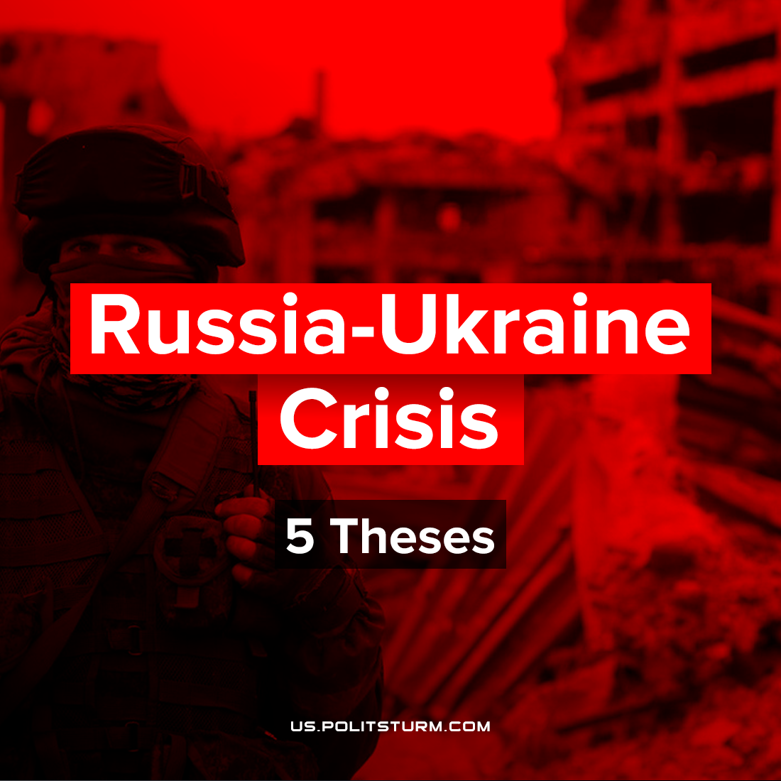

Original article
2022-02-21
1 min read

1. The current aggravation of the Donbass conflict is the result of a behind-the-scenes struggle between Russian and Western imperialist capital — a consequence of inter-imperialist contradictions between groups of capitalists who are dividing capital, markets and spheres of influence once again.
2. Recognition of the puppet “people’s republics” is a bargaining chip in negotiations of the Russian imperialists with the Western ones. The dragging out and aggravation of the situation around this issue is a clear confirmation of this.
3. The capitalists remind the Russian and Ukrainian workers once again, that they act solely in their own interests, without regard for the opinion of the majority of the population. They are ready to solve their problems by any means, including military ones.
4. Regarding any development of these events: what is happening now will make it possible to justify a deep economic crisis, a drop in living standards and the need to work more for the “national interests”, as well as to expand repression in both countries and pressure on any opposition, including communists.
5. Any action in the international sphere taken by warring governments is done in the interests of the capitalist class. In turn, the fundamental interest of the workers of all countries is to get rid of the ruling handful of owners and move towards a socialist society – a society without wars, a society without national oppression and exploitation.
Not the worker of another nation, but the capitalist class is the only and real enemy of all the exploited.

Original article

