Russia Recognises Taliban Government to Regain Regional Influence
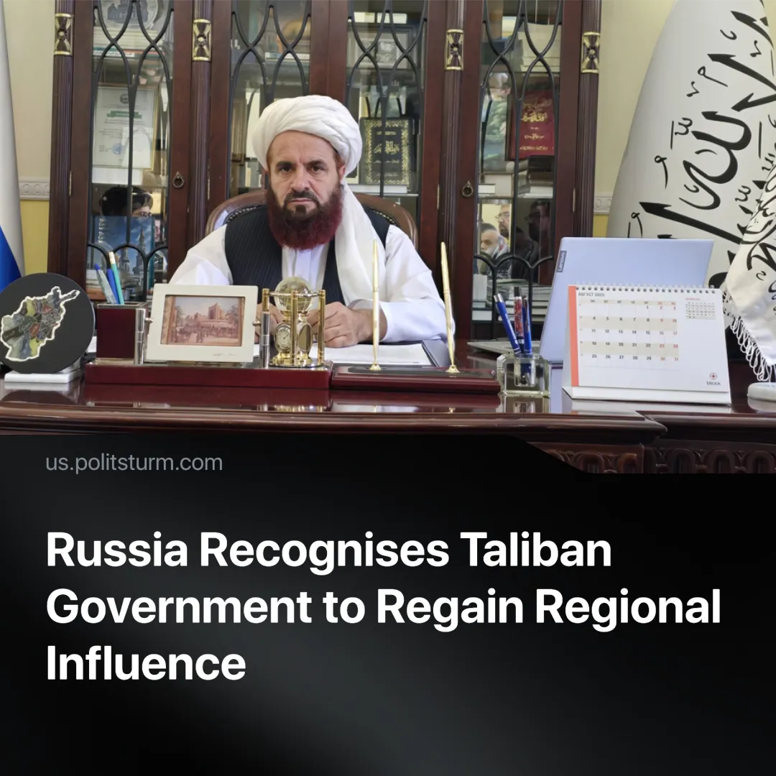

Original article
2025-07-16
1 min read

Russia has become the first major power to officially recognise Afghanistan’s Taliban government, following defeats in the Middle East.
Details. Russia’s official recognition of the Taliban regime was formalised on July 3, 2025, when it accredited Taliban envoy Gul Hassan Hassan.
► Afghanistan’s Foreign Minister Amir Khan Muttaqi welcomed the decision as the start of “a new phase of positive relations.”
► Russian Foreign Minister Lavrov emphasised new “commercial and economic” cooperation in energy, transport, and infrastructure.
► The Taliban government continues to brutally repress minorities, enforcing a system of gender apartheid, banning education for girls, and violently silencing dissent.
Context. The Taliban seized power after the US withdrawal in 2021, establishing a hardline Sharia-based regime now seeking international recognition. Russia’s recognition comes amid the collapse of several of its allied governments in the region.
► Today, they align more closely with Russia and China, both of which have sent official delegations and signalled future cooperation.
► The US has also stabilised relations with similar regimes, such as the new Hay'at Tahrir al-Sham government in Syria.
► In 1979, the USSR intervened in Afghanistan at the request of its government to support a progressive regime that promoted secularism, women’s education, and workers’ rights. The US and UK had already begun arming Islamist insurgents through Operations Cyclone and Faraday. Today’s Russian state — like China, the UK, and the US before it — now openly backs theocratic regimes in pursuit of imperialist interests and market access.

Original article

