In Russia, Law Enforcement Can Freely Enter Migrants' Homes
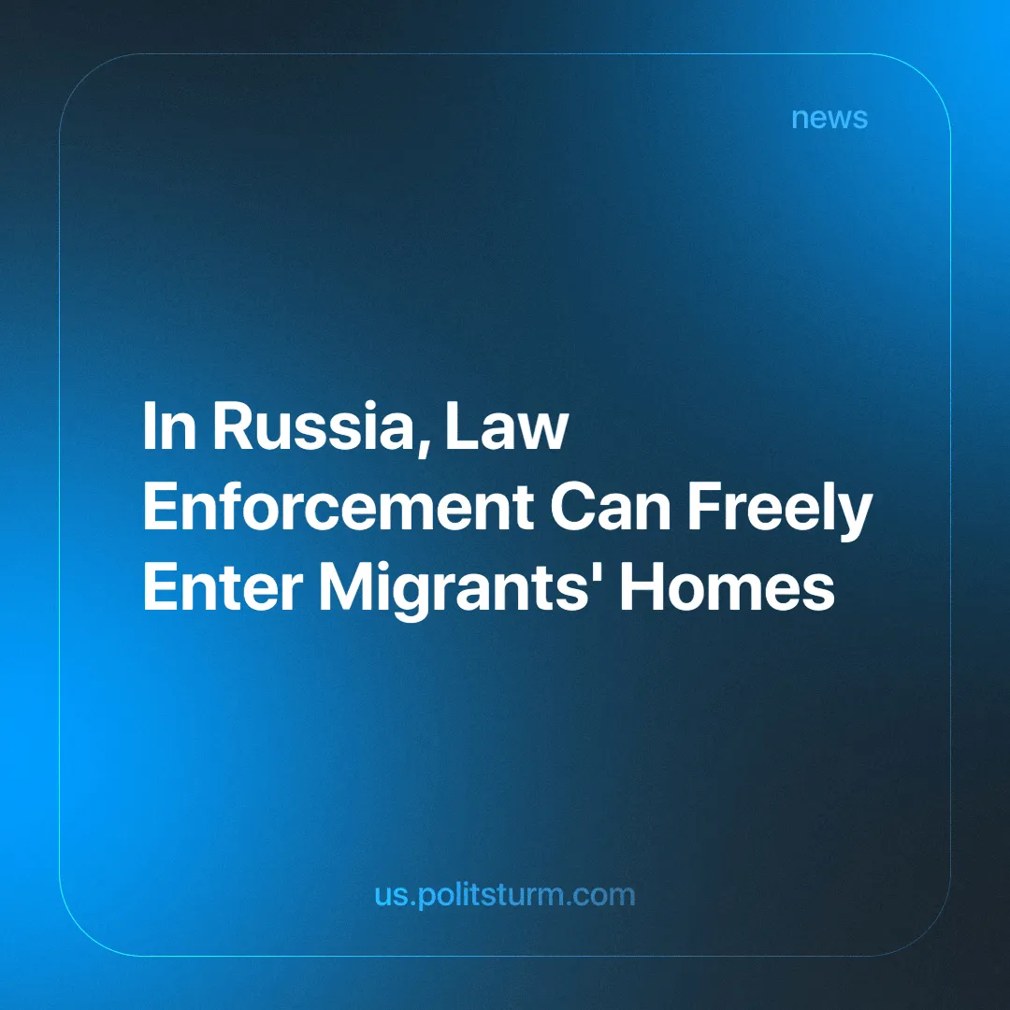

Original article
2025-02-03
4 min read

"The internal state of our society largely depends on how effectively you work... I am counting on you very much, and this is the kind of work the people of Russia expect from you," — Putin stated at an expanded meeting of the Ministry of Foreign Affairs board regarding the Ministry of Internal Affairs. [1].
What kind of "work" do Russian citizens expect from the Ministry of Internal Affairs? And what kind of work do they actually get? Officially, authorities claim that much depends on fulfilling legal duties and principles for the sake of "citizens." These words are spoken so casually, as if the state's law enforcement agencies, in a society divided into classes of property owners and wage workers, are guided solely by "principles" and "legal obligations."
In reality, the Ministry of Internal Affairs of Russia is assigned the role of protecting the private property of major entrepreneurs. For them, the law is nothing but fiction if it hinders the pursuit of their desired profits. For them, murders and robberies in broad daylight are easily justified and bought off by those who supposedly "strictly follow" the laws [2].
It is important to note the consequences of expanding the powers of law enforcement. For example, the authorities have allowed police officers to "freely enter homes and other premises where migrants reside." The police will also be granted the authority to monitor foreign nationals awaiting deportation, including through the use of technical means. Law enforcement officers will be allowed to access data from mobile devices and geolocation services, as well as payment systems that operate within facial recognition networks [3].
The new year of 2025 has even begun with certain officers of the Ministry of Internal Affairs (MVD) being granted the authority to administratively expel foreigners from Russia [4]:
"Officials of the Ministry of Internal Affairs will be granted the authority to make decisions on the administrative deportation of foreign nationals from the country in cases specified by the Code of Administrative Offenses of the Russian Federation," — writes RIA Novosti.
These measures, according to officials, are intended to prevent crime among migrants. However, the Institute of Demographic Research of the Federal Scientific Center of the Russian Academy of Sciences (FNIСS RAN) [5] emphasizes that in 2022, migrants committed only 2% of all crimes, or 40.15 thousand cases. A recent report from the Investigative Committee of the Russian Federation shows that by the end of 2024, they had committed 26 thousand crimes — a reduction of nearly one and a half times compared to two years earlier [6].
However, this does not prevent migrants from being made into enemies of the people. While spreading nationalism, lawmakers do not ask why people flee from other countries. Instead, migrants are falsely accused of high crime rates, inherently low education levels, and other harmful stereotypes [7]:
"We must no longer tolerate attacks on our children, aggression, and rudeness. Migrants are taking over jobs and ignoring rules of conduct. Many work illegally, while their families take up places in kindergartens, schools, and hospitals," — insisted Leonid Slutsky, a State Duma deputy from the LDPR (Liberal Democratic Party of Russia).
Are the people to blame for migrating? In the CIS* countries, as well as in other dependent states, the quality of life is declining, exploitation and taxation are increasing — all the burdens of life are placed on the working class. Is it fair to condemn them for refusing to live in the poverty and misery caused by Russian business interests, especially considering the example of the CIS*? The same is happening in the United States [8].
Based on all the above, it is clear that the state is not interested in supporting the masses. Instead, it is focused on creating the illusion of efficient work, pretending to protect the rights of the “native population,” while openly fostering hatred and oppression toward migrant workers. The media frequently raises the issue of crimes or offenses committed by immigrants.
Russian capitalists, invite hired workers from other countries with one hand and, at the same time, point the other hand at them, directing the anger of frustrated Russian workers toward them. Capitalists of any nationality do not miss the opportunity, in times of crisis that threaten their power, to shift the hostile gaze of domestic and migrant workers onto one another. By pitting workers of different nationalities against each other, capitalists of these nations secure the safety of their precarious position. The nationality of workers is of no importance to the entrepreneur, as the main thing is their own profit.
*CIS — Commonwealth of Independent States, a regional organization of former Soviet republics established after the dissolution of the Soviet Union.
Sources:
[1] RIA — "Putin evaluated the importance of the Ministry of Internal Affairs" — April 2, 2024.
[2] TASS — "Businessman Konoplev was released from the pre-trial detention center the day after his arrest" — October 3, 2024.
[3] RBC — "Police will be allowed to freely enter the homes of illegal migrants" — January 2, 2025.
[4] RIA — "Police will be able to independently deport violator migrants starting February 5" — January 5, 2025.
[5] RBC — "Institute of Demographic Research of the RAN assessed crime rates among migrants in Russia" — February 10, 2024.
[6] Kommersant — "SKR: In 2024, crime among illegal migrants grew almost threefold" — October 1, 2024.
[7] Arguments of the Week — "State Duma Deputy Slutsky accused migrants of taking jobs in Russia" — September 2, 2024.
[8] Lenta.ru — "Two Homelands, No Home: How Mexicans Deported from the U.S. Live" — April 3, 2017.

Original article

